UNITED STATES
SECURITIES AND EXCHANGE COMMISSION
Washington, D.C. 20549
SCHEDULE 14A
Proxy Statement Pursuant to Section 14(a) of
the Securities Exchange Act of 1934 (Amendment No. )
Filed by the Registrant ☒
Filed by a Party other than the Registrant ☐
Check the appropriate box:
☐ | Preliminary Proxy Statement
☐ | Confidential, for Use of the Commission Only (as permitted by Rule 14a-6(e)(2))
☒ | Definitive Proxy Statement
☐ | Definitive Additional Materials
☐ | Soliciting Material under §240.14a-12
LIQUIDITY Services, Inc.
(Name of Registrant as Specified In Its Charter)
(Name of Person(s) Filing Proxy Statement, if other than the Registrant)
Payment of Filing Fee (Check all boxes that apply):
☒ | No fee required.
☐ | Fee paid previously with preliminary materials.
☐ | Fee computed on table in exhibit required by Item 25(b) per Exchange Act Rules 14a-6(i)(1) and 0-11.


Fellow Stockholders:
We are pleased to invite you to attend the 2026 Annual Meeting of Stockholders of Liquidity Services, Inc. to be held on Thursday, February 26, 2026, at 11:30 a.m., Eastern Time, at the offices of Liquidity Services, Inc. at 6931 Arlington Road, Suite 460, Bethesda, MD 20814.
Details regarding admission to the Annual Meeting and the business to be conducted are more fully described in our proxy statement for this meeting.
This year, we are taking advantage of Securities and Exchange Commission rules allowing us to furnish proxy materials to stockholders over the Internet. We believe that these rules provide you with access to our proxy materials more quickly and reduces the environmental impact of printing and mailing the materials to you. Accordingly, we are mailing to stockholders a Notice of Internet Availability of Proxy Materials, which contains instructions on how to access and review our proxy materials, as well as instructions on how to vote online or by telephone. If you would like to receive a paper copy of the proxy materials, please follow the instructions for requesting such materials included in the Notice of Internet Availability of Proxy Materials.
Your vote is important. Whether or not you plan to attend the Annual Meeting, we hope you will vote as soon as possible. You may vote over the Internet, by telephone or, if you received a paper copy of a proxy or voting instruction card by mail, by signing, dating, and mailing the proxy card promptly in the return envelope. Voting over the Internet, by phone or by written proxy will ensure your representation at the Annual Meeting regardless of whether you attend in person.
Thank you for your ongoing support and continued interest in Liquidity Services, Inc.
Sincerely,

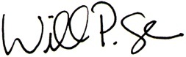
WILLIAM P. ANGRICK, III
Chairman and Chief Executive Officer

notice of annual meeting of liquidity services, INC. STOCKHOLDERS

Important Notice Regarding the Availability of Proxy Materials for the 2026 Annual Meeting of Stockholders to be Held on February 26, 2026: This Notice of Annual Meeting of Stockholders and Proxy Statement, Annual Report and Other Proxy Materials are Available at www.envisionreports.com/LQDT.
Time and Date | 11:30 a.m., Eastern Time, on February 26, 2026.
Place | The offices of Liquidity Services, Inc., 6931 Arlington Road, Suite 460, Bethesda, MD 20814.
Notice Regarding the Availability of Proxy Materials | This proxy statement and our 2025 Annual Report are available free of charge on the following website: www.envisionreports.com/LQDT. You will need to reference the control number found on your proxy card or Notice of Internet Availability of Proxy Materials to vote.  We will make the Notice of Internet Availability of Proxy Materials available to stockholders on or about January 16, 2026. On or about the same date, we will begin mailing paper copies of our proxy materials to stockholders who have requested them.
Items of Business | •  Elect each of the Class II directors named in the proxy statement to the Board of Directors to hold office until our 2029 Annual Meeting of Stockholders or until his, her or their successor has been elected or appointed;  •  Ratify the appointment of Deloitte & Touche LLP as our independent registered public accounting firm for fiscal 2026;  •  Approve an advisory resolution on named executive officer compensation;  •  Approve an amendment to increase the authorized number of shares under the Company’s Third Amended and Restated 2006 Omnibus Long-Term Incentive Plan (the “LTIP”); and  •  Transact any other business that may properly come before the Annual Meeting or any adjournment or postponement of the Annual Meeting.
Adjournments and Postponements | Any action on the items of business described above may be considered at the Annual Meeting at the time and on the date specified above or at any time and date to which the Annual Meeting may be properly adjourned or postponed.
Record Date | You are entitled to notice of and to vote at the Annual Meeting and at any adjournment or postponement that may take place only if you were a stockholder as of the close of business on December 29, 2025 (the “Record Date”).
Annual Meeting Admission | You will need an admission ticket or proof of ownership of shares of our stock to enter the Annual Meeting. If your shares are held beneficially in the name of a broker, bank or other nominee and you plan to attend the Annual Meeting, you must present proof of your beneficial ownership of our stock, such as a bank or brokerage account statement, as of the close of business on the Record Date to be admitted to the Annual Meeting. If you would rather have an admission ticket, you may obtain one in advance by mailing a written request, along with proof of your beneficial ownership of our stock as of the close of business on the Record Date, to: Liquidity Services, Inc., 6931 Arlington Road, Suite 460, Bethesda, MD 20814, Attention: Corporate Secretary. All stockholders also must present a form of personal identification to be admitted to the Annual Meeting. No cameras, recording equipment, electronic devices, large bags, briefcases or packages will be permitted in the Annual Meeting.

notice of annual meeting of liquidity services, INC. STOCKHOLDERS

Voting | Your vote is very important. Whether or not you plan to attend the Annual Meeting, we encourage you to read our proxy statement and submit your proxy or voting instruction card as soon as possible. You may submit your proxy or voting instruction card for the Annual Meeting by completing, signing, dating and returning your proxy or voting instruction card in the pre-addressed envelope provided, or, in most cases, by using the telephone or the Internet. For specific instructions on how to vote your shares, please refer to the section entitled “Questions and Answers” beginning on page 2 of the proxy statement and the instructions on the proxy or voting instruction card. You may revoke a proxy before its exercise at the Annual Meeting by following the instructions in the accompanying proxy statement. Any stockholder attending the Annual Meeting may personally vote on all matters considered, in which event the signed proxy will be revoked.

By Order of the Board of Directors,
/s/ Mark A. Shaffer
MARK A. SHAFFER
Chief Legal Officer and Corporate Secretary

table of contents

 | Page
Proxy Statement Summary | 1
Questions and Answers | 2
Governance of the Company | 7
Compensation of Non-Employee Directors | 22
Beneficial Ownership of Shares of Common Stock | 24
Delinquent Section 16(a) Reports | 27
Certain Relationships and Related Party Transactions | 28
Proposals Requiring Your Vote | 29
Proposal 1 – Election of Directors | 29
Our Board of Directors | 31
Proposal 2 – Ratification of Independent Registered Public Accounting Firm | 39
Proposal 3 – Approval of an Advisory Resolution on Named Executive Officer Compensation | 41
Proposal 4 – Approval of an Amendment to Increase the Authorized Number of Shares Under the Company’s Third Amended and Restated 2006 Omnibus Long-Term Incentive Plan | 42
Executive Compensation | 58
Compensation Committee Report | 94
Equity Compensation Plan Information | 95
Requirements, Including Deadlines for Submission of Proxy Proposals, Nomination of Directors and Other Business of Stockholders | 96
Annual Report | 98
Appendix A (Proposed Amendment to the Company’s Third Amended and Restated 2006 Omnibus Long-Term Incentive Plan) | A-1
Appendix B (Liquidity Services, Inc. Third Amended and Restated 2006 Omnibus Long-Term Incentive Plan, as amended) | B-1



PROXY STATEMENT SUMMARY

Proposals  Requiring Your Vote | Board’s Voting Recommendation | Page Reference  (for more detail)
Proposal 1 –  ELECTION OF CLASS II DIRECTORS | FOR  each director nominee | 29
Proposal 2 –  RATIFICATION OF INDEPENDENT REGISTERED PUBLIC ACCOUNTING FIRM | FOR | 39
Proposal 3 –  APPROVAL OF AN ADVISORY RESOLUTION ON NAMED EXECUTIVE OFFICER COMPENSATION | FOR | 41
Proposal 4 –  APPROVAL OF AN AMENDMENT TO INCREASE THE AUTHORIZED NUMBER OF SHARES UNDER THE COMPANY’S THIRD AMENDED AND RESTATED 2006 OMNIBUS LONG-TERM INCENTIVE PLAN | FOR | 42

1

Questions and Answers

Q. | Why did I receive a Notice of Internet Availability of Proxy Materials for the 2026 Annual Meeting of Stockholders to be held on February 26, 2026 (the “Notice”)?
A. | You received the Notice, which provides you with instructions to access our proxy materials and how to vote your shares of Company common stock, because our records indicate you held shares of our common stock as of the close of business on December 29, 2025 (the “Record Date”), which entitles you to vote at our 2026 Annual Meeting of Stockholders (the “Annual Meeting”) and at any adjournment or postponement of such meeting. Our proxy materials are part of a solicitation of proxies by the Board of Directors for voting at the Annual Meeting. If you would prefer to attend the Annual Meeting in person, you are invited to do so.  Unless the context otherwise requires, the terms “us,” “we,” “our” and the “Company” include Liquidity Services, Inc. and its consolidated subsidiaries. The terms “Board of Directors” and “Board” mean the Board of Directors of the Company.
Q. | Can I request paper copies of the proxy materials for the Annual Meeting?
A. | Yes. If you would like to receive a paper copy of our proxy materials, please follow the instructions for requesting those materials included in the Notice.
Q. | When and where is the Annual Meeting?
A. | The Annual Meeting will take place on Thursday, February 26, 2026 at 11:30 a.m., Eastern Time, at our corporate headquarters located at 6931 Arlington Road, Suite 460, Bethesda, Maryland 20814.
Q. | When were the proxy materials made available?
A. | The Notice, our 2026 proxy statement, proxy card and voting instructions and our 2025 Annual Report are first being mailed and made available to our stockholders on or about January 16, 2026.
Q. | Who may vote at the Annual Meeting?
A. | All holders of common stock of the Company as of the close of business on the Record Date are entitled to vote their shares at the Annual Meeting. As of the Record Date, there were 30,805,564 shares of common stock outstanding and entitled to vote.  All stockholders entitled to vote will vote together as a single class on each matter properly brought before the Annual Meeting.
Q. | What shares can I vote?
A. | You can vote all shares of the Company’s common stock you owned on the Record Date, including shares you hold as the stockholder of record and shares you hold as a beneficial owner.  Each outstanding share of the Company’s common stock entitles its holder to cast one vote on each director nominee and one vote on each other matter to be voted upon.
2

QUESTIONS AND ANSWERS

Q. | What is the difference between holding shares as the stockholder of record and as the beneficial owner?
A. | If your shares are registered directly in your name with the Company’s transfer agent, Computershare Trust Company, N.A., you are considered the “stockholder of record” with respect to those shares. If you are a stockholder of record, a Notice has been sent directly to you by the Company.  If your shares are held in a stock brokerage account or by a bank or other nominee, you are considered the “beneficial owner” of shares held in street name. Access to these proxy materials and our 2025 Annual Report was provided to you by your bank, broker or other nominee, who is considered the stockholder of record with respect to those shares. As the beneficial owner, you may direct your broker, bank or other nominee on how to vote your shares by following their instructions for voting.
Q. | What do I need to bring to the Annual Meeting?
A. | You must bring these two items with you to enter the Annual Meeting:  (1)  Your admission ticket or proof of beneficial ownership of our stock, and  (2)  Photo identification, such as a driver’s license or passport.
Q. | Where is my admission ticket?
A. | If you are a stockholder of record, your admission ticket will be mailed to you by the Company.  If you are a beneficial owner, you may use proof of your ownership of our stock as of the close of business on the Record Date, such as a bank or brokerage account statement, as your admission ticket. If you would prefer to obtain an actual admission ticket, please mail a written request, along with your proof of ownership, to:  Liquidity Services, Inc.  6931 Arlington Road, Suite 460  Bethesda, MD 20814  Attention: Corporate Secretary
Q. | Are any items prohibited at the Annual Meeting?
A. | Yes. Cameras, recording equipment, electronic devices, large bags, briefcases and packages are prohibited at the Annual Meeting. Any stockholder who attempts to bring prohibited items into the Annual Meeting will not be admitted.
Q. | How do I vote my shares?
A. | You may vote using any of the following methods:  (1)  By mail;  (2)  By telephone or Internet; or  (3)  In person at the Annual Meeting.
3

QUESTIONS AND ANSWERS

Q. | How do I vote by mail?
A. | Complete, sign and date the proxy card or voting instruction card you received with these proxy materials and return it in the prepaid envelope.  If you are a stockholder of record and you return your signed proxy card but do not indicate your voting preferences, the persons named in the proxy card will vote your shares in accordance with the recommendations of the Board of Directors.  If you are a stockholder of record, and the prepaid envelope is missing, please mail your completed proxy card to Liquidity Services, Inc., 6931 Arlington Road, Suite 460, Bethesda, MD 20814, Attention: Corporate Secretary.
Q. | How do I vote by telephone or Internet?
A. | To vote by telephone, call the toll-free telephone number on your proxy card. Please have your proxy card in hand when you call. Voice prompts will allow you to vote your shares and confirm that your instructions have been properly recorded.  To vote by Internet, visit www.envisionreports.com/LQDT (for shares you hold as the stockholder of record) and/or www.edocumentview.com/LQDT (for shares you hold as a beneficial owner in street name). You will need to provide certain information from your proxy card when you go online.
Q. | How do I vote in person?
A. | You may vote in person by attending the Annual Meeting. For additional information regarding attendance at the Annual Meeting, see answers to the questions “What do I need to bring to the Annual Meeting?,” “Where is my admission ticket?” and “Are any items prohibited at the Annual Meeting?” above.  You may also be represented by another person at the Annual Meeting by executing a legal proxy designating that person. If you are a beneficial owner of shares, you must obtain a legal proxy from your broker, bank or other nominee and present it to the inspector of election with your ballot to vote at the Annual Meeting.
Q. | What can I do if I change my mind after I vote my shares?
A. | If you are a stockholder of record, you can revoke your proxy before it is exercised by:  •  sending written notice to the Corporate Secretary of the Company;  •  delivering a valid, later dated proxy or a later dated vote by telephone or Internet prior to the Annual Meeting; or  •  voting in person at the Annual Meeting.  If you are a beneficial owner, you can revoke your proxy before it is exercised by contacting your broker, bank or other nominee and submitting new voting instructions. You may also vote in person at the Annual Meeting if you obtain a legal proxy as described in the answer to the previous question.  All shares represented by properly executed proxies received before the Annual Meeting and not revoked will be voted under the instructions stated in such proxies. Properly executed proxies that do not contain voting instructions will be voted under the recommendations of the Board of Directors set forth under “What are the voting requirements for the matters to be voted on at the Annual Meeting?” below.
4

QUESTIONS AND ANSWERS

Q. | What is “householding” and how does it affect me?
A. | If you received the Notice, householding does not affect you.  If you received our proxy materials and 2025 Annual Report through the mail, householding may affect you. “Householding” is a procedure approved by the Securities and Exchange Commission (the “SEC”) that permits us to send a single copy of our proxy materials and 2025 Annual Report to stockholders of record who share the same address and last name, unless one or more of these stockholders notifies us they wish to receive an individual copy. This procedure reduces our printing costs and postage fees and conserves natural resources. Stockholders affected by householding will receive separate proxy cards.  If you are a stockholder of record multiple Notices or copies of our proxy materials and 2025 Annual Report were mailed to your address, and you would like to participate in householding, please contact our transfer agent, Computershare Trust Company, N.A. (in writing: c/o Shareholder Services, P.O. Box 505000, Louisville, KY 40233-5000; from within the United States by telephone: 800-662-7232; and from outside the United States by telephone: + 1 781-575-2879). If you are a stockholder of record and you do not wish to participate in householding, please contact our transfer agent.  If you are a beneficial owner, you may request information about householding from your broker, bank or other nominee.
Q. | What are my voting options?
A. | For Proposal 1 (Election of Directors), you may vote “for” one or more nominees, or you may “withhold” your vote from one or more nominees.  For Proposal 2 (Ratification of Independent Registered Public Accounting Firm), you may vote “for” or “against” the proposal or you may indicate that you wish to “abstain” from voting on the proposal.  For Proposal 3 (Approval of an Advisory Resolution on Named Executive Officer Compensation), you may vote “for” or “against” the proposal or you may indicate that you wish to “abstain” from voting on the proposal.  For Proposal 4 (Approval of an Amendment to Increase the Authorized Number of Shares Under the Company’s Third Amended and Restated 2006 Omnibus Long-Term Incentive Plan), you may vote “for” or “against” the proposal or you may indicate that you wish to “abstain” from voting on the proposal.
Q. | What is the quorum requirement for the Annual Meeting?
A. | The presence of the holders of a majority of the outstanding shares of common stock entitled to vote at the Annual Meeting, present in person or represented by proxy, is necessary to constitute a quorum. Abstentions and broker non-votes are counted as present and entitled to vote for purposes of determining a quorum.

Q. | What is a “broker non-vote”?
A. | A “broker non-vote” occurs when a broker, bank or other nominee holding shares for a beneficial owner does not vote on a particular proposal because that holder does not have discretionary voting power for that particular item and has not received instructions from the beneficial owner.

5

QUESTIONS AND ANSWERS

Q. | What are the voting requirements for the matters to be voted on at the Annual Meeting?
A. | A plurality of the votes cast by stockholders who are present in person or by proxy at the Annual Meeting is required for the election of directors. This means that the director nominees with the most “for” votes will be elected. Thus, shares as to which a stockholder “withholds” voting authority and broker non-votes will not be counted towards any director nominee’s achievement of a plurality and will not affect the outcome of the election of directors. Stockholders may not cumulate their votes in favor of any one nominee.  The affirmative “for” vote of a majority of the votes cast by stockholders who are present, either in person or by proxy, at the Annual Meeting and entitled to vote on the proposal is required to approve each of Proposals 2, 3 and 4. Votes cast “against” each of Proposals 2, 3 and 4 will count against the approval of the proposal. Abstentions and broker non-votes will not be counted as votes cast and will not affect the outcome of these proposals.  If you are a stockholder of record and sign your proxy card with no further instructions, your shares will be voted in accordance with the recommendations of the Board (“for” all director nominees identified in Proposal 1 and “for” each of Proposals 2, 3 and 4).  Brokers, banks and other nominees are not expected to be able to vote without instructions from the beneficial owner on Proposals 1, 3 and 4. Therefore, if your shares are held through a broker, bank or other nominee, they are not expected to be voted on these proposals unless you affirmatively vote your shares in one of the ways described above. If you are a beneficial owner, your broker, bank or other nominee may vote your shares on Proposal 2 even if the broker, bank or other nominee does not receive voting instructions from you.
Q. | Could other matters be decided at the Annual Meeting?
A. | As of the date of this proxy statement, we did not know of any matters to be acted on at the Annual Meeting other than those referred to in this proxy statement.  If other matters are properly presented at the Annual Meeting for consideration, the proxy holders named on the proxy card will have the discretion to vote on those matters for you.
Q. | Who will pay for the cost of this proxy solicitation?
A. | We will pay the cost of soliciting proxies. Proxies may be solicited on our behalf by directors, officers or employees, acting without special compensation, in person, by telephone or electronically.
Q. | Who will count the vote?
A. | Representatives of our transfer agent, Computershare Trust Company, N.A., will tabulate the votes and act as inspectors of election.

6

Governance of the Company

Corporate Governance Guidelines
The Board is committed to sound and effective corporate governance practices and has adopted a set of guidelines describing the corporate governance principles and procedures by which it functions (the “Governance Guidelines”). The Corporate Governance and Nominating Committee (the “Governance Committee”) reviews the Governance Guidelines periodically, or more frequently as necessary, and recommends changes to the Board as appropriate. The Governance Guidelines, and the charter of each of the committees of the Board (i.e., the Audit Committee, the Governance Committee and the Compensation Committee), are available on our website at https://investors.liquidityservices.com/corporate-governance. Stockholders may request a free copy of these documents by sending a written request to our Corporate Secretary at Liquidity Services, Inc., 6931 Arlington Road, Suite 460, Bethesda, MD 20814.
Among other matters, the Governance Guidelines address board selection, composition and evaluation, engagement of outside advisors, succession planning and stockholder communication with the Board.
Board Leadership Structure
The Board believes it is important to retain the flexibility to select its leadership structure, and regularly reviews the Board leadership structure as part of the succession planning process. The Board presently believes that combining the roles of Chairman and Chief Executive Officer (“CEO”) is in the best interests of the Company and our stockholders and has selected Mr. Angrick for these roles. Mr. Angrick, a co-founder of the Company, has extensive industry experience and knowledge gained through 26 years of hands-on management and engagement with the Company’s senior leaders, employees and business partners, as well as influential industry participants. Mr. Angrick has a history of outstanding leadership through both strong and challenging periods as our Chairman and CEO since 2000.
Lead Independent Director
The Board believes that strong, independent Board leadership and oversight is critical to effective corporate governance. Accordingly, the Board has established the position of Lead Director to provide an appropriate balance of leadership among directors, given the combination of the roles of Chairman and CEO. The Lead Director is an independent director elected for a period of at least one year by the independent directors and whose responsibilities include:
•
Setting the agendas for and leading executive sessions;
•
Calling meetings of the independent directors;
•
Facilitating teamwork and communication among the independent directors at and outside of Board meetings;
•
Serving as liaison between the Chairman and the independent directors;
•
Presiding at all Board meetings at which the Chairman is not present;
•
Approving Board meeting schedules and agendas, and working with the Chairman and committee chairs to ensure there is sufficient time for discussion of all agenda items; and
•
Leading the performance assessment of the CEO, in conjunction with the Compensation Committee.
Beatriz V. Infante has served as the Lead Director since February 1, 2023.
7

Governance of the Company

Director Independence
The Board makes an affirmative determination regarding the independence of each director annually, based upon the recommendation of the Governance Committee. Under the Nasdaq Stock Market LLC’s (“Nasdaq”) listing standards (the “Nasdaq Standards”), an independent director is a director who the Board determines meets the objective standards for “director independence” set forth in the Nasdaq Standards and who is free of any other relationship with the Company that, in the Board’s opinion, would interfere with exercising such person’s independent judgment in carrying out the responsibilities of a director. The Board has not established categorical standards or guidelines to use in making these independence determinations but rather considers all relevant facts and circumstances. Directors who serve on the Audit Committee each must also satisfy heightened SEC independence standards, which state that Audit Committee members may not accept, directly or indirectly, any consulting, advisory or other compensatory fee from the Company other than their director compensation or fixed payments under a retirement plan for prior service. Similarly, in determining whether the directors who serve on the Compensation Committee satisfy the Nasdaq Standards for service on that committee, the Board must consider the source of compensation of each member, including any consulting, advisory or other compensatory fee from the Company other than their director compensation or fixed payments under a retirement plan for prior service, as well as whether the member is affiliated with the Company, any of its subsidiaries or any affiliate of its subsidiaries.
The Board has determined that Katharin S. Dyer, George H. Ellis, Thierno A. Fall (referred to herein as Amath Fall), Paul J. Hennessy, Beatriz V. Infante and Edward J. Kolodzieski (75% of our directors as of the date of this proxy statement) are independent under the Nasdaq Standards. The Board has also determined that Mr. Angrick, our Chairman and CEO, is not independent under the Nasdaq Standards. Additionally, although the Board has determined that Mr. Mateus-Tique, who retired from his position as our President and Chief Operating Officer in 2009, would qualify as independent under the Nasdaq Standards, the Company has elected to not treat him as such due to his former role with the Company.

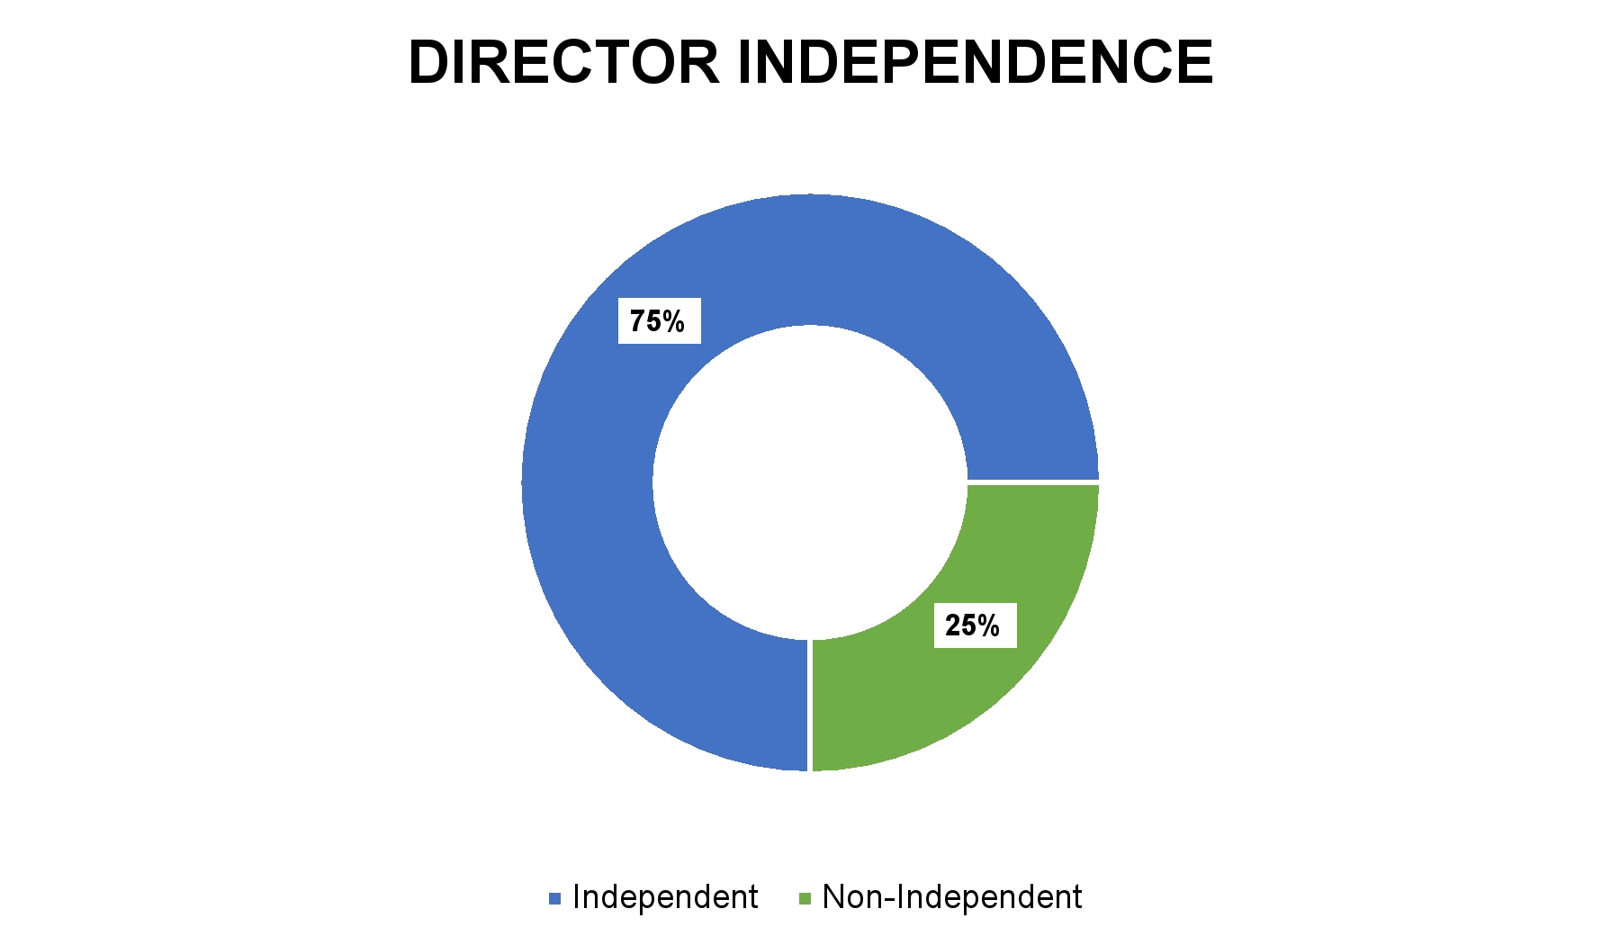

8

Governance of the Company

Board Oversight of Risk
The Board has overall responsibility for oversight of the risks facing the Company. The Board implements its risk oversight function both directly and indirectly through delegation to committees that report back to the Board. For example, the Board retains direct responsibility for overseeing cyber security risk while the oversight of other risks, such as risks related to accounting and compensation, is delegated to committees. The below chart describes the Board’s oversight of risk management:

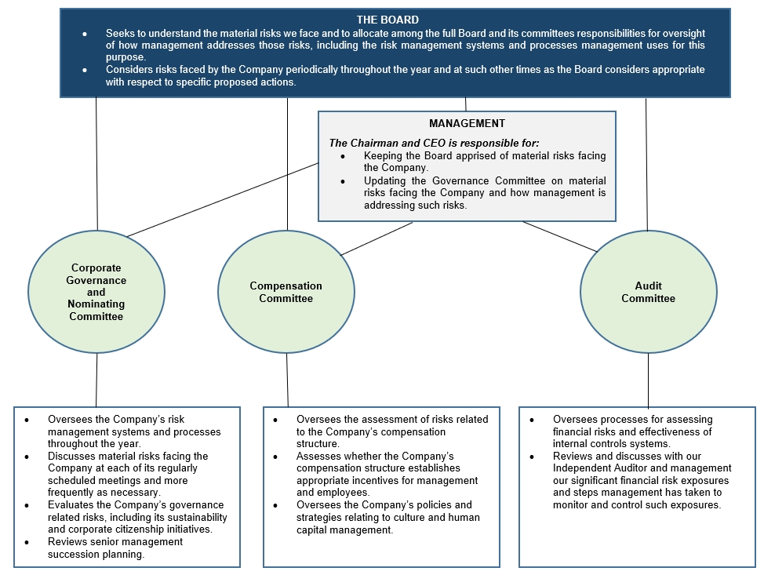

Continuous Oversight; Identification and Management of New Risks. Oversight of risk is a continuous process. Management regularly reviews and analyzes the risk profile of the Company and the effectiveness of the Company’s risk mitigation measures. During fiscal 2025, the Company enhanced its existing enterprise risk management process. Management continues to present to the Governance Committee on material risks facing the Company on a quarterly basis, but the enhanced process permits more of a detailed focus on a different aspect of the process at each quarterly meeting and aligns the discussion topics with the annual public company cycle. The members of the Governance Committee continue to receive ample time to review and discuss the risks and the related mitigation measures with management. Information on risks and mitigation measures is also periodically presented to the full Board to allow all of the directors the information needed to ensure they can adequately oversee the Company’s risk profile.
9

Governance of the Company

Risk Considerations in Our Compensation Program. The Company regularly assesses its risk exposure, including exposures that may be associated with our compensation programs. In fiscal 2025, our compensation risk assessment considered a variety of factors. Through this assessment, we determined that our compensation programs do not pose excessive risk because:
•
Our compensation programs appropriately balance fixed compensation with short-term and long-term variable compensation and cash-based compensation with equity-based compensation, so no single pay element would motivate employees to engage in excessive risk taking.
•
The design of annual incentive compensation does not lend itself to excessive risk taking because we:
•
fund annual incentive awards based on a variety of pre-established performance conditions, thus diversifying the risk associated with any single indicator of performance;
•
establish performance targets objectively determined with verifiable results;
•
incorporate pre-established caps for all awards; and
•
retain discretion to decrease bonus payouts.
•
The Company’s long-term incentive program encourages employees to focus on the long-term success of the Company by providing stock options, stock appreciation rights, restricted stock awards and restricted stock units (“RSUs”), which reward employees if the Company’s stock price increases, decline in value if our stock price declines, and incentivize appropriate, but not excessive, risk-taking.
Board and Committee Membership
Our bylaws provide that our Board shall consist of at least three members and the exact number of directors will be determined from time to time by resolution of our Board. Our Board currently comprises eight directors, divided into three classes: Class I, Class II and Class III. The term for each class of directors expires at successive annual meetings. The Class I directors are William P. Angrick, III and Edward J. Kolodzieski, the Class II directors are George H. Ellis, Paul J. Hennessy and Jaime Mateus-Tique, and the Class III directors are Katharin S. Dyer, Amath Fall and Beatriz V. Infante. Mr. Ellis will be retiring from the Board at the end of his current term. Accordingly, he has not been nominated for election at this Annual Meeting and the Board will be reduced from eight to seven directors following Mr. Ellis’ retirement. The Board will remain divided into the three classes described above.
The Board met six times during fiscal 2025. All directors who served in fiscal 2025 (i.e., Mr. Angrick, Ms. Dyer, Mr. Ellis, Mr. Fall, Ms. Infante, Mr. Kolodzieski, and Mr. Mateus-Tique) attended 75% or more of the total number of meetings of the Board, and of each committee on which he, she or they served during fiscal 2025. Mr. Hennessy was appointed to the Board on October 1, 2025, the first day of fiscal 2026, and as such, did not attend Board meetings in fiscal 2025. Our directors are also encouraged to attend each Annual Meeting of Stockholders. All directors (other than Mr. Hennessy who had not yet been appointed) attended the 2025 Annual Meeting.
10

Governance of the Company

The table below provides membership information for the Board and each committee of the Board as of the date of this proxy statement.

Name | Position | Year Current  Term Expires | Director Since | Independent | Audit Committee | Compensation Committee | Governance Committee
Mr. Angrick | Class I director | 2025 | 2000 | NO
Mr. Kolodzieski | Class I director | 2025 | 2015 | YES |  | ● | ●
Mr. Ellis | Class II director | 2026 | 2010 | YES | ● |  | ●
Mr. Hennessy | Class II director | 2026 | 2025 | YES | ● |  | ●
Mr. Mateus-Tique | Class II director | 2026 | 2000 | NO
Ms. Dyer | Class III director | 2027 | 2020 | YES |  | ● | Chair
Mr. Fall | Class III director | 2027 | 2023 | YES | Chair
Ms. Infante* | Class III director | 2027 | 2014 | YES | ● | Chair

* Lead independent director

Board Committees and Composition
The Board’s current standing committees are the Audit Committee, the Compensation Committee and the Governance Committee. The Board reviews committee membership, charters and responsibilities every year. Each committee’s charter is available on the Investors section of our website at https://investors.liquidityservices.com/corporate-governance.

Additional information on each committee, including the members as of the date of this proxy statement, the number of meetings held in fiscal 2025 and the duties and responsibilities of such committee, are available on the following pages.

The Board anticipates reducing the size of the Governance and Audit Committees from four to three independent directors following Mr. Ellis’ retirement from the Board at the Annual Meeting.
11

Governance of the Company

Audit Committee

Members
Mr. Ellis (until his retirement at the Annual Meeting), Mr. Fall (Chair), Mr. Hennessy (effective his date of appointment on October 1, 2025), and Ms. Infante

Meetings
The Audit Committee met 5 times in fiscal 2025.

Director Independence
The Board has determined that every member of the Audit Committee is independent, as defined by the Company’s director independence standards, the Nasdaq Standards and SEC rules.

Financial Expert
The Board has determined that each of Mr. Ellis and Mr. Fall is an “audit committee financial expert” within the meaning of such term under Item 407 of the Sarbanes-Oxley Act of 2002.

Committee Report
See page 40.

Primary Duties and Responsibilities*
•
Be directly responsible for the appointment, compensation, retention, termination and oversight of the work of the Independent Auditor.
•
Evaluate the Independent Auditor’s qualifications, performance and independence.
•
Pre-approve all audit and permissible non-audit services provided by the Independent Auditor.
•
Discuss with the internal auditors and the Independent Auditor the overall scope and plans for their respective audits, including the adequacy of staffing and budget or compensation.
•
Review and discuss with the Independent Auditor the matters required to be discussed by the Independent Auditor under applicable standards.
•
Review and discuss: (i) the Company’s quarterly financial statements and annual audited financial statements with management and the Independent Auditor prior to including the financial statements in any filing made with the SEC; and (ii) the results of quarterly reviews and annual audits.
•
Review and approve related person transactions.
•
Review and discuss earnings press releases, as well as corporate practices with respect to earnings press releases, financial information, and earnings guidance provided to analysts and rating agencies.
•
Review and discuss management’s assessment of the effectiveness of internal control over financial reporting and the Independent Auditor’s report on the Company’s internal control over financial reporting.
•
Discuss with management, the internal auditors, and the Independent Auditor any significant changes in internal control over financial reporting that are disclosed, or considered for disclosure, in the Company’s periodic filings with the SEC.
•
Review and discuss the adequacy and effectiveness of the Company’s disclosure controls and procedures.
•
Review the policies and procedures with respect to officers’ expense accounts and perquisites, including use of corporate assets, and consider the results of any review of these areas by the internal auditor or the Independent Auditor.
•
Oversee the Company’s compliance programs with respect to legal and regulatory requirements and the Company’s code of conduct and procedures to monitor compliance.
•
At least annually, meet to review the implementation and effectiveness of the Company’s compliance programs with the Company’s Chief Legal Officer.
•
Oversee the Company’s processes for assessing financial-related risks and review and discuss the Company’s major financial risk exposures and the steps management has taken to monitor and control such exposures.
•
Periodically review and discuss with management the Company’s overall hedging strategy and the use of swaps and other derivative instruments by the Company or any of its subsidiaries for hedging risks pursuant to the Company’s Financial Risk Management and Hedging Policy, or otherwise.
•
Consult with the Company’s management to review and discuss the Company’s financial reporting of cyber security risks and incidents in accordance with SEC rules.
12

Governance of the Company

•
Establish and oversee procedures for the receipt, retention, and treatment of complaints received by the Company regarding accounting, internal accounting controls, auditing and federal securities law matters, and the confidential, anonymous submission by employees of the Company of concerns regarding questionable accounting or auditing matters, and federal securities law matters.
•
Set hiring policies for employees or former employees of the Independent Auditor that meet applicable SEC regulations.
•
Review and discuss with management its governance-related risks, including its sustainability and corporate citizenship initiatives, and its governance disclosures included in the Company’s Annual Report on Form 10-K.
•
Perform an evaluation of its performance at least annually.
•
Review and reassess the adequacy of its charter at least annually and submit proposed revisions, if any, for the approval of the Board.
•
Review the Company’s financial reporting of cybersecurity risks and incidents in accordance with SEC rules; provided, however, the Board retains primary responsibility for oversight of the Company's cyber risk management program, including risk identification, mitigation strategy and efforts, and resources.

* For a full description of the duties and responsibilities of the Audit Committee, see the Audit Committee Charter, available on our website at https://investors.liquidityservices.com/corporate-governance.

13

Governance of the Company

Governance Committee

Members
Ms. Dyer (Chair), Mr. Ellis (until his retirement at the Annual Meeting), Mr. Hennessy (effective his date of appointment on October 1, 2025), and Mr. Kolodzieski

Meetings
The Governance Committee met 5 times during fiscal 2025.

Director Independence
The Board has determined that every member of the Governance Committee is independent, as defined by the Company’s director independence standards and the Nasdaq Standards.

Primary Duties and Responsibilities*
•
Recommend director candidates.
•
Develop and recommend to the Board criteria for identifying and evaluating director candidates.
•
Review director candidates’ qualifications (including independence) and any potential conflicts with the Company’s interests.
•
Assess the contributions of current directors in connection with their re-nomination.
•
Periodically review and recommend to the Board updates to the Company’s procedures for the consideration of director candidates recommended by stockholders.
•
Consider any director candidates recommended by the Company’s stockholders.
•
Oversee the Company’s corporate governance practices and procedures.
•
Review the Board’s committee structure, composition and responsibilities and recommend to the Board for its approval directors to serve as members of each committee and the chairperson of each committee.
•
Monitor the functioning of the Board’s committees and make recommendations to the Board regarding changes.
•
Review the Company’s corporate governance guidelines on a periodic basis and recommend changes as appropriate to the Board.
•
Oversee the Company’s succession planning related to senior management and make recommendations to the CEO regarding management succession planning.
•
Oversee the Company’s risk management systems and processes and review and discuss the material risks facing the Company and how management is addressing such risks.
•
Review and assess the channels through which the Board receives information, and the quality and timeliness of information received.
•
Oversee the annual evaluation process for the Board, its committees, and individual directors.
•
Report regularly to the Board with respect to its activities, periodically update the Board on material developments in the area of corporate governance, and annually review governance disclosures to be included in the Company’s proxy statement.
•
Perform an evaluation of its performance at least annually.
•
Review and reassess the adequacy of its charter at least annually and submit proposed revisions, if any, for the approval of the Board.
•
Evaluate the Company’s governance-related risks, including its sustainability and corporate citizenship initiatives.
•
Oversee and review the governance disclosures in the Company’s proxy statement.

* For a full description of the duties and responsibilities of the Governance Committee, see the Governance Committee Charter, available on our website at https://investors.liquidityservices.com/corporate-governance.
14

Governance of the Company

Compensation Committee
Members
Ms. Infante (Chair), Ms. Dyer and Mr. Kolodzieski
Meetings
The Compensation Committee met 4 times during fiscal 2025.
Director Independence
The Board has determined that each member of the Compensation Committee is independent, as defined by the Company’s director independence standards and the Nasdaq Standards.
Committee Report
See page 94.

Primary Duties and Responsibilities*
•
Oversee the Company’s overall compensation structure, policies and programs, and assess whether the Company’s compensation structure establishes appropriate incentives.
•
Oversee the assessment of risks associated with the Company’s compensation programs.
•
Conduct an annual performance assessment of the CEO and review and approve annually corporate goals and objectives relevant to compensation of the CEO and other executive officers.
•
Review and approve annually the compensation of the CEO and other executive officers.
•
Review and approve any employment-related agreements, any proposed severance arrangements or change in control and similar agreements/provisions, and any amendments, supplements or waivers to the foregoing agreements, with the CEO and other executive officers.
•
Biennially review and make recommendations to the Board with respect to the compensation of members of the Board who are not executive officers.
•
Administer and implement the Company’s incentive compensation plans and equity-based plans.
•
Assess annually the desirability of proposing and make recommendations to the Board with respect to (a) any new incentive compensation plans and equity-based plans and (b) any amendments to, including increases in shares reserved for issuance under, existing plans.
•
Administer and make recommendations to the Board regarding the adoption, amendment or rescission of the Company’s retirement, excess benefit and deferred compensation plans, if any.
•
Assess the results of the Company’s most recent advisory vote on executive compensation.
•
Review and approve the inclusion of the advisory vote on executive compensation proposal, and the frequency of such proposal, in the Company’s proxy statement when and as applicable.
•
Retain and terminate compensation consultants, legal counsel or other advisors, be directly responsible for the appointment, compensation and oversight of the work of such consultants, legal counsel or advisors, and receive appropriate funding from the Company for payment of compensation of such consultants, legal counsel or advisors.
•
Assess the independence of any compensation consultants, legal counsel and other advisors who provide advice to the Compensation Committee in accordance with the Nasdaq Standards.
•
Review and discuss with management the Company’s Compensation Discussion and Analysis and related disclosures and recommend to the Board based on such review and discussions whether the Company’s Compensation Discussion and Analysis should be included in the Company’s annual report and proxy statement.
•
Oversee preparation of the Compensation Committee report.
•
Annually review the performance of the investment funds offered through the Liquidity Services, Inc. 401(k) Profit Sharing and Trust Plan (the “401(k) Plan”), the performance of trustees and investment advisors, and the performance of the plan committees in the discharge of their duties.
•
Periodically review the Company’s Director Stock Ownership Policy and Executive Stock Ownership Policy.
•
Assist the Board in its oversight of the Company’s policies and strategies relating to culture and human capital management.
•
Review and discuss with management the human capital management disclosures included in the Company’s proxy statement and its periodic filings with the SEC.
15

Governance of the Company

•
Perform an evaluation of its performance at least annually.
•
Review and reassess the adequacy of its charter at least annually and recommend any proposed revisions, if any, for approval by the Board.
* For a full description of the duties and responsibilities of the Compensation Committee, see the Compensation Committee Charter, available on our website at https://investors.liquidityservices.com/corporate-governance.
16

Governance of the Company

Recommendation of Director Candidates
As indicated above, one of the primary duties and responsibilities of the Governance Committee is to develop and recommend to the Board criteria for identifying and evaluating director candidates. The Governance Committee has developed, and the Board has approved the use of, the following criteria for identifying and evaluating director candidates.
Identification. Candidates may come to the attention of the Governance Committee through the directors, the CEO, professional search firms (to whom we pay a fee), stockholders or other persons. The Company has also sought to identify potential candidates through professional associations and initiatives, such as the National Association of Corporate Directors (“NACD”), The Boston Club, The Athena Alliance and Stanford Women on Boards.
The Governance Committee will consider candidates for director suggested by our stockholders, provided that the recommendations are made in accordance with the procedures required under our bylaws and described in this proxy statement under the heading “Requirements, Including Deadlines, for Submission of Proxy Proposals, Nomination of Directors and Other Business of Stockholders”. Director candidates recommended by stockholders under these procedures will be evaluated by the Governance Committee like other director candidates using the process set forth below.
Evaluation. Initially, the Governance Committee looks for individuals who meet certain minimum qualifications approved by the Board, including the highest level of personal and professional ethics and integrity, sound judgment, the ability to make independent analytical inquiries, the willingness to devote adequate time and resources to diligently perform Board duties and appropriate and relevant business experience and acumen. For additional information on the types of business experience considered by the Governance Committee, see “Proposal 1—Election of Directors” below. The Governance Committee also considers the number of other boards of public companies on which the candidate currently serves.
Next, the Governance Committee considers whether the candidate would be a good fit for the Board overall. The goal is to find candidates with experiences and skill sets that complement those of current directors to create a balanced Board with varied viewpoints and deep expertise. The Governance Committee considers the various characteristics of each candidate, such as professional experience, race, ethnicity, gender, age, thought, skills and background, to determine if such candidate would provide a unique perspective that may help the Board address the complex issues it faces.
Code of Conduct
Our Board has adopted a code of conduct (the “Code of Conduct”) applicable to all of our directors, officers and employees to protect and promote organization-wide integrity and to enhance the Company’s ability to achieve its mission.
The Code of Conduct embodies general principles such as compliance with laws, acting with honesty and integrity, avoidance of conflicts of interest, maintenance of accurate and timely financial and business records, use of the Company’s assets for legitimate business purposes only, provision and acceptance of gifts to or from customers, suppliers and governments in compliance with law, protecting the Company’s information and dealing fairly with other companies.
All directors, officers, and employees must report violations and suspected violations of the Code of Conduct and any concerns they may have pertaining to non-compliance with the Code of Conduct by following certain procedures described in the Code of Conduct. The Code of Conduct includes instructions on how to anonymously submit concerns through a hotline that is available 24 hours a day / 365 days a year. All reports of suspected Code of Conduct violations will be forwarded to the Company’s Legal Department and Human Resources Department, except for complaints and concerns involving accounting or auditing matters, which will be handled in accordance with procedures established by the Audit Committee.
The Code of Conduct is available on our website, www.liquidityservices.com, at “Investors—Corporate Governance—Governance Documents”. A free printed copy is available to any stockholder who requests it by
17

Governance of the Company

writing to us at Liquidity Services, Inc., 6931 Arlington Road, Suite 460, Bethesda, MD 20814, Attention: Legal Department. We intend to disclose future amendments to certain provisions of the Code of Conduct, or waivers of such provisions if granted to executive officers and directors, on our website within four business days following the date of such amendment or waiver.
Human Capital Management
To achieve our goal to build the world’s leading marketplace for surplus assets to benefit buyers, sellers, and the planet, it is crucial that we attract, nurture, and retain employees who deliver outstanding performance. We strive to make the Company a rewarding place to work by promoting diversity based on experiences, perspectives and skills. As of September 30, 2025, our number of employees by region was as follows:
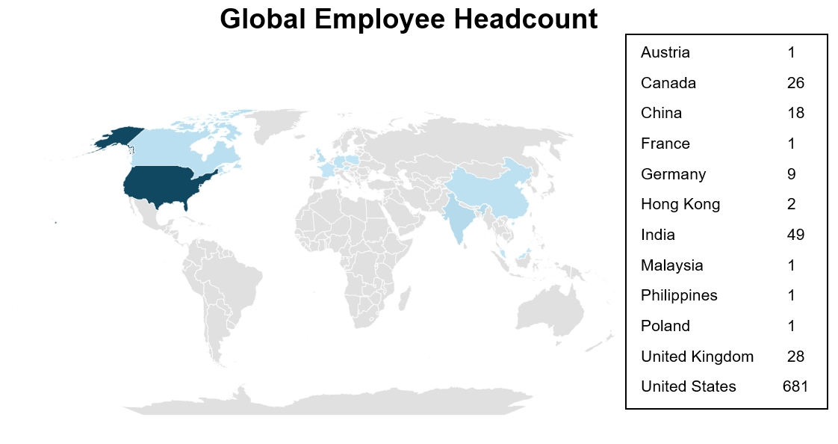
We also utilize temporary workers to augment staffing during peak business cycles and to fill certain open positions on a temporary basis.
Importance of our Employees. We believe our employees are key to achieving our business goals and growth strategy. Our human capital objective is to attract, retain, develop, and motivate talented employees. We use online search tools, specialized recruiting firms, employee referral programs, job postings on various media platforms, and university recruiting to identify and attract talented candidates. By leveraging the variety of experiences, skills and perspectives inherent in a diverse workforce, we aim to improve our problem-solving abilities and bring innovative solutions to a wider range of clients and customers.
Health and Well-Being. We value the health and well-being of our employees and provide generous benefit options for our employees and their families. Our plans are designed to enhance employee wellness by focusing on health, financial security, life, and learning. Our health benefits include multiple medical plans, dental and vision coverage, mental health support and paid parental leave. In the U.S., we pay a significant portion of the benefit premiums related to our health benefits. Employees are offered certain benefits at no charge to them or their families (e.g., Life and AD&D insurance, short-term and long-term disability insurance, and Health Savings Account contributions). The financial security benefits program includes a 401(k) plan with discretionary employer match and access to health savings accounts and health and dependent care flexible spending accounts. We provide a range of insurance products and employee assistance programs. Internationally, we also offer a variety of benefit plans customized to reflect local conditions. Our learning and development programs include tuition support for employees and a global training and development program that focuses on building technical skills and leadership
18

Governance of the Company

development, as well as training in various topics including cybersecurity, anti-harassment, ethics, and regulatory compliance.
Culture and Community. The Company's culture is rooted in our core values and aligned to the Company’s strategic framework. Our culture expresses our expansive vision and fervor for community and collaboration and is honed by the following core values:
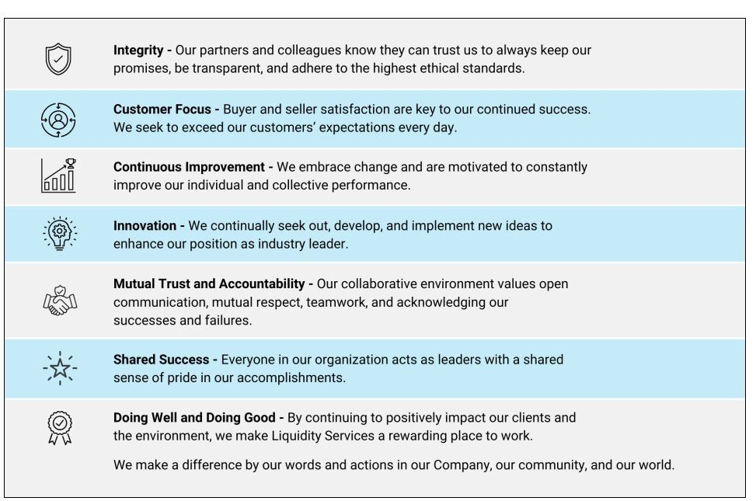
We reinforce, monitor, and assess our culture through a variety of programs which include performance management, succession planning, and employee engagement surveys, all of which serve to further our human capital objectives. Each of our team members is part of our global initiative to make a difference in the communities where we live and work. We actively support our global communities through outreach programs, relief efforts, sustainability initiatives, education and mentorship programs.
Flexible Workspace. We are a remote-first work environment. We are committed to allowing flexibility in our workplace to promote high performance and retention while also continuing to meet customer and business needs.
Sustainability Efforts. At our core, the Company strives to benefit businesses, communities, and the environment through our marketplaces which enable the continued use of surplus assets that may otherwise end up in landfills. These efforts extend to our employees as well, where our remote work structure for applicable employees has enabled lower expended energy and emissions from both transportation-related activities and operations across our real estate portfolio.
Communication with Directors
Stockholders and other interested parties may communicate with the Board by writing to us c/o the Corporate Secretary, Liquidity Services, Inc., 6931 Arlington Road, Suite 460, Bethesda, MD 20814. Communications intended for a specific director or directors should be addressed to the attention of the relevant individual(s) c/o the Corporate Secretary at the same address.
Our Corporate Secretary will review all correspondence intended for the Board and forward to the Board a summary of such correspondence and a copy of the correspondence that, in the opinion of the Corporate Secretary,
19

Governance of the Company

requires the Board’s attention. Directors may at any time review a log, and receive copies, of all correspondence received by the Corporate Secretary that is intended for the Board.
In addition, the Audit Committee has established a procedure for parties to submit concerns regarding what they believe to be questionable accounting, internal controls and auditing matters. Concerns may be reported through our Compliance Helpline at 888-475-8376. Concerns may be submitted anonymously and confidentially.
Our Executive Officers

Our team of experienced executive officers also support the governance of the Company. Biographical information on our executive officers (other than Mr. Angrick, whose biographical information appears in this proxy statement under “Proposal 1 - Our Board of Directors”) is below:

Name | Age |  | Position
Jorge A. Celaya | 59 |  | Chief Financial Officer
John P. Daunt | 60 |  | Chief Commercial Officer
Steven J. Weiskircher | 52 |  | Chief Technology Officer
Mark A. Shaffer | 52 |  | Chief Legal Officer and Corporate Secretary
Novelette Murray | 60 |  | Chief Human Resources Officer
Jorge A. Celaya has served as our Chief Financial Officer since joining the Company in 2015. Mr. Celaya has more than 35 years of executive experience and financial leadership in capital markets, financial accounting, operations, and strategic transformation with global and publicly held companies in diverse industries. Before joining the Company, he co-founded Avanz Capital, an independent investment firm focused on private equity investing across emerging markets. Before that, Mr. Celaya was Executive Vice President and Chief Financial Officer for both FTI Consulting, a global provider of business restructuring, financial consulting, and e-discovery software and services, and Sitel Corporation, a global provider of business process outsourcing services. From 1990 to October 2003, Mr. Celaya also held various corporate and operating group positions with Schlumberger Ltd. where he worked across multiple industries and sectors both domestically and internationally. Mr. Celaya holds a Bachelor of Arts degree and a Master’s in Business degree from the University of Texas at Austin.
John P. Daunt has served as our Chief Commercial Officer since April 2019. Previously, Mr. Daunt was our Senior Vice President, CAG North America, from June 2018 to April 2019, Senior Vice President, Global Operations and DoD from August 2015 to May 2018 and Senior Vice President, Account Management from November 2014 to July 2015. Before joining the Company, Mr. Daunt served as Senior Vice President of FedBid, Inc., a company that allows federal, state and local governments, and educational institutions to purchase goods and services through a reverse auction-based platform, from March 2013 to November 2014. Prior to that, Mr. Daunt was Vice President and General Manager of AssetNation and an Account Executive at Ariba, Inc. Mr. Daunt also served as a Naval Flight Officer in the US Navy. Mr. Daunt holds a B.S. in Entrepreneurial Studies from Babson College.
Steven J. Weiskircher has served as our Chief Technology Officer since August 2019. Prior to joining the Company, Mr. Weiskircher was Vice President, Omnichannel, Marketing, and Digital Delivery Technology at GameStop, a video game, consumer electronics, and wireless services retailer, from July 2018 through July 2019. Prior to that, Mr. Weiskircher worked for ThinkGeek, a retailer, as Chief Information Officer from February 2013 through July 2018. Mr. Weiskircher has also been employed as Chief Information Officer at Fanatics, Inc. and as Vice President, Information Technology at Crutchfield Corporation. Mr. Weiskircher served as a Captain in the U.S. Army Signal Corps. Mr. Weiskircher holds a B.S. in Mechanical Engineering from Virginia Tech and a M.S. in Management Information Systems from the University of Virginia.
Mark A. Shaffer has served as our Chief Legal Officer and Corporate Secretary since July 2016. Before this role, Mr. Shaffer was our Senior Associate General Counsel and Assistant General Counsel from September 2012 to July 2016. Before joining the Company, Mr. Shaffer served as Senior Counsel and Global Compliance Officer for Barnes Group, Inc., an international industrial and aerospace manufacturer and service provider, from
20

Governance of the Company

June 2010 to August 2012. Before that, he served in other roles at Barnes Group and as Senior Counsel at the law firm of Miller Canfield, where he focused on industrial and automotive mergers and acquisitions and commercial negotiations. Mr. Shaffer also served as Senior Counsel for Kmart Corporation and as an associate at the law firms of LeBoeuf, Lamb, Greene & MacRae LLP and Latham & Watkins LLP. Mr. Shaffer holds a B.S. in Foreign Service and a J.D. from Georgetown University. Mr. Shaffer became a NACD Board Leadership Fellow in 2020.
Novelette Murray has served as our Chief Human Resources Officer since October 2020. In this role, Ms. Murray leads all aspects of human resources and is responsible for aligning talent with the Company’s business strategy, including hiring, training, development, performance management, diversity and inclusion, and succession planning. Ms. Murray originally joined the Company in 2010 as the Director of Human Resources. She was promoted multiple times during her tenure with the Company, serving as both Sr. Director of Human Resources and Vice President, HR Operations before becoming Chief Human Resources Officer. Prior to her employment with the Company, Ms. Murray served as Senior Human Resources Manager for the U.S. Concrete Pipe Division of Cemex, a global building materials company, from 2006 to 2010. Prior to that, Ms. Murray was the Director of Human Resources for Houston ENT, an otolaryngology physician group, from 2000 to 2006, and a Human Resources Associate at GE Healthcare, a manufacturer of medical imaging equipment, from 1995 to 2000. Ms. Murray received a B.A. in Organizational Communication with honors from Rollins College and an M.B.A. from University of Maryland University College.
21

Compensation of Non-Employee Directors

Director Compensation
Our non-employee directors receive a combination of cash and equity compensation for service as directors. Directors employed by the Company (such as Mr. Angrick) receive no compensation for their service as directors. The Compensation Committee, in consultation with its independent compensation consultant, periodically reviews non-employee director compensation and recommends changes based on competitive market data. Based on such review and recommendations, the Board approved the following compensation for non-employee directors for 2025 which was unchanged from 2024:
•
Total annual target compensation for 2025 (excluding the additional retainers set forth below) was set at $210,000.
•
The total annual target compensation was partially payable in cash and partially payable in equity. The portion payable in cash was $45,000 and the portion payable in equity was $165,000.
•
All equity is granted in the form of restricted stock units (“RSUs”) which vest on the first anniversary of the grant date.
•
Directors are entitled to additional cash retainers for committee service and leadership:
Cash Compensation Element: | 2025 Amount:
Lead Director Service | $20,000
Audit Committee Chair Service | $20,000
Compensation Committee Chair Service | $15,000
Governance Committee Chair Service | $10,000
Non-Chair Audit Committee Service | $10,000
Non-Chair Compensation Committee Service | $7,500
Non-Chair Governance Committee Service | $4,000
Cash retainers to our non-employee directors are paid quarterly in advance. Non-employee directors are also reimbursed for expenses they incur in attending Board and committee meetings.
Director Stock Ownership and Anti-Hedging Requirements
We require our non-employee directors to hold shares of our common stock having a value equal to five times the value of his, her or their annual cash retainer. New non-employee directors have five years after his, her or their appointment to the Board to satisfy this requirement. Each non-employee director has satisfied or is on track to satisfying the stock ownership requirement within the applicable timeframe. Non-employee directors may not purchase any financial instrument or enter any transaction that hedges or offsets any decrease in the market value of our common stock (including, but not limited to, prepaid variable forward contracts, equity swaps, collars, or exchange funds). A copy of the Director Stock Ownership Policy is available under the Investors section of our website at www.liquidityservices.com.
22

COMPENSATION OF NON-EMPLOYEE DIRECTORS

Director Compensation for Calendar Year 2025
The following table sets forth the total cash and equity compensation paid to each of our non-employee directors for service on the Board and its committees during 2025:
Name | Retainer Fees (Paid in Cash) | Stock  Awards(1)(2)(3) | Total ($)
Katharin S. Dyer | $62,500 | $165,000 | $277,500
George H. Ellis | $59,000 | $165,000 | $224,000
Amath Fall | $65,000 | $165,000 | $230,000
Beatriz V. Infante | $90,000 | $165,000 | $255,000
Paul J. Hennessy(4) | $26,938 | $165,000 | $191,938
Edward Kolodzieski | $56,500 | $165,000 | $221,500
Jaime Mateus-Tique | $45,000 | $165,000 | $210,000

(1)
The amounts reported in these columns reflect the aggregate grant date fair value of grants of options and RSUs to each of the non-employee directors, computed under U.S. generally accepted accounting principles (“GAAP”), disregarding estimates of forfeitures related to service-based vesting conditions. For additional information about the assumptions used in these calculations, see Note 2 and Note 13 to our audited consolidated financial statements in our Annual Report on Form 10-K for the fiscal year ended September 30, 2025 (the “2025 Form 10-K”).
(2)
On March 1, 2025, we granted 4,928 RSUs to each of Ms. Dyer, Mr. Ellis, Mr. Fall, Ms. Infante, Mr. Kolodzieski and Mr. Mateus-Tique. The number of RSUs granted was determined by dividing the value of the award ($165,000) by the closing price of our common stock on the Nasdaq Stock Market on the business day prior to the grant date ($33.48). Mr. Hennessy was granted 7,186 RSUs on October 1, 2025, the effective date of his appointment. The number of RSUs granted to Mr. Hennessy was calculated in the same manner described above using the closing price of our common stock on June 23, 2025, the date the Board approved the grant ($22.96).
(3)
On September 30, 2025, each of Ms. Dyer, Mr. Ellis, Mr. Fall, Ms. Infante, Mr. Kolodzieski and Mr. Mateus-Tique held 4,928 unvested RSUs. Mr. Hennessy did not hold any unvested RSUs as of September 30, 2025.
(4)
Mr. Hennessy’s appointment to the Board was effective October 1, 2025. He received a pro rata portion of the calendar year 2025 cash retainer.
23

Beneficial Ownership of Shares of Common Stock

The following table sets forth information regarding ownership of our common stock as of the Record Date, other than as set forth below, by each of our directors and executive officers, all our directors and executive officers as a group and the holders of 5% or more of our common stock known to us. The information in this table is based on our records, information filed with the SEC and information provided to us. To our knowledge, except as disclosed in the table below, none of our stockholders hold 5% or more of our common stock. Except as otherwise indicated, (1) each person has sole voting and investment power (or shares such powers with her, his or their spouse) with respect to the shares set forth in the following table and (2) the business address of each of our officers and directors is 6931 Arlington Road, Suite 460, Bethesda, MD 20814.
 | Number of Shares  Beneficially Owned | Percentage of Shares Outstanding(1)
5% or Greater Stockholders
BlackRock, Inc.(2)  55 East 52nd Street  New York, NY 10055 | 3,351,684 | 10.37%
The Vanguard Group(3)  100 Vanguard Blvd.  Malvern, PA 19355 | 1,759,689 | 5.44%
Renaissance Technologies LLC(4)  800 Third Avenue  New York, NY 10022 | 1,649,189 | 5.10%
Officers and Directors
William P. Angrick, III(5) | 7,925,056 | 24.52%
Jorge A. Celaya(6) | 210,653 | *
John P. Daunt(7) | 102,860 | *
Katharin S. Dyer(8) | 36,395 | *
George H. Ellis(9) | 11,208 | *
Amath Fall(10) | 18,252 | *
Paul J. Hennessy(11) | 0 | *
Beatriz V. Infante(12) | 92,296 | *
Edward J. Kolodzieski(13) | 24,535 | *
Jaime Mateus-Tique(14), | 440,736 | 1.36%
Novelette Murray(15) | 69,472 | *
Mark A. Shaffer(16) | 74,067 | *
Steven J. Weiskircher(17) | 63,744 | *
All directors and executive officers as a group  (13 individuals) | 9,069,274 | 28.06%
* Less than 1% of the outstanding shares of our common stock.

(1)
The percentages of shares outstanding for our 5% or greater stockholders and for our directors and executive officers were calculated based on 32,323,599 shares of common stock, which is equal to the 30,805,564 shares of common stock outstanding as of the Record Date plus 1,410,179 shares of common stock issuable pursuant to options held by our directors and executive officers that are exercisable as of the Record Date or within 60 days of such date and 107,856 RSUs scheduled to vest within 60 days of such date.
24

(2)
Based on a review of a Form 13F-HR filed on November 12, 2025, BlackRock, Inc. beneficially owned 3,351,684 shares of common stock, had sole voting authority with respect to 3,351,684 shares of common stock and had sole investment discretion with respect to 3,309,441 shares of common stock.
(3)
Based on a review of a Form 13F-HR filed on November 7, 2025, The Vanguard Group beneficially owned 1,759,689 shares of common stock, had sole voting authority with respect to 0 shares of common stock and had sole investment discretion with respect to 1,572,673 shares of common stock.
(4)
Based on a review of a Form 13F-HR filed on November 13, 2025, Renaissance Technologies LLC beneficially owned 1,649,189 shares of common stock, had sole voting power with respect to 1,649,189 shares of common stock and had sole dispositive power with respect to 1,649,189 shares of common stock.
(5)
Includes 5,151,001 shares of common stock held by the William P. Angrick, III Revocable Trust, 873,379 shares of common stock held by the William P. Angrick III 2005 Irrevocable Trust, 114,699 shares of common stock held by the Stephanie S. Angrick Revocable Trust and 575,513 shares of common stock held by the Stephanie S. Angrick 2005 Irrevocable Trust. Mr. Angrick disclaims beneficial ownership of these securities. The amount in the table above also includes 1,146,512 shares of common stock issuable pursuant to options held by Mr. Angrick that are exercisable as of the Record Date or within 60 days of such date and 63,952 RSUs that are scheduled to vest within 60 days of the Record Date. 1,400,000 shares of common stock are pledged as collateral to secure certain personal indebtedness.
(6)
Includes 38,102 shares of common stock held by the Jorge Celaya Revocable Trust, 163,047 shares of common stock issuable pursuant to options held by Mr. Celaya that are exercisable as of the Record Date or within 60 days of such date, and 9,504 RSUs that are scheduled to vest within 60 days of the Record Date.
(7)
Includes 48,052 shares of common stock held by the Daunt Family Trust, 43,391 shares of common stock issuable pursuant to options held by Mr. Daunt that are exercisable as of the Record Date or within 60 days of such date, and 11,417 RSUs that are scheduled to vest within 60 days of the Record Date.
(8)
Ms. Dyer does not hold any RSUs that are scheduled to vest within 60 days of the Record Date or any options that are exercisable as of the Record Date or within 60 days of such date.
(9)
Mr. Ellis does not hold any RSUs that are scheduled to vest within 60 days of the Record Date or any options that are exercisable as of the Record Date or within 60 days of such date.
(10)
Mr. Fall does not hold any RSUs that are scheduled to vest within 60 days of the Record Date or any options that are exercisable as of the Record Date or within 60 days of such date.
(11)
Mr. Hennessy does not hold any RSUs that are scheduled to vest within 60 days of the Record Date or any options that are exercisable as of the Record Date or within 60 days of such date.
(12)
Ms. Infante does not hold any RSUs that are scheduled to vest within 60 days of the Record Date or any options that are exercisable as of the Record Date or within 60 days of such date.
(13)
Mr. Kolodzieski does not hold any RSUs that are scheduled to vest within 60 days of the Record Date or any options that are exercisable as of the Record Date or within 60 days of such date.
(14)
Includes 12,966 shares held directly by Mr. Mateus-Tique, 163,208 shares of common stock held by the Jaime Mateus-Tique 2005 Irrevocable Trust, 164,562 shares of common stock held by the Em El 2007 Irrevocable Trust and 100,000 shares of common stock held by Mr. Mateus Tique’s spouse. Mr. Mateus Tique does not hold any RSUs that are scheduled to vest within 60 days of the Record Date or any options that are exercisable as of the Record Date or within 60 days of such date.
(15)
Includes 25,172 shares held directly by Ms. Murray, 38,382 shares of common stock issuable pursuant to options held by Ms. Murray that are exercisable as of the Record Date or within 60 days of such date, and 5,918 RSUs that are scheduled to vest within 60 days of the Record Date.
(16)
Includes 53,304 shares of common stock held by The Mark A. Shaffer Revocable Trust, 12,739 shares of common stock issuable pursuant to options held by Mr. Shaffer that are exercisable as of the Record Date or within 60 days of such date, and 8,024 RSUs that are scheduled to vest within 60 days of the Record Date.
(17)
Includes 48,595 shares held directly by Mr. Weiskircher, 6,108 shares of common stock issuable pursuant to options held by Mr. Weiskircher that are exercisable as of the Record Date or within 60 days of such date, and 9,041 RSUs that are scheduled to vest within 60 days of the Record Date.
25

Stock Ownership and Anti-Hedging Requirements
A NEO must hold common stock with a value equal to 150% of the NEO’s annual base salary except the Chairman and CEO, who must hold common stock with a value equal to 600% of his, her or their annual base salary. Each NEO has five years after her, his or their date of hire or appointment to satisfy this requirement. Each of our NEOs has satisfied, or is on track to satisfy, the stock ownership requirement within the applicable timeframe. Executive officers may not purchase any financial instrument or enter any transaction that hedges, pledges or offsets any decrease in the market value of our common stock (including, but not limited to, prepaid variable forward contracts, equity swaps, collars, or exchange funds) without advance approval from our Board. On September 11, 2020, the Board approved in advance Mr. Angrick’s pledge of 1,400,000 shares of common stock. This approval was reviewed and extended on December 6, 2021 until such date as the Board revokes its approval. In reviewing and extending this approval, the Board took note of certain facts and circumstances that helped moderate risk to the Company from the pledge, including: (i) shares pledged by Mr. Angrick would be derived from shares purchased by Mr. Angrick for investment purposes as compared to shares received by Mr. Angrick as executive compensation; (ii) the pledge having a 50% loan-to-value ratio and only requiring funding for the difference between 50% of the original share value at the time of pledge and the then current price; (iii) the limited size of the pledge in reference to Mr. Angrick’s overall holdings; and (iv) Mr. Angrick’s lack of reliance on the pledged shares for compliance with the Company’s executive stock holding policy.
Additionally, non-executive employees who are deemed to be “insiders” under the Company’s Insider Trading Policy cannot enter into hedging, pledging or similar arrangements with respect to Company securities without advance approval from the Board.

26

Delinquent Section 16(a) Reports

Section 16(a) of the Securities Exchange Act of 1934, as amended (the “Exchange Act”), requires our directors, executive officers and beneficial owners of greater than ten percent of our common stock to file reports of holdings and transactions in our common stock with the SEC. Based solely on a review of these records filed during or with respect to fiscal 2025, we believe that in fiscal 2025 all persons satisfied these filing requirements on a timely basis, except a Form 4 reflecting the vesting of restricted stock units on August 25, 2025 for each of our NEOs and Ms. Murray that were not filed until September 9, 2025, due to an administrative oversight.

27

Certain Relationships and Related Party Transactions

The Company did not participate in or review any potential related party transactions since the beginning of fiscal 2025 and there currently are no proposed related party transactions. To be considered a related party transaction under current SEC rules, a transaction, or a series of similar transactions, (i) must involve an amount in excess of $120,000, (ii) must include the Company as a participant, and (iii) one of our executive officers, directors, director nominees or greater than 5% stockholders, or an immediate family member of any such person, must have a direct or indirect material interest in the transaction. Should we consider participating in a related party transaction in the future, such transaction would be reviewed and be subject to approval by the Audit Committee, in accordance with the Audit Committee’s written charter. We have not adopted specific standards that would govern such review.
As a general matter, our written Code of Conduct prohibits conflicts of interest. We consider a conflict of interest to exist when a person’s private interest interferes in any way with the interests of the Company, including: (i) a conflict that makes it difficult for an employee, officer or director to perform his, her or their work objectively and effectively; (ii) when an employee, officer or director, or any member of his, her or their family, receives improper personal benefits because of his, her or their position in or with our Company; or (iii) when an employee, officer or director is engaged in a business or business activity in competition with or injurious to us. The Code of Conduct requires that the Chief Legal Officer be consulted with questions about conflicts of interest in addition to requiring that our directors and officers consult with the Chief Legal Officer before engaging in any transaction involving a potential conflict of interest.
28

Proposals Requiring your Vote

Overview of Proposal 1

Our Class II directors are George H. Ellis, Paul J. Hennessy and Jaime Mateus-Tique. Their current terms end at this Annual Meeting. Mr. Ellis will retire from the Board and has not been nominated for election at the Annual Meeting. We thank Mr. Ellis for his many years of dedicated service to the Company and its stockholders. Mr. Hennessy and Mr. Mateus-Tique have each consented to be nominated to serve as a director for an additional three-year term. Mr. Mateus-Tique was last elected at the 2023 Annual Meeting of Stockholders. Mr. Hennessy was appointed to the Board effective October 1, 2025. Each nominee will, if elected, continue in office until our 2029 Annual Meeting of Stockholders or until his, her or their successor has been duly elected and qualified, or until the earlier of his, her or their death, resignation or retirement.
2026 Director Nominees
Nominee Name | Director Since | Independent | Committee Memberships
Paul J. Hennessy | 2025 | YES | Audit Committee;  Governance Committee
Jaime Mateus-Tique | 2000 | NO | None
If you are a stockholder of record, the proxy holders named on the proxy card intend to vote your proxy for the election of each nominee, unless you indicate on the proxy card that your vote should be withheld from any or all the nominees. Brokers, banks, and other nominees may not vote in the election of directors without instructions from the beneficial owner. Therefore, if your shares are held through a broker, bank, or other nominee, they will not be voted in the election of directors unless you affirmatively vote your shares.
We expect each nominee to serve as a director if elected. If any nominee cannot serve, proxies will be voted in favor of the other nominees and may be voted for substitute nominees selected by the Board, unless the Board reduces the number of directors serving on the Board.
Selection of Directors
In evaluating director candidates and considering incumbent directors for nomination, the Board and the Governance Committee consider a variety of factors as discussed above under “Governance Committee”. Among other things, the Board has determined that it is important to have individuals with the following skills, qualifications and experiences on the Board:
•
Industry Experience and/or Company Knowledge. It is important for our directors to know the Company and the online auction marketplace industry to understand its business, operations, and strategy. Four of our directors (50%) have this experience.
•
Senior Leadership Experience. It is important for our directors to have successfully served in senior leadership roles at other organizations, which demonstrates strong abilities to motivate and manage others and to identify and develop leadership qualities in others. All of our directors (100%) have this experience.
•
High-Growth Company Experience. As a high-growth company, it is important for our directors to have experience with other companies that have undergone periods of significant growth because they can provide insight on the challenges faced by companies in these situations, including how to balance strategic acquisitions with organic growth, manage expectations about the scope, speed, and success of our growth
29

PROPOSALS requiring your vote
Proposal 1 - Election of Directors

strategy, and leverage operational infrastructure to support expansion. All of our directors (100%) have this experience.
•
U.S. Public Company Board Service Experience. Directors who have served on other public company boards can offer advice and perspective regarding board dynamics and operations; the relationship between the Board and management; and other matters, including corporate governance, executive compensation, and oversight of strategic, operational, and compliance-related matters. Three of our directors (37.5%) of our directors have this experience.
•
Media and Technology Experience. As the Company is a provider of online marketplaces, it is important for our directors to have media and technology experience, especially as this experience relates to the Internet. All of our directors (100%) have this experience.
•
Financial and/or Accounting Experience. It is important for our directors to have knowledge of finance and financial reporting processes to enable them to understand and evaluate the Company’s capital structure and to oversee the preparation of our financial statements. Six of our directors (75%) have this experience.
•
Data Analytics and E-commerce Marketing Experience. With the continued growing importance of data analytics and e-commerce marketing in the Company’s business strategy, it is important for our directors to have experience in this area. Three of our directors (37.5%) of our directors have this experience.

Name | Industry Experience and/or Company Knowledge | Senior Leadership Experience | High-Growth Company Experience | U.S. Public Company Board Service Experience | Media and Technology Experience | Financial and/or Accounting Experience | Data Analytics and  E-commerce Marketing Experience
Mr. Angrick | ● | ● | ● |  | ● | ●
Ms. Dyer |  | ● | ● |  | ● |  | ●
Mr. Ellis |  | ● | ● | ● | ● | ●
Mr. Fall |  | ● | ● |  | ● | ●
Mr. Hennessy | ● | ● | ● | ● | ● |  | ●
Ms. Infante |  | ● | ● | ● | ● | ●
Mr. Kolodzieski | ● | ● | ● |  | ● | ● | ●
Mr. Mateus-Tique | ● | ● | ● |  | ● | ●

Additional information on our directors and their specific qualifications and experience are set forth below. For more information on the director nomination process, refer to “Governance Committee” above.
Vote Required
Each director will be elected by a plurality of the “for” votes cast by stockholders who are present, either in person or by proxy, at the Annual Meeting and entitled to vote in the election of directors.
RECOMMENDATION OF THE BOARD
ü | Your Board of Directors unanimously recommends a vote FOR the election of Jaime Mateus-Tique and Paul J. Hennessy as directors.

30

PROPOSALS requiring your vote
Proposal 1 - Election of Directors

Our Board of Directors
William P. Angrick, III
Director Since: January 2000  Age: 58  Not Independent (Chairman & CEO)  Committee(s):  None | Key Skills, Qualifications and Experience:  ü Industry Experience and/or Company Knowledge  ü Senior Leadership Experience  ü Financial and/or Accounting Expertise  ü High-Growth Company Experience  ü Media and Technology Experience
Class: Class I Director

Last Elected: 2025 (Votes for: 98%)

Current Term Expires: 2028

Biography:
William P. Angrick, III is a co-founder of the Company and he has served as the Company’s Chairman and Chief Executive Officer since January 2000. Previously, Mr. Angrick worked with Deutsche Banc Alex. Brown’s Consumer and Business Services Investment Banking Group from 1995 to 1999.

Education:
Mr. Angrick holds an M.B.A. from the Kellogg Graduate School of Management at Northwestern University and a B.B.A. with honors from the University of Notre Dame. Mr. Angrick earned his CPA certificate in 1990.

31

PROPOSALS requiring your vote
Proposal 1 - Election of Directors

KATHARIN S. DYER
Director Since: January 2020  Age: 68  Independent  Committee(s):  Compensation Committee  Governance Committee (Chair) | Key Skills, Qualifications and Experience:  ü Senior Leadership Experience  ü High-Growth Company Experience  ü Media and Technology Experience  ü Data Analytics and E-commerce Marketing Experience
Class: Class III Director

Last Elected: 2024 (Votes For: 91%)

Current Term Expires: 2027

Biography:
Ms. Dyer has served as a director of the Company since January 2020. She is currently the Chair of the Governance Committee and a member of the Compensation Committee. Since June 2018, she has been the Chief Executive Officer of PivotWise, a strategic advisory firm focused on digital transformation founded by Ms. Dyer. Previously, she was a Global Partner and a member of the senior leadership team at IBM Global Business Services from 2016 to 2018. From 2013 to 2015, she served as EVP and General Manager, Global Chief Marketing Officer, Merchant Services at American Express Company which covers more than 112 million business and consumer card members and 18 million American Express accepting merchants. Ms. Dyer has also served as Global Management Board Member and Global Chief Transformation Officer for the digital and media agencies of the Publicis Groupe; EVP, Executive Leadership Team, and Client Portfolio General Manager of Digitas; and in leadership roles at Advanta, MNC Financial, Sallie Mae, and Citigroup. She has also served as Guest Lecturer at Harvard Business School and Boston College Carroll School of Management. She is an Advisory Council Member of the Harvard Business Review. Ms. Dyer is also an Advisory Board Member for InVitro Capital, an AI Venture Studio with AI solutions across industries. She dedicates her time to organizations including WOMEN in America Executive Mentoring. She also currently serves on the boards of Principal Funds, a leading global mutual fund complex and served on the boards of Noora Health, Providence Health, the YWCA of Nashville and Middle Tennessee, and CARE, a leading global NGO working to end poverty in more than 90 developing countries. Ms. Dyer is a Board Member of NACD Tennessee Chapter, Teach for America Middle Tennessee, Women Corporate Directors, and Extraordinary Women on Boards.

Education:
Ms. Dyer holds an M.B.A. from the University of Maryland and a B.A. from the University of Kentucky.

32

PROPOSALS requiring your vote
Proposal 1 - Election of Directors

GEORGE H. ELLIS
Director Since: May 2010  Age: 76  Independent  Committee(s):  Audit Committee  Governance Committee | Key Skills, Qualifications and Experience:  ü Senior Leadership Experience  ü Financial and/or Accounting Experience  ü High-Growth Company Experience  ü Media and Technology Experience  ü U.S. Public Company Board Service Experience
Class: Class II Director

Last Elected: 2023 (Votes For: 97%)

Current Term Expires: 2026*

* Mr. Ellis will retire from the Board at the end of his current term.

Biography:
Mr. Ellis has served as a director of the Company since May 2010 and is currently a member of the Audit Committee and the Governance Committee. Mr. Ellis has served as the Chief Financial Officer of Accumen Inc., a provider of health system performance optimization solutions, since November 2020. From 2015 through 2020, Mr. Ellis was a Managing Director in the healthcare practice of Huron Consulting, Inc. Prior to that, Mr. Ellis served as the Chief Financial Officer of Studer Group, a private equity-backed healthcare consulting firm, from September 2011 to February 2015. From July 2006 to August 2011, Mr. Ellis served as the Chief Financial Officer of Global 360, Inc., a software development company. Mr. Ellis has also served in several capacities at Softbrands, Inc., a software developer and provider of related professional services, including as a member of its board of directors from October 2001 to August 2009, as Chairman from October 2001 to June 2006, and as Chief Executive Officer from October 2001 to January 2006. Mr. Ellis served on the board of directors of NEON Systems, Inc. from January 2000 to December 2005, PeopleSupport, Inc. from October 2004 to October 2008, and Blackbaud, Inc. from March 2006 to June 2024. He also served as a director of AremisSoft Corp. from April 1999 until February 2001 and as Chairman and Chief Executive Officer of AremisSoft from October 2001 to July 2002. Previously, Mr. Ellis served as Chief Financial Officer of Sterling Software, Inc., Chief Financial Officer and founder of Sterling Commerce, Inc., a spin-off of Sterling Software, and Executive Vice President and Chief Operating Officer of the Communities Foundation of Texas. Mr. Ellis is a Certified Public Accountant and is admitted to the State Bar of Texas. Mr. Ellis is a board fellow with NACD and is certified in Cyber Security for Board Members through NACD.

Education:
Mr. Ellis holds a B.S. degree from Texas Tech University and a J.D. from Southern Methodist University Dedman School of Law.

33

PROPOSALS requiring your vote
Proposal 1 - Election of Directors

AMATH Fall
Director Since: February 2023  Age: 56  Independent  Committee(s):  Audit Committee (Chair) | Key Skills, Qualifications and Experience:  ü Senior Leadership Experience  ü Financial and/or Accounting Experience  ü High-Growth Company Experience  ü Media and Technology Experience
Class: Class III Director

Current Term Expires: 2027

Last Elected: 2024 (Votes For: 98%)

Biography:
Mr. Fall has served as a director of the Company since February 2023 and currently serves as the Chair of the Audit Committee. From February 2024 until July 2025, Mr. Fall was the Chief Financial Officer of Artisan Design Group, a leading nationwide provider of design, procurement, and installation services for interior finishes including flooring, cabinets, and countertops, serving single and multi-family residential and commercial construction companies, and property managers. Prior to that, Mr. Fall served as Operating Partner at The Sterling Group, a private equity firm based in Houston, Texas from 2022 to 2024. From 2019 to 2021, Mr. Fall served as the Chief Financial Officer and then as the Chief Operating Officer from 2020 to 2021 of Berlin Packaging, a $2.5B in sales global packing distribution company based in Chicago, Illinois. From 2016 to 2019, Mr. Fall was the Chief Financial Officer of FleetPride, Inc., a $1.6B in sales, heavy-duty truck distribution company based in Irving, TX. Prior to FleetPride, Mr. Fall held CFO positions in three other companies and served as Vice President of Financial Planning and Analysis at AmeriCold (NYSE: COLD), and Nashfinch, now SpartanNash (NASDAQ: SPTN).

Mr. Fall holds a NACD Directorship Certification from the National Association of Corporate Directors. Additionally, he is a Certified Public Accountant, a Certified Management Accountant, a Certified Financial Accountant, a Chartered Global Management Accountant, and a Certified Forensic Accountant. Mr. Fall is also a member of the American Institute of Certified Public Accountants.

Education:
Mr. Fall holds a B.S. degree in Accounting and a M.S. degree in Business Economics from the University of Nebraska at Omaha.

34

PROPOSALS requiring your vote
Proposal 1 - Election of Directors

PAUL J. HENNESSY
Director Since: October 2025  Age: 61  Independent  Committee(s):  Audit Committee  Governance Committee | Key Skills, Qualifications and Experience:  ü Industry Experience and/or Company Knowledge  ü Senior Leadership Experience  ü High-Growth Company Experience  ü Media and Technology Experience  ü Data Analytics and E-commerce Marketing Experience
Class: Class II Director

Appointed: 2025

Current Term Expires: 2026

Biography:
Mr. Hennessy has served as a director of the Company since October 1, 2025. He is an experienced CEO with over 30 years of leadership experience focused on growing and optimizing innovative, market leading technology and marketplace businesses. He has served as the Chief Executive Officer of Shutterstock, Inc. (NYSE: SSTK) since July 2022 and as a member of Shutterstock's board of directors since April 2015. From June 2016 to May 2022, Mr. Hennessy served as Chief Executive Officer and member of the board of directors of Vroom, Inc., a provider of AI-powered analytics, financing and digital services for automotive dealers and consumers of pre-owned vehicles. Prior to joining Vroom, from April 2015 through June 2016, Mr. Hennessy served as Chief Executive Officer of Priceline.com, a pioneer in online travel and travel related reservation and search services. From November 2011 to March 2015, Mr. Hennessy served as Chief Marketing Officer of Booking.com, an online booking accommodations provider. From July 2006 to October 2011, Mr. Hennessy was Chief Distribution Officer of Priceline.com.

Education:
Mr. Hennessy holds a B.S. in marketing management from Dominican College and an M.B.A. from Long Island University.

35

PROPOSALS requiring your vote
Proposal 1 - Election of Directors

BEATRIZ V. INFANTE
Director Since: May 2014  Age: 71  Independent  Committee(s):  Audit Committee  Compensation Committee (Chair) | Key Skills, Qualifications and Experience:  ü Senior Leadership Experience  ü Media and Technology Experience  ü High-Growth Company Experience  ü Financial and/or Accounting Experience  ü U.S. Public Company Board Service Experience
Class: Class III Director

Last Elected: 2024 (Votes For: 97%)

Current Term Expires: 2027

Biography:
Ms. Infante has served as a director of the Company since May 2014, and she currently serves as Lead Independent Director, Chair of the Compensation Committee and a member of the Audit Committee. Since 2009, Ms. Infante has served as the Chief Executive Officer of BusinessExcelleration, a business consultancy specializing in corporate transformation and renewal. Since October 2017, she has served as director of Ribbon Communications, a global provider of secure, cloud-native communications software and IP optical network solutions, and is currently Chair of its Compensation Committee and a member of its Audit Committee and its Technology and Innovation Committee. Since January 2018, she has served as a director of PriceSmart Inc., the largest operator of membership warehouse clubs in Latin America and the Caribbean, and currently serves as Chair of its Digital Transformation Committee and as a member of its Audit Committee. Ms. Infante previously served as a member of PriceSmart’s Compensation Committee from 2018 to 2019 and served as Chair of such committee from 2019 until July 2022. From January 2010 to October 2017, she served as a director and member of the Compensation Committee of Sonus Networks. From May 2012 until its acquisition by Broadcom in May 2015, Ms. Infante served as a director of Emulex, and was the Chair of its Nominating and Governance Committee and member of its Compensation Committee. From July 2016 until its acquisition by Veeco in May 2017, Ms. Infante served as a director and member of the Nominating and Corporate Governance Committee of Ultratech, Inc. From 1994 to 2019, she served on the Advisory Committee to the Princeton University School of Engineering and Applied Science. Ms. Infante served as Chief Executive Officer and a director of ENXSuite Corporation from May 2010 until it was acquired in October 2011. Ms. Infante served as Chief Executive Officer and a director of VoiceObjects, Inc. from March 2006 until VoiceObjects, Inc. was acquired in December 2008. Ms. Infante served as a director and Interim Chief Executive Officer of Sychron, Inc. from December 2004 to June 2005 until its sale to an investor group. Ms. Infante was Chief Executive Officer and President of Aspect Communications Corporation, a market leader in communications solutions, from April 2000 until October 2003, and was additionally named Chairman in February 2001. Between October 1998 and April 2000, she held additional roles at Aspect Communications.

Ms. Infante has demonstrated her commitment to boardroom excellence by completing NACD's comprehensive program of study for experienced corporate directors - a rigorous suite of courses spanning leading practices for boards and committees. Ms. Infante has been a NACD Board Leadership Fellow since 2012. Ms. Infante supplements her board leadership skills through ongoing engagement with the director community and access to leading practices.

Education:
Ms. Infante holds a B.S.E degree in Electrical Engineering and Computer Science from Princeton University and a M.S. degree in Engineering Science from California Institute of Technology.

36

PROPOSALS requiring your vote
Proposal 1 - Election of Directors

EDWARD J. KOLODZIESKI
Director Since: November 2015  Age: 65  Independent  Committee(s):  Compensation Committee  Governance Committee | Key Skills, Qualifications and Experience:  ü Senior Leadership Experience  ü Media and Technology Experience  ü High-Growth Company Experience  ü Financial and/or Accounting Experience  ü U.S. Public Company Board Service Experience
Class: Class I Director

Current Term Expires: 2028

Last Elected: 2025 (Votes For: 91%)

Biography:
Mr. Kolodzieski has served as a director of the Company since November 2015, and currently serves as a member of the Compensation Committee and the Governance Committee. From 2013 to 2024, Mr. Kolodzieski has also served as a Senior Advisor for CVC Capital Partners in the consumer products, retail, and supply chain sectors. In April 2024 he joined the Board of Directors of Aperture Pet & Life and in April 2025 became the Chairman of the Board of Directors. Previously, Mr. Kolodzieski served as Chairman of the Board for Archway Marketing Services from September 2015 through June 2018, Chairman of And Go Concepts, LLC from August 2018 through March 2020, a Board Director of Vi-Jon Inc from August 2013 through September 2020, and a Director of 99 Holdings from January 2020 through March 2024. Prior to that, Mr. Kolodzieski served as Executive Vice President - Global Sourcing at Wal-Mart, Inc. from February 2010 through his retirement from Wal-Mart in February 2013. Prior to this position, he held several other senior executive positions with Wal-Mart, including Chairman of the Board and Chief Executive Officer of Walmart Japan, Chief Operating Officer of Wal-Mart International, and SVP of Wal-Mart's Neighborhood Market division. Before joining Wal-Mart, he was the President of Acme Markets of Virginia, a supermarket firm with operations in five Mid-Atlantic States. Mr. Kolodzieski retired in August 2024 as a certified law enforcement officer with over 40 years' experience, and has received training in cyber security and Internet fraud investigations. He has completed courses from the U.S. Department of Justice / National White Collar Crime Center and the Carnegie Mellon University CERT Cyber Security Certification Program.

Mr. Kolodzieski has demonstrated his commitment to boardroom excellence by completing NACD's comprehensive program of study for corporate directors, a rigorous suite of courses spanning leading practices for boards and committees. Mr. Kolodzieski was a 2013 NACD Board Governance Fellow.

Education:
Mr. Kolodzieski holds a B.S. in Business Management from University of South Florida and an M.B.A. from University of Tampa.

37

PROPOSALS requiring your vote
Proposal 1 - Election of Directors

Jaime Mateus-Tique
Director Since: April 2000  Age: 59  Not Independent (Co-Founder)  Committee(s):  None | Key Skills, Qualifications and Experience:  ü Industry Experience and/or Company Knowledge  ü Senior Leadership Experience  ü Financial and/or Accounting Expertise  ü High-Growth Company Experience  ü Media and Technology Experience
Class: Class II Director

Last Elected: 2023 (Votes for: 94%)

Current Term Expires: 2026

Biography:
Mr. Mateus-Tique is a co-founder of the Company who has served as a director of the Company since April 2000. Mr. Mateus-Tique served as the Company’s President and Chief Operating Officer from April 2000 until his retirement in September 2009. Before co-founding the Company, Mr. Mateus-Tique served as a senior engagement manager at McKinsey & Co., a management consulting firm, from September 1995 to March 2000. Currently, Mr. Mateus-Tique is an instructor of Immunology & Immunotherapy at the Icahn School of Medicine - Mount Sinai Hospital, New York.

Education:
Mr. Mateus-Tique holds a PhD in Biomedical Science and a Master in Biomedical Science degree from the Icahn School of Medicine, an M.B.A. from the Kellogg Graduate School of Management at Northwestern University, a B.S in Mathematics and a Master in Management degree from Ecole des Hautes Etudes Commerciales in Paris.

38

PROPOSALS requiring your vote
Proposal 2 – Ratification of Independent Registered Public Accounting Firm

Overview of Proposal 2
The Audit Committee has selected Deloitte & Touche LLP to serve as our Independent Auditor for fiscal 2026.
We are asking our stockholders to ratify the selection of Deloitte & Touche LLP as our Independent Auditor. Although ratification is not required by our bylaws or otherwise, we are submitting the selection of Deloitte & Touche LLP to our stockholders for ratification because we value our stockholders’ views on our Independent Auditor and as a matter of good corporate practice. If our stockholders fail to ratify the selection, the Audit Committee will review its future selection of our Independent Auditor. Even if this selection is ratified, pursuant to the Sarbanes-Oxley Act of 2002, the Audit Committee is directly responsible for the appointment, compensation, retention and oversight of the work of our Independent Auditor and may determine to change the firm selected at such time and based on such factors as it determines to be appropriate.
Representatives of Deloitte & Touche LLP are expected to be present at the Annual Meeting to answer appropriate questions. They also will have the opportunity to make a statement if they desire to do so.
Vote Required
The affirmative “for” vote of the majority of the votes cast by stockholders who are present, either in person or by proxy, at the Annual Meeting and entitled to vote on the proposal is required for approval of Proposal 2.

RECOMMENDATION OF THE BOARD
ü | Your Board of Directors unanimously recommends a vote FOR the ratification of Deloitte & Touche LLP as our Independent Auditor for fiscal 2026.

Audit and Non-Audit Fees
The following table presents fees for professional audit services rendered by Deloitte & Touche LLP for the audit of the Company’s annual financial statements for the fiscal years ended September 30, 2025 and September 30, 2024, and for fees billed for other services rendered by Deloitte & Touche LLP during those periods.

 | Fiscal 2025 | Fiscal 2024
Audit Fees(1) | $1,279,425 | $1,259,934
Audit-Related Fees | $0 | $0
Tax Fees(2) | $353,973 | $311,028
All Other Fees (3) | $1,895 | $1,895
Total Fees | $1,635,293 | $1,572,857

(1)
Audit fees consisted principally of work performed in connection with the audit of our consolidated financial statements and the review of our unaudited quarterly financial statements.
(2)
Tax fees consisted principally of tax return preparation, planning and compliance work.
(3)
All other fees consisted principally of access to online accounting research software applications and data.
39

PROPOSALS requiring your vote
Proposal 2 – Ratification of Independent Registered Public Accounting Firm

Policy on Audit Committee Pre-Approval of Audit and Permissible Non-Audit Services of Independent Auditor
Under its Charter, its policy and applicable law, the Audit Committee preapproves all audit and permissible non-audit services to be provided by our Independent Auditor, including audit services, audit-related services, tax services and other services. The Audit Committee has delegated authority to the Chair of the Audit Committee in some cases to preapprove the provision of services by our Independent Auditor, which preapprovals the Chair then communicates to the full Audit Committee. To avoid potential conflicts of interest, the law prohibits a publicly traded company from obtaining certain non-audit services from its Independent Auditor. We obtain these services from other service providers as needed.
Audit Committee Report
The Company’s management team is responsible for the Company’s financial statements, internal controls and financial reporting process. Our Independent Auditor is responsible for auditing the financial statements and for expressing an opinion as to whether those audited financial statements fairly present, in all material respects, the financial position, results of operations and cash flows of the Company in conformity with GAAP. The Audit Committee was established for the purpose of representing and assisting the Board in overseeing the Company’s accounting and financial reporting processes and audits of the Company’s annual financial statements, including the integrity of the Company’s financial statements, the Company’s compliance with legal and regulatory authority requirements, the Independent Auditor’s qualifications, independence, and performance. The members of the Audit Committee are not professional accountants or auditors, and their functions are not intended to duplicate or to certify the activities of management or the Independent Auditor.
In this context, the Audit Committee has reviewed and discussed the audited financial statements with management. The Audit Committee has discussed with the Independent Auditor the matters required to be discussed with the Independent Auditor pursuant to the applicable requirements of the Public Company Accounting Oversight Board (“PCAOB”) and the SEC. The Audit Committee has received the written disclosures and the letter from the Independent Auditor required by applicable requirements of the PCAOB regarding the Independent Auditor’s communications with the Audit Committee concerning independence and has discussed with the Independent Auditor its independence.
Based upon the reviews and discussions referred to above, the Audit Committee recommended to the Board that the Company’s audited financial statements for fiscal 2025 be included in the 2025 Form 10-K to be filed with the SEC. The Board approved including the Company’s audited financial statements for fiscal 2025 in the 2025 Form 10-K.

The Audit Committee:
Amath Fall, Chair
George H. Ellis
Beatriz V. Infante
Paul J. Hennessy

The Audit Committee Report does not constitute soliciting material and shall not be deemed to be filed or incorporated by reference into any other filing under the Securities Act of 1933, as amended, or the Exchange Act, except to the extent that we specifically incorporate the Audit Committee Report by reference therein.
40

PROPOSALS requiring your vote
Proposal 3 – Approval of an Advisory Resolution on Named Executive Officer Compensation

Overview of Proposal 3
We are asking stockholders to approve an advisory resolution on the compensation of the Company’s named executive officers as reported in this proxy statement. As described below in the “Compensation Discussion and Analysis” section of this proxy statement, the Compensation Committee’s goals in setting executive compensation are to support the attainment of our short-term and long-term financial and strategic objectives, reward executives for continuous growth in earnings and stockholder value and align executives’ interests with those of our stockholders. To achieve these goals, our executive compensation structure emphasizes performance-based compensation, including annual incentive compensation and stock-based awards with multi-year vesting schedules.
We urge stockholders to read the “Compensation Discussion and Analysis,” beginning on page 58 of this proxy statement, which describes in more detail how our executive compensation policies and procedures operate and are designed to achieve our compensation objectives, as well as the Summary Compensation Table and other related compensation tables and narrative, appearing on page 75 through page 93, which provide detailed information on the compensation of our NEOs. The Board and the Compensation Committee believe that the policies and procedures articulated in the “Compensation Discussion and Analysis” are effective in achieving our goals and that the compensation of our NEOs reflects and supports these compensation policies and procedures.
In accordance with Section 14A of the Exchange Act, and as a matter of good corporate governance, stockholders will be asked at the Annual Meeting to approve the following advisory resolution:
“RESOLVED, that the stockholders of Liquidity Services, Inc. approve, on an advisory basis, the compensation of the named executive officers described in the Compensation Discussion and Analysis and disclosed in the Summary Compensation Table and the related compensation tables, notes and narrative in the Proxy Statement for the Company’s 2026 Annual Meeting of Stockholders.”
This advisory resolution, commonly referred to as a “say on pay” resolution, is non-binding. Although non-binding, the Board and the Compensation Committee will review and consider the voting results when making future decisions regarding our executive compensation program.
The Board has adopted a policy of providing for annual “say on pay” advisory votes. Unless the Board modifies its policy on the frequency of holding “say on pay” advisory votes, the next “say on pay” advisory vote will occur in 2027.
Vote Required
The affirmative “for” vote of the majority of the votes cast by stockholders who are present, either in person or by proxy, at the Annual Meeting and entitled to vote on the proposal is required for approval of Proposal 3.

RECOMMENDATION OF THE BOARD
ü | Your Board of Directors unanimously recommends a vote FOR the advisory resolution on executive compensation.

41

PROPOSALS requiring your vote
Proposal 4 – Approval of an Amendment to Increase the Authorized Number of Shares Under the Company’s
Third Amended and Restated 2006 Omnibus Long-Term Incentive Plan

Overview of Proposal 4
At the Annual Meeting, stockholders will be presented with a proposal to approve an amendment to the LTIP (the “Amendment”) to increase the number of shares of common stock reserved for issuance thereunder from 22,800,000 to 25,725,000. This increase of 2,925,000 shares would represent approximately 9.5% of the Company’s 30,805,564 outstanding shares of common stock as of the Record Date. We anticipate that this increase would serve the Company’s equity compensation needs through fiscal 2028. The following discussion of the LTIP and the Amendment is qualified by reference to the full text of each, which is included as Appendix B and Appendix A, respectively, to this proxy statement.
We are requesting an increase in the number of shares of common stock available under the LTIP for several reasons:
✓
We provide awards under the LTIP that are designed to advance the interests of the Company and its stockholders by providing equity-based incentives for effective service and high levels of performance by award recipients.
✓
We believe that equity-based incentives are necessary for us to deliver on our commitment to maintain a pay-for-performance culture.
✓
Equity-based incentives are regularly awarded by our peers and it is critical for us to be able to provide comparable incentives for the recruitment and retention of top talent, including directors, executives and key employees below the executive level.
✓
If the Amendment is not approved, we will be required to develop an alternative cash-based compensation structure to effectively recruit and retain top talent. To serve our recruitment and retention purposes, such a cash-based compensation structure may need to be more generous than our equity-based structure, would significantly increase our cash compensation expense, and would put a drain on available cash that could otherwise be deployed for strategic purposes.
✓
Approving a prudent and limited multi-year pool of available shares for our LTIP reduces the administrative cost of conducting annual requests for increases in the number of shares available under the LTIP.
On January 13, 2026, the Board unanimously approved the Amendment, subject to approval by the Company’s stockholders at the Annual Meeting. If the Amendment is not approved by the Company’s stockholders, the LTIP as currently in effect as of the date hereof will continue to operate according to its terms, but our pool of currently available shares will likely be fully depleted by awards granted during fiscal 2026.
Importance of Equity Compensation
We believe the Company’s future progress, growth and profitability depends in part on its ability to attract, motivate and retain high quality executives, directors, and employees and that the ability to provide equity compensation is critical to achieving this success. This is especially true given our overall compensation philosophy. Historically, we have paid cash compensation at or below the median of the market, relying on the performance-driven opportunity inherent in equity awards to motivate our executives and employees. The Company would be at a severe competitive disadvantage if it cannot use equity to recruit, motivate and retain directors, officers and other employees. The use of equity as part of our compensation program is critical because it fosters a pay-for-performance culture that is a key element of our overall compensation philosophy. We believe equity compensation provides additional motivation for directors and employees to create stockholder value because the value such individuals realize from their equity compensation is based on the Company’s stock price. Equity compensation further aligns the compensation interests of our executives, directors, and employees with the investment interests of our stockholders and promotes a focus on long-term value creation because our equity compensation awards vest based on passage of time or performance criteria.
If the Amendment is not approved, we may not be able to appropriately incentivize our executives, directors, and employees through equity compensation awards, which may affect our ability to remain competitive in the retention and
42

PROPOSALS requiring your vote
Proposal 4 – Approval of an Amendment to Increase the Authorized Number of Shares Under the Company’s
Third Amended and Restated 2006 Omnibus Long-Term Incentive Plan

recruitment of executives, directors, and employees with an interest in creating long-term stockholder value, and to reward employees for building and sustaining stockholder value.
Successfully retaining high-performing employees has been a particularly significant concern for most employers in recent years as the employment market has been particularly competitive. To address this concern, over the last five fiscal years, we granted equity compensation more deeply into our organization than we have historically, which accelerated the depletion of shares available under the LTIP. As described herein under “Executive Compensation–Long-Term Equity Compensation", our NEOs and key employees below the executive level have received grants of equity compensation for fiscal 2026. We also anticipate having sufficient shares available to make annual grants to our directors in March of 2026. However, we do not have sufficient shares available under the LTIP to make grants to directors, officers, or key employees in future years. If the Amendment is approved, we can continue to reward our officers, directors and key employees below the executive level and better and more efficiently incentivize them to remain with the Company and continue to perform at a high level.
Furthermore, as noted above if the Amendment is not approved, we may be compelled to increase significantly the cash component of our employee and director compensation, which may not necessarily align compensation interests with the investment interests of our stockholders as effectively as the alignment provided by equity-based compensation. Replacing equity awards with cash also would increase cash compensation expenses and use cash that could be better utilized if reinvested in our business.

Management of Dilution

The potential dilution from the proposed share increase is 9% as of the Record Date. If the proposed share increase is approved, the Company's total potential dilution would increase from 15% as of the Record Date to 24%. We recognize the effect of this dilution on stockholders and are committed to managing dilution in a manner that permits us to continue to grant equity compensation while reducing the overall impact to our stockholders.
We grant equity compensation to ensure alignment between our employees and directors and stockholders and take active steps to avoid disrupting that alignment by:

✓
Engaging in an annual planning process designed to keep our burn rate within the range of our peer group;
✓
Providing employees with multiple non-dilutive approaches to conducting tax withholding and options exercises; and
✓
Conducting a robust share repurchase program, which, over the last five fiscal years, has resulted in a reduction of approximately 8.5% in our total net shares outstanding from 33,534,898 as of September 30, 2020 to 30,676,595 as of September 30, 2025.
Burn Rate. As noted above, the Company mitigates dilution in part by engaging in an annual planning process that carefully analyzes our burn rate. The burn rate shows how rapidly a company is depleting its shares reserved for equity compensation and is defined as the number of shares granted under the Company's equity incentive plans divided by total common shares outstanding at the end of the year. Over the past three fiscal years, the Company's annual burn rate has averaged 3.2%. The Company’s share repurchase activity, which is described in greater detail below, also impacted our burn rate by reducing the number of shares outstanding in the denominator of the burn rate calculation. During our annual planning process and prior to making any grants, we review our burn rate and compare it to our peer companies. Our goal is to ensure that our burn rate is within the range granted by our peer companies and is reasonable from a competitive standpoint.
43

PROPOSALS requiring your vote
Proposal 4 – Approval of an Amendment to Increase the Authorized Number of Shares Under the Company’s
Third Amended and Restated 2006 Omnibus Long-Term Incentive Plan

For example, prior to making any grants to our employees for fiscal 2026, we reviewed data provided by the Compensation Consultant showing that our projected simple equity burn rate (i.e., total options and RSUs granted divided by the weighted-average total common shares outstanding) for fiscal 2025 was below the 25th percentile of our peer group.* The below chart summarizes this data as of the end of fiscal 2025:
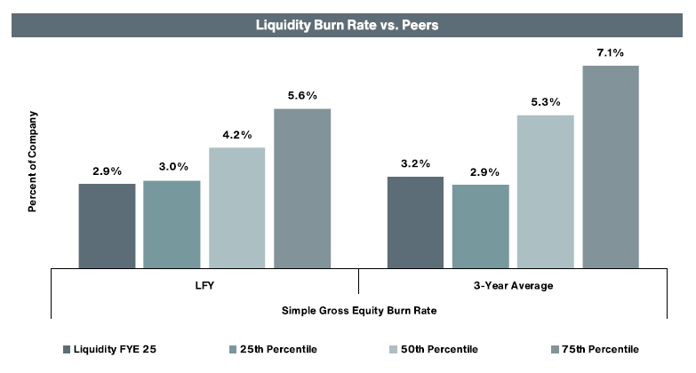
* The peer group used in the above chart is the same peer group approved by the Compensation Committee for fiscal 2025, as further described below under “Executive Compensation–General Compensation Philosophy–Role of the Compensation Consultant”.
We continually monitor our burn rate to ensure that we remain good stewards of the shares our stockholders have granted us under the LTIP.
Plan Management. The Company’s management of its equity compensation plans also reduces impacts to stockholder dilution by permitting participants to elect that the Company:
✓
Withhold shares to satisfy withholding tax obligations on full-value awards;
✓
Withhold shares to the satisfy exercise price and/or withholding tax obligations on option awards; and/or
✓
Receive shares to satisfy exercise price obligations on option awards.
If we did not permit the above, we would have issued a total of 888,513 shares from our equity compensation plans in fiscal 2025 from the vesting of full-value awards and the exercise of stock options. These actions reduced the dilutive impact of our equity compensation plans by 283,938 shares, or 32%.
44

PROPOSALS requiring your vote
Proposal 4 – Approval of an Amendment to Increase the Authorized Number of Shares Under the Company’s
Third Amended and Restated 2006 Omnibus Long-Term Incentive Plan

Share Repurchase Program. Our share repurchase program has also contributed to our mitigation of dilution by reducing the total number of shares outstanding. Our share repurchase program is a multi-year effort, which has resulted in a significant reduction in our total net shares outstanding from 33,534,898 as of September 30, 2020 to 30,676,595 as of September 30, 2025. The decrease in net shares outstanding over the past five fiscal years is shown in the below chart:
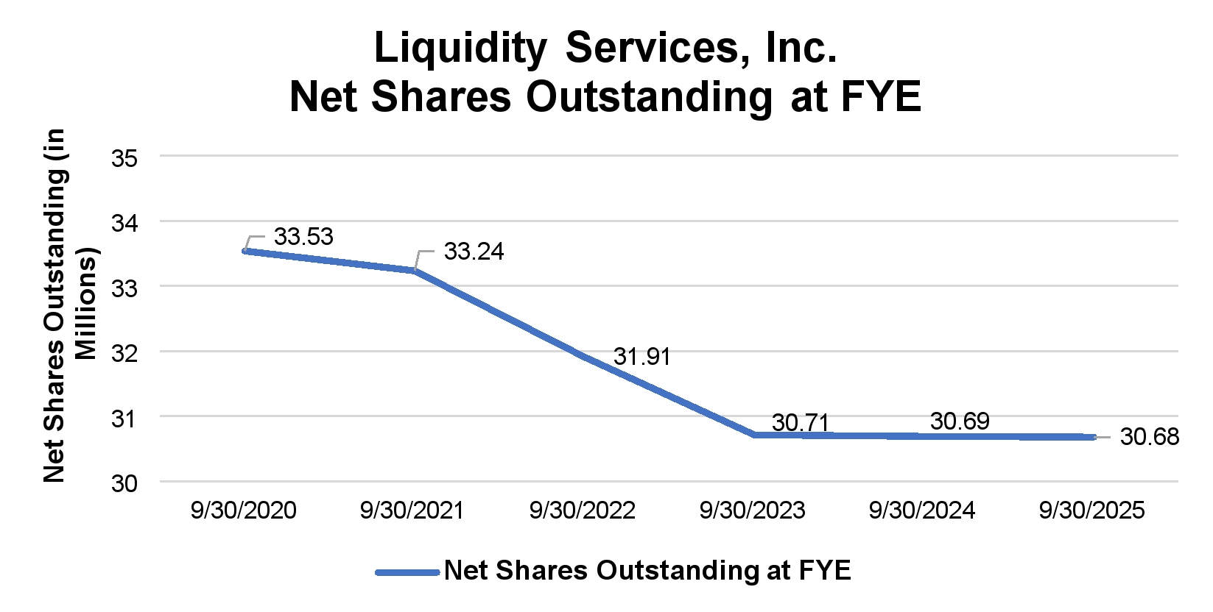
The following table provides additional detail on share activity for the past five fiscal years that resulted in the decrease in net shares outstanding described above:
 |  | Shares Outstanding | Treasury Stock | Net Shares Outstanding
 | September 30, 2020 | 34,082,406 | (547,508) | 33,534,898
Fiscal 2021 | Stock Options Exercised | 1,033,529 | - | 1,033,529
Fiscal 2021 | Full-Value Awards Vested | 800,088 | - | 800,088
Fiscal 2021 | Shares Withheld for Exercise Price and/or Tax Obligations | (445,195) | - | (445,195)
Fiscal 2021 | Shares Received for Exercise Price Obligations | - | (82,612) | (82,612)
Fiscal 2021 | Shares Repurchased | - | (1,591,963) | (1,591,963)
Fiscal 2021 | Other* | (13,733) | - | (13,733)
Fiscal 2021 | September 30, 2021 | 35,457,095 | (2,222,083) | 33,235,012
Fiscal 2021 | FY21 Change # | 1,374,689 | 1,674,575 | (299,886)
Fiscal 2021 | FY21 Change % | 4% | 305% | (2%)
Fiscal 2022 | Stock Options Exercised | 316,994 | - | 316,994
Fiscal 2022 | Full-Value Awards Vested | 328,730 | - | 328,730
Fiscal 2022 | Shares Withheld for Exercise Price and/or Tax Obligations | (240,976) | - | (240,976)
Fiscal 2022 | Shares Received for Exercise Price Obligations | - | (23,839) | (23,839)
Fiscal 2022 | Shares Repurchased | - | (1,567,277) | (1,567,277)
Fiscal 2022 | Other* | (137,757) | - | (137,757)
Fiscal 2022 | September 30, 2022 | 35,724,057 | (3,813,199) | 31,910,858
Fiscal 2022 | FY22 Change # | 266,962 | (1,591,116) | (1,324,154)
Fiscal 2022 | FY22 Change % | 1% | 71% | (4%)
45

PROPOSALS requiring your vote
Proposal 4 – Approval of an Amendment to Increase the Authorized Number of Shares Under the Company’s
Third Amended and Restated 2006 Omnibus Long-Term Incentive Plan

 |  | Shares Outstanding | Treasury Stock | Net Shares Outstanding
Fiscal 2023 | Stock Options Exercised | 372,362 | - | 372,362
Fiscal 2023 | Full-Value Awards Vested | 252,228 | - | 252,228
Fiscal 2023 | Shares Withheld for Exercise Price and/or Tax Obligations | (206,301) | - | (206,301)
Fiscal 2023 | Shares Received for Exercise Price Obligations | - | (12,705) | (12,705)
Fiscal 2023 | Shares Repurchased | - | (1,607,141) | (1,607,141)
Fiscal 2023 | September 30, 2023 | 36,142,346 | (5,433,045) | 30,709,301
Fiscal 2023 | FY23 Change # | 418,289 | (1,619,846) | (1,201,557)
Fiscal 2023 | FY23 Change % | 1% | 42% | (4%)
Fiscal 2024 | Stock Options Exercised | 554,191 | - | 554,191
Fiscal 2024 | Full-Value Awards Vested | 314,309 | - | 314,309
Fiscal 2024 | Shares Withheld for Exercise Price and/or Tax Obligations | (303,006) | - | (303,006)
Fiscal 2024 | Shares Received for Exercise Price Obligations | - | (17,564) | (17,564)
Fiscal 2024 | Shares Repurchased | - | (564,887) | (564,887)
Fiscal 2024 | September 30, 2024 | 36,707,840 | (6,015,496) | 30,692,344
Fiscal 2024 | FY24 Change # | 565,494 | (582,451) | (16,957)
Fiscal 2024 | FY24 Change % | 2% | 11% | 0%
Fiscal 2025 | Stock Options Exercised | 235,835 | - | 235,835
Fiscal 2025 | Full-Value Awards Vested | 652,678 | - | 672,678
Fiscal 2025 | Shares Withheld for Exercise Price and/or Tax Obligations | (283,938) | - | (283,938)
Fiscal 2025 | Shares Received for Exercise Price Obligations | - | (1,397) | (1,397)
Fiscal 2025 | Shares Repurchased | - | (623,687) | (623,687)
Fiscal 2025 | September 30, 2025 | 37,317,175 | - | 37,317,175
Fiscal 2025 | FY25 Change # | 609,335 | (625,084) | (15,749)
Fiscal 2025 | FY25 Change % | 2% | 10% | 0%

* Relates to forfeiture of award prior to vesting due to employee termination.

We have existing authorization from our Board to continue making repurchases in fiscal 2026. On November 17, 2025, the Board authorized the repurchase of up to $15.0 million of our outstanding shares of common stock through December 31, 2027. This authorization follows the complete utilization of our previous authorization to repurchase up to $10.0 million in shares through December 31, 2026, which was approved by the Board in December 2024. Although the timing and actual number of shares repurchased will depend on a variety of factors, including price, general business and market conditions, and the existence of alternative investment opportunities, offsetting dilution from our equity compensation plans will remain an important factor in our decision-making regarding share repurchases.
Effect of Stock Option Grants
We have historically granted a significant portion of our long-term incentives in the form of stock options. Although equity awards in the form restricted stock or RSUs are more common in the market and in our peer group, we continue to deliver a significant portion of our long-term incentives in the form of stock options because of the strong linkage between stock option awards and stockholder return. Grantees only receive value from the options if there is an increase in the value of the Company’s shares following the date of grant. A grantee is unlikely to exercise an option that is underwater (i.e., the exercise price for such option exceeds the market price) so if our stock price declines, the options may expire before ever being exercised. While this approach to option grants is different than members of our peer group, we believe the high levels
46

PROPOSALS requiring your vote
Proposal 4 – Approval of an Amendment to Increase the Authorized Number of Shares Under the Company’s
Third Amended and Restated 2006 Omnibus Long-Term Incentive Plan

of support for our annual say-on-pay proposal during the past several years indicates that our stockholders are aligned with this philosophy. The Company will continue to monitor peer and market practices regarding the use of options and restricted stock or RSUs and will take any developments into account when evaluating the long-term incentives mix going forward.
The following table provides details regarding the number of equity awards granted annually under the LTIP for each of the past five fiscal years by type of award as well as the number of performance-based awards granted and earned in each year for the past five fiscal years and our weighted average shares of common stock outstanding:
Share Element | 2025 | 2024 | 2023 | 2022 | 2021
Time-Based Stock Options Granted | 125,000 | 125,955 | 178,048 | 141,712 | 558,673
Time-Based Full-Value Awards Granted | 353,943 | 372,746 | 478,813 | 386,834 | 190,945
Performance-Based Stock Options Granted | 125,000 | 125,955 | 175,910 | 139,945 | 549,600
Performance-Based Stock Options Earned/Vested | 172,746 | 12,936 | 4,000 | 485,324 | 909,500
Performance-Based Full-Value Awards Granted | 304,521 | 303,610 | 288,420 | 458,585 | 139,600
Performance-Based Full-Value Awards Earned/Vested | 310,682 | 35,900 | 1,230 | 175,535 | 483,054
Weighted-Average Shares of Common Stock Outstanding During the Fiscal Year | 30,932,459 | 30,496,306 | 30,576,142 | 32,292,978 | 33,333,557
As a result of the importance to our compensation philosophy of delivering a significant portion of our long-term incentives in the form of stock options, the overhang of our equity program is generally higher than that of members of our peer group. When restricted stock, restricted stock units, or performance shares are granted, the average “overhang” in the market typically reflects three, or at most four years, of outstanding awards. When options are granted, the average “overhang” in the market is greater because outstanding options may be exercised at any time during the ten years following the date of grant and thus, are outstanding for a longer period of time. As of December 31, 2025, approximately 55% of our options have been outstanding for four or more years. The below chart shows the age of our outstanding options as of December 31, 2025:
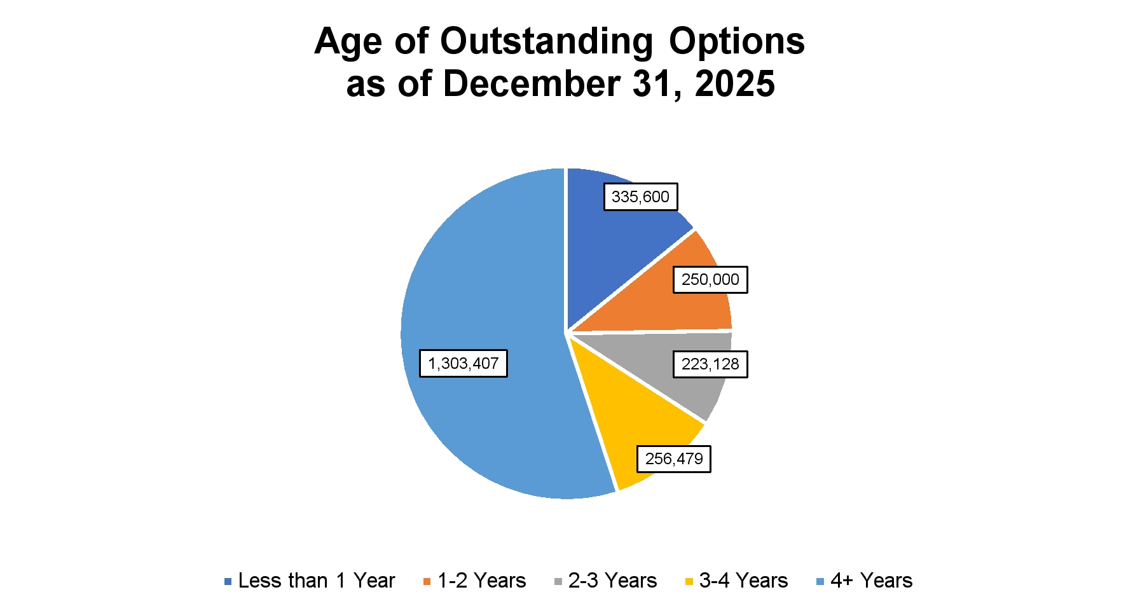
47

PROPOSALS requiring your vote
Proposal 4 – Approval of an Amendment to Increase the Authorized Number of Shares Under the Company’s
Third Amended and Restated 2006 Omnibus Long-Term Incentive Plan

As described in our past proxy statements, we have reduced but not eliminated grants of options to our NEOs over the past several fiscal years, which has had a positive impact in our equity overhang. This change along with our other efforts to manage dilution has had a notable impact on our equity overhang over the past several years. The below chart compares our equity overhang practices to those of our peer group at the end of fiscal 2019, at which time our practices put us above the 50th percentile of our peers.
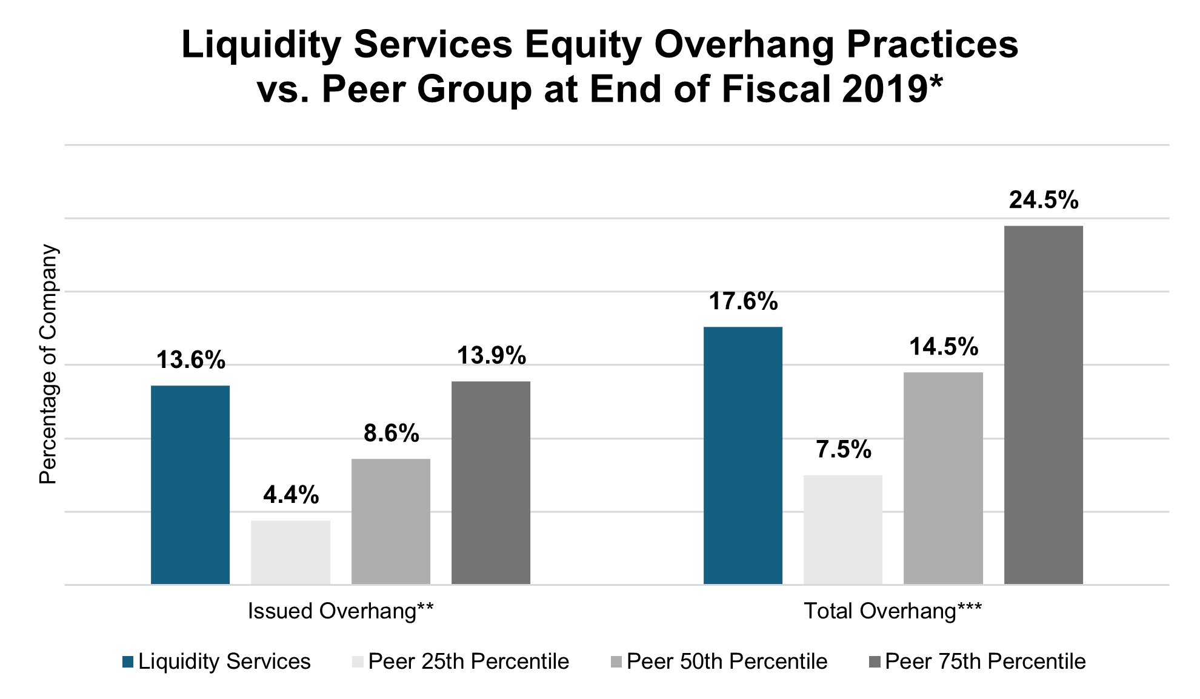
* The peer group used for comparison purposes in the above chart is the same peer group developed in consultation with the Compensation Consultant as part of its review of the Company’s executive compensation practices in fiscal 2019, as further described in the Company's 2020 proxy statement filed with the SEC on January 28, 2020.
** “Issued Overhang” means total options and unvested restricted stock outstanding divided by total common shares issued and outstanding (including treasury shares).
*** “Total Overhang” means total options and unvested restricted stock outstanding plus shares available for future grant divided by total common shares issued and outstanding (including treasury shares).

48

PROPOSALS requiring your vote
Proposal 4 – Approval of an Amendment to Increase the Authorized Number of Shares Under the Company’s
Third Amended and Restated 2006 Omnibus Long-Term Incentive Plan

In comparison, the below chart compares our equity overhang at the end of fiscal 2025 to that of our peer group and reflects that our practices are more in line with our peers (i.e., below the 50th percentile for Issued Overhang and below the 25th percentile for Total Overhang):
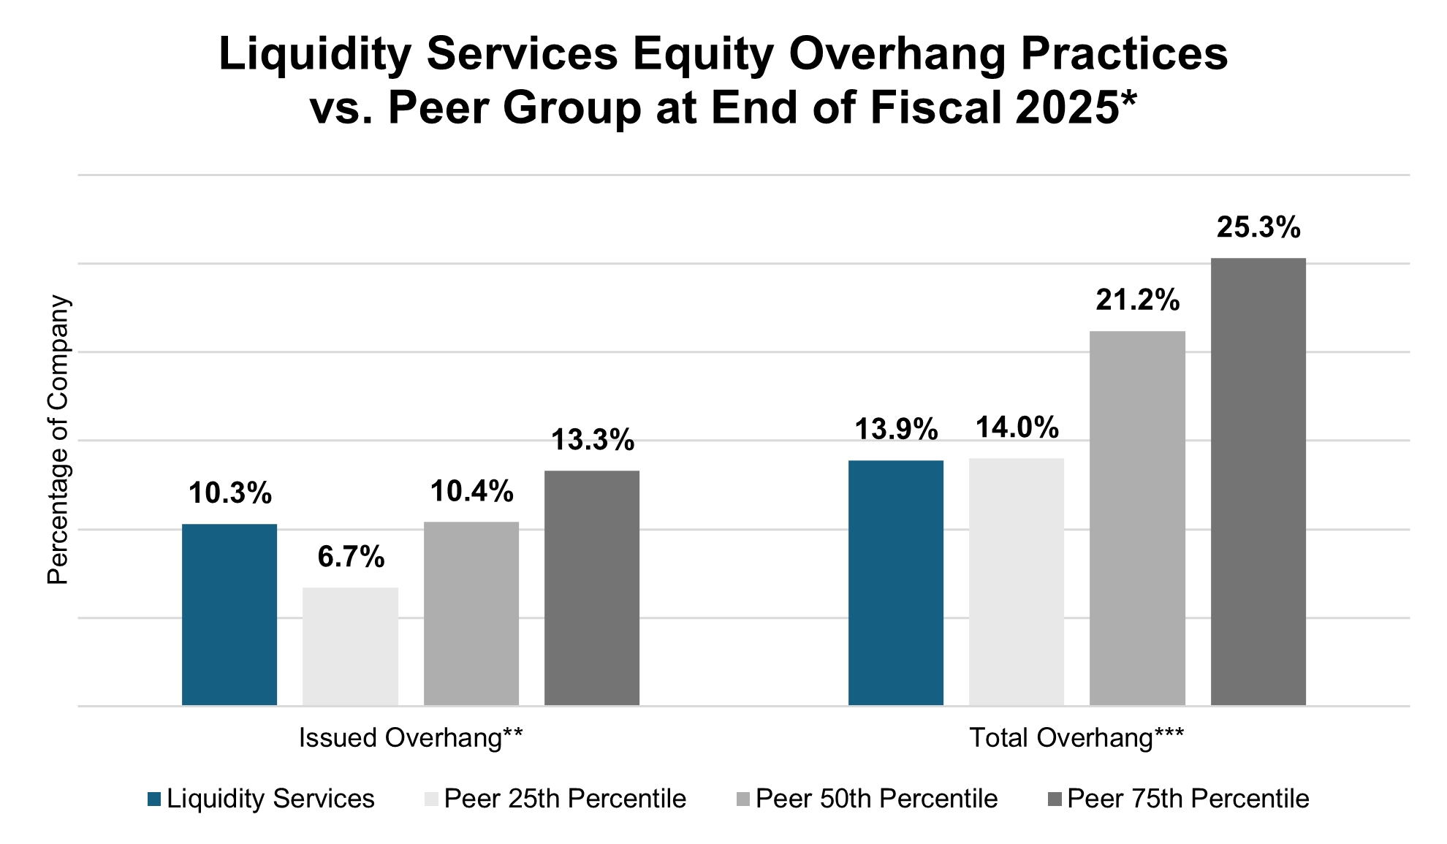
* The peer group used for comparison purposes in the above chart is the same peer group developed in consultation with the Compensation Consultant as part of its review of the Company’s executive compensation practices, as further described below under “Executive Compensation–General Compensation Philosophy–Role of the Compensation Consultant”.
** “Issued Overhang” means total options and unvested restricted stock outstanding divided by total common shares issued and outstanding (including treasury shares).
*** “Total Overhang” means total options and unvested restricted stock outstanding plus shares available for future grant divided by total common shares issued and outstanding (including treasury shares).

This improvement reflects our commitment to managing dilution in a manner that permits us to continue to grant equity compensation while reducing the overall impact to our stockholders.
Consideration of Projected Share Usage
When considering the number of additional shares to request under the Amendment, in addition to the items mentioned above, the Compensation Committee also reviewed our projected future share usage. The projected future usage of shares for long-term incentive awards under the LTIP, as amended, was reviewed under a variety of scenarios and assumptions. These assumptions included potential changes to hiring needs, adjustments to grant practices, stock price changes, anticipated forfeitures of awards previously granted and other external market factors, and certain assumptions concerning the use of equity compensation in connection with hypothetical acquisitions. If our assumptions prove to be accurate, the 2,925,000 shares to be added to the LTIP by the Amendment, in combination with the remaining authorized shares and shares that are likely to be added back to the LTIP from forfeitures of awards previously granted, are expected to satisfy the Company’s equity compensation needs for two additional fiscal years (i.e., through fiscal 2028).
This approach is consistent with our past practice. For example, we last requested an increase in the number of shares authorized for issuance under the LTIP at our 2024 Annual Meeting of Stockholders. That increase, which was approved by our stockholders, were expected to, and did, satisfy our equity compensation needs through fiscal 2026. The Compensation Committee values stockholder input on our equity compensation practices and has determined that requesting smaller, more frequent increases in the number of shares authorized under the LTIP is preferable to larger, less frequent requests because it provides our stockholders with the opportunity to weigh in on share usage more frequently. The Compensation Committee remains committed to effectively managing the number of shares reserved for issuance under the LTIP, as amended by the Amendment (the “Amended Plan”), while mitigating the effect on our stockholders.
49

PROPOSALS requiring your vote
Proposal 4 – Approval of an Amendment to Increase the Authorized Number of Shares Under the Company’s
Third Amended and Restated 2006 Omnibus Long-Term Incentive Plan

Changes in Amended Plan
The Amendment increases the number of shares of common stock reserved for issuance under the LTIP. No other changes are being proposed to the LTIP at this time.
Summary of Amended Plan
The following summary of the material terms of the LTIP, as amended by the Amendment, is qualified in its entirety by reference to the full text of the LTIP and the Amendment. The Amendment, which is the subject of this Proposal 4, is attached as Appendix A to this Proxy Statement. The LTIP is attached as Appendix B to this Proxy Statement.
By the Numbers. The following table sets forth certain information about the Amended Plan:
Number of new shares being authorized | 2,925,000
Number of shares outstanding as of the Record Date | 30,805,564
Number of shares available for future awards as of the Record Date | 78,294
Number of shares relating to outstanding time-based stock options as of the Record Date | 1,149,652
Number of shares relating to outstanding performance-based stock options as of the Record Date | 1,218,212
Number of shares relating to outstanding awards of time-based restricted stock and restricted stock units as of the Record Date | 1,128,486
Number of shares relating to outstanding awards of performance-based restricted stock and restricted stock units as of the Record Date | 980,700
Maximum option term | 10 years
Minimum exercise price (relative to the market value on date of grant) | 100%
Weighted average remaining term of outstanding options as of the Record Date | 6.05 years
Weighted average exercise price of outstanding options as of the Record Date | $14.89
Total number of shares available for future awards if this proposal is approved* | 3,003,294
* This total includes the shares available for future awards as of the Record Date (i.e., 78,294) plus the number of new shares being authorized (i.e., 2.925,000). It does not include those shares that will be returned to the LTIP in connection with existing grants that expire prior to vesting after the Record Date.

Plan Features. The Amended Plan includes the following key features, which we believe show the alignment of the Amended Plan to stockholder interests:
•
The Amended Plan requires one-year minimum vesting on all awards;
•
The Amended Plan prohibits dividends or dividend equivalents on unvested awards, liberal share recycling, and tax gross-ups on awards;
•
The Amended Plan fully discloses the effect a change in control would have on equity awards;
•
The Amended Plan does not contain an evergreen provision;
•
The Amended Plan prohibits repricing without stockholder approval;
•
The Amended Plan includes individual award limits, including director compensation limits; and
•
The Company maintains a robust clawback policy.
Purpose. The Amended Plan is intended to enhance the Company's ability to attract and retain highly qualified officers, directors, key employees, and other persons, and to motivate such officers, directors, key employees, and other persons to serve the Company and to expend maximum effort to improve the business results and earnings of the Company, by providing to such persons an opportunity to acquire or increase a direct proprietary interest in the operations and future
50

PROPOSALS requiring your vote
Proposal 4 – Approval of an Amendment to Increase the Authorized Number of Shares Under the Company’s
Third Amended and Restated 2006 Omnibus Long-Term Incentive Plan

success of the Company. To this end, the Amended Plan provides for the grant of stock options, stock appreciation rights, restricted stock, stock units, dividend equivalent rights and cash awards.
Administration. The Amended Plan is administered by the Board, the Compensation Committee or such other committees as the Board may from time to time delegate. The Board or its designated committee has the authority to designate grantees, determine the type(s) of awards to be made to a grantee, determine the number of shares to be subject to an award, establish the terms and conditions of each award, prescribe the form of each award agreement and amend, modify or supplement the terms of each outstanding award, provided that no amendment, modification or supplement shall, without the consent of the grantee, impair the grantee's rights under such award or amend or modify an award such that it would be treated as a repricing without approval of the Company's stockholders.
Notwithstanding the foregoing, no amendment or modification may be made to an outstanding option or stock appreciation right (“SAR”) which reduces the exercise price of the award, either by lowering the exercise price or by canceling the outstanding option or SAR and granting either a replacement option or SAR with a lower exercise price, another award or a cash payment in lieu thereof without the approval of the stockholders of the Company, provided, that, appropriate adjustments may be made to outstanding options and SARs in connection with changes in the Company's capitalization.
Eligibility. Awards may be granted under the Amended Plan to employees, officers, directors, consultants, advisers and outside directors of the Company and its affiliates. As of the Record Date, approximately 147 individuals participated in the LTIP.
Shares Subject to the Plan. If the Amendment is approved by the stockholders at the Annual Meeting, subject to adjustment for certain changes in the Company's capitalization, the total number of shares of the Company’s common stock that may be issued under the Amended Plan will be 25,725,000. For this purpose, every share of common stock issued pursuant to an award granted after January 9, 2015 that is an option or SAR will count as one share and every share of common stock issued pursuant to an award granted after January 9, 2015 other than an option or SAR will count as 1.5 shares of common stock. The number of shares that may be issued as incentive stock options (“ISOs”) shall not exceed 19,100,000. Stock issued or to be issued under the Amended Plan shall be authorized but unissued shares; or, to the extent permitted by applicable law, issued shares that have been reacquired by the Company. If any shares covered by an award are not purchased or are forfeited, or if an award otherwise terminates without delivery of any stock subject thereto, then the number of shares of stock counted against the aggregate number of shares available under the Amended Plan with respect to such award shall, to the extent of any such forfeiture or termination, again be available for making awards under the Amended Plan; provided, however, that any shares of common stock that again become available for grant after January 9, 2015 will be added back on a one-for-one basis if such shares of common stock were subject to awards of options or SARs or added back as 1.5 shares of common stock for all shares granted as awards other than options or SARs. Notwithstanding the foregoing, the following shares shall not be available for future grant: (a) shares tendered or withheld in payment of the exercise price of an option, and (b) shares withheld by the Company or otherwise received by the Company to satisfy tax withholding obligations in connection with an award. In addition, all shares covered by a SAR (including shares subject to a stock-settled SAR that were issued upon the net settlement or net exercise of such SAR) shall be counted against the number of shares of common stock available for issuance under the Amended Plan. The Board shall have the right to substitute or assume awards in connection with mergers, reorganizations, separations and certain other transactions. The maximum number of shares of common stock subject to options or SARs granted under the Amended Plan to any one individual in any one calendar year may not exceed 1,000,000; the maximum number of shares of common stock subject to awards granted under the Amended Plan other than options and SARs to any one individual in any one calendar year may not exceed 700,000; the maximum amount that may be earned pursuant to a cash award under the Amended Plan by any one individual in any one calendar year may not exceed $3,000,000; the maximum amount that may be earned as a performance award or other cash award in respect of a performance period by any one individual may not exceed $5,000,000; and the aggregate dollar value of equity-based and cash compensation granted under the Amended Plan or otherwise during any one calendar year to any one non-employee director may not exceed $420,000.
Several types of stock grants can be made under the Amended Plan. A summary of these grants is set forth below.
Stock Options. Stock options granted under the Amended Plan can be either ISOs or nonqualified stock options. An option may constitute an ISO only (i) if the grantee of such option is an employee of the Company or any subsidiary of
51

PROPOSALS requiring your vote
Proposal 4 – Approval of an Amendment to Increase the Authorized Number of Shares Under the Company’s
Third Amended and Restated 2006 Omnibus Long-Term Incentive Plan

the Company; (ii) to the extent specifically provided in the related award agreement; and (iii) to the extent that the aggregate fair market value (determined at the time the option is granted) of the shares of stock with respect to which all ISOs held by such grantee become exercisable for the first time during any calendar year (under the Amended Plan and all other plans of the grantee's employer and its affiliates) does not exceed $100,000. This limitation is applied by taking options into account in the order in which they were granted.
The exercise price of stock options is at least the fair market value on the date of grant; provided, however, that in the event a grantee is a 10 percent stockholder, the option price of an option that is intended to be an ISO may not be less than 110 percent of the fair market value on the date of grant. Options become exercisable at such times and under such conditions as are determined by the Board; provided, however, that the vesting of any option that is based on performance criteria and level of achievement versus such criteria will be subject to a performance period of not less than one (1) year, and the vesting of any option that is based solely upon continued employment and/or the passage of time may not vest in full over a period of less than one (1) year from the grant date, except that the administrator may provide for the satisfaction and/or lapse of all conditions under any such award in the event of the participant's death or disability or in connection with a corporate transaction of the Company, and the administrator may provide that any such restriction or limitation will not apply in the case of an option that is issued in payment or settlement of compensation that has been earned by the participant or that qualifies as a substitute award under the Amended Plan. Notwithstanding the foregoing, the administrator may grant awards covering an aggregate of five percent (5%) or fewer of the total number of shares authorized under the Amended Plan without regard to such minimum vesting requirements. In no case will an individual holding an option receive dividend payments or dividend equivalents.
Each option terminates ten years from the date of grant, or as set forth in the Amended Plan or fixed by the Board; provided, however, that in the event that the grantee is a 10 percent stockholder, an option that is intended to be an ISO generally cannot be exercisable after five years from the date of grant. An option that is exercisable may be exercised by the grantee's delivery to the Company of a written notice of exercise. Such notice must be accompanied by payment in full of the option price of the shares for which the option is being exercised plus the amount (if any) of federal and/or other taxes which the Company may, in its judgment, be required to withhold with respect to an award, or by “cashless exercise.” Each award agreement sets forth the extent to which the grantee has the right to exercise the option following termination of the grantee's service.
SARs. A SAR confers on the grantee, upon exercise thereof, the excess of (A) the fair market value of one share of stock on the date of exercise over (B) the grant price of the SAR as determined by the Board. The award agreement for a SAR specifies the grant price of the SAR, which must be at least the fair market value of a share of stock on the date of grant. SARs may be granted in conjunction with all or part of an option granted under the Amended Plan or at any subsequent time during the term of such option, in conjunction with all or part of any other award or without regard to any option or other award; provided that a SAR that is granted subsequent to the date of grant of a related option must have a grant price that is no less than the fair market value of one share of stock on the date of grant. The Board determines the time or times at which and the circumstances under which a SAR may be exercised in whole or in part (including based on achievement of performance goals and/or future service requirements), the time or times at which SARs cease to be or become exercisable following termination of service or upon other conditions, the method of exercise, method of settlement, form of consideration payable in settlement, method by or forms in which stock will be delivered or deemed to be delivered to grantees, whether or not a SAR is granted in tandem or in combination with any other award, and any other terms and conditions of any SAR; provided, however, that the term of each SAR shall be no more than ten years, and the vesting of any SAR that is based on performance criteria and level of achievement versus such criteria will be subject to a performance period of not less than one (1) year, and the vesting of any SAR that is based solely upon continued employment and/or the passage of time may not vest in full over a period of less than one (1) year from the grant date, except that the administrator may provide for the satisfaction and/or lapse of all conditions under any such award in the event of the participant's death or disability or in connection with a corporate transaction of the Company, and the administrator may provide that any such restriction or limitation will not apply in the case of a SAR that is issued in payment or settlement of compensation that has been earned by the participant or that qualifies as a substitute award under the Amended Plan. Notwithstanding the foregoing, the administrator may grant awards covering an aggregate of five percent (5%) or fewer of the total number of shares authorized under the Amended Plan without regard to such minimum vesting requirements. In no case will an individual holding a SAR receive dividend payments or dividend equivalents.
52

PROPOSALS requiring your vote
Proposal 4 – Approval of an Amendment to Increase the Authorized Number of Shares Under the Company’s
Third Amended and Restated 2006 Omnibus Long-Term Incentive Plan

Restricted Stock and Restricted Stock Units. Awards of restricted stock or restricted stock units may be made for no consideration. At the time a grant of restricted stock or restricted stock units is made, the Board may, in its sole discretion, establish a restricted period applicable to such restricted stock or restricted stock units. Each award of restricted stock or restricted stock units may be subject to a different restricted period. The Board may, in its sole discretion, at the time a grant of restricted stock or restricted stock units is made, prescribe restrictions in addition to or other than the expiration of the restricted period, including the satisfaction of corporate or individual performance objectives, which may be applicable to all or any portion of the restricted stock or restricted stock units. The grant, issuance, retention, vesting and/or settlement of shares of common stock under any such award that is based on performance criteria and level of achievement versus such criteria will be subject to a performance period of not less than one (1) year, and the grant, issuance, retention, vesting and/or settlement of shares of common stock under any restricted stock or restricted stock unit award that is based solely upon continued employment and/or the passage of time may not vest or be settled in full over a period of less than one (1) year from the grant date, except that the administrator may provide for the satisfaction and/or lapse of all conditions under any such award in the event of the participant's death or disability or in connection with a corporate transaction of the Company, and the administrator may provide that any such restriction or limitation will not apply in the case of a restricted stock or stock unit award that is issued in payment or settlement of compensation that has been earned by the participant or that qualifies as a substitute award under the Amended Plan. Notwithstanding the foregoing, the administrator may grant awards covering an aggregate of five percent (5%) or fewer of the total number of shares authorized under the Amended Plan without regard to such minimum vesting requirements. Neither restricted stock nor restricted stock units may be sold, transferred, assigned, pledged or otherwise encumbered or disposed of during the restricted period or prior to the satisfaction of any other restrictions prescribed by the Board.
Unless the Board otherwise provides, except as provided below, holders of restricted stock have the right to vote such stock and the right to receive any dividends declared or paid with respect to such stock provided that any such dividends will be subject to the same vesting restrictions as the underlying shares subject to the award. Dividends accrued with respect to the shares subject to any restricted stock award, whether subject to time-based and/or performance-based vesting criteria, will become payable no earlier than the date the applicable vesting criteria have been satisfied and the underlying restricted stock has become vested and/or been earned, as applicable. The Board may provide that any dividends paid on restricted stock be reinvested in shares of stock. All distributions, if any, received by a grantee with respect to restricted stock as a result of any stock split, stock dividend, combination of shares, or other similar transaction are subject to the restrictions applicable to the original grant. Holders of restricted stock units have no rights as stockholders of the Company. The Board may provide that the holder of such restricted stock units be entitled to receive, upon the Company's payment of a cash dividend on its outstanding stock, a cash payment for each restricted stock unit held equal to the per share dividend paid on the stock provided that any such dividends will be subject to the same vesting restrictions as the underlying shares subject to the award. Dividends accrued with respect to the shares subject to any restricted stock unit award, whether subject to time-based and/or performance-based vesting criteria, will become payable no earlier than the date the applicable vesting criteria have been satisfied and the underlying restricted stock units have become vested and/or been earned, as applicable. The Board may also provide that such cash payment will be deemed reinvested in additional stock units at a price per unit equal to the fair market value of a share of stock on the date that such dividend is paid. Unless the Board otherwise provides, upon the termination of a grantee's service, any restricted stock or restricted stock units held by such grantee that have not vested, or with respect to which all applicable restrictions and conditions have not lapsed, shall immediately be deemed forfeited.
Dividend Equivalent Rights. A dividend equivalent right is an award entitling the recipient to receive credits based on cash distributions that would have been paid on the shares of stock specified in the dividend equivalent right (or other award to which it relates) if such shares had been issued to and held by the recipient. The terms and conditions of dividend equivalent rights shall be specified in the grant. Dividend equivalents credited to the holder of a dividend equivalent right may be paid currently or may be deemed to be reinvested in additional shares of stock, which may thereafter accrue additional equivalents. Any such reinvestment is made at fair market value on the date of reinvestment. Dividend equivalent rights may be settled in cash or stock or a combination thereof, in a single installment or installments, all determined in the sole discretion of the Board. A dividend equivalent right granted as a component of another award may provide that such dividend equivalent right shall be settled upon exercise, settlement, or payment of, or lapse of restrictions on, such other award, and that such dividend equivalent right will expire or be forfeited or annulled under the same conditions as such other award. A dividend equivalent right granted as a component of another award may also contain terms and conditions different from such other award. Notwithstanding anything in the Amended Plan to the contrary, in no event will dividend equivalent rights granted as a component of an award, whether subject to time-based and/or performance-based vesting
53

PROPOSALS requiring your vote
Proposal 4 – Approval of an Amendment to Increase the Authorized Number of Shares Under the Company’s
Third Amended and Restated 2006 Omnibus Long-Term Incentive Plan

criteria, be paid during the vesting period with respect to the unvested and/or unearned portion of any such awards. Specifically, dividends and dividend equivalents will not be paid on options or SARs. Dividend equivalent rights accrued on shares subject to any such awards will become payable no earlier than the date the vesting criteria have been satisfied and the underlying restricted stock or stock units have become vested and/or been earned, as applicable. Except as may otherwise be provided by the Board, a grantee's rights in all dividend equivalent rights or interest equivalents shall automatically terminate upon the grantee's termination of service for any reason.
Performance Goals. The right of a grantee to exercise or receive a grant or settlement of any award, and the timing thereof, may be subject to such performance conditions as may be specified by the Board or the Compensation Committee. If and to the extent that the Compensation Committee determines that an award to be granted to a grantee who is designated by the Compensation Committee as likely to be a covered employee within the meaning of Section 162(m) of the Internal Revenue Code of 1986, as amended (the “Code”) for grants made prior to November 2, 2017 should qualify as “performance-based compensation” for purposes of Section 162(m) of the Code, the grant, exercise and/or settlement of such award shall be contingent upon achievement of pre-established performance goals. For purposes thereof, the performance goals may consist of one or more of the following business criteria for the Company, on a consolidated basis, and/or specified subsidiaries or business units of the Company (except with respect to the total stockholder return and earnings per share criteria), shall be used exclusively by the Compensation Committee in establishing performance goals for such awards: (1) total stockholder return; (2) such total stockholder return as compared to total return (on a comparable basis) of a publicly available index such as, but not limited to, the Standard & Poor's 500 Stock Index; (3) net income; (4) pretax earnings; (5) contribution margin or earnings before interest expense, taxes, depreciation and amortization; (6) pretax operating earnings after interest expense and before bonuses, service fees, and extraordinary or special items; (7) operating margin; (8) earnings per share; (9) return on equity; (10) return on capital; (11) return on investment; (12) operating earnings; (13) working capital; (14) ratio of debt to stockholders' equity; (15) revenue; (16) gross merchandise value; (17) launch of a new marketplace on an e-commerce platform or the launch of an existing marketplace on a new e-commerce software platform by a specific date; and (18) growth of a new marketplace or e-commerce product as objectively measured by a gross merchandise volume target, contribution margin, number of sellers and/or buyers or a combination thereof. Business criteria may be measured on an absolute basis or on a relative basis (i.e., performance relative to peer companies) and on a GAAP or non-GAAP basis. To the extent consistent with Section 162(m) of the Code with respect to grants made on or before November 2, 2017, the Compensation Committee may appropriately adjust any evaluation of performance under a business criteria (A) to eliminate the effects of charges for restructurings, discontinued operations, and all items of gain, loss or expense that are unusual or infrequently occurring or related to the acquisition or disposal of a segment of a business or related to a change in accounting principle all as determined in accordance with applicable accounting provisions, as well as the cumulative effect of accounting changes, in each case as determined in accordance with GAAP or identified in the Company's financial statements or notes to the financial statements, (B) to exclude any of the following events that occurs during a performance period: (i) asset write-downs, (ii) litigation, claims, judgments or settlements, (iii) the effect of changes in tax law or other such laws or provisions affecting reported results, (iv) accruals for reorganization and restructuring programs (v) accruals of any amounts for payment under the Amended Plan or any other compensation arrangement maintained by the Company, (vi) foreign exchange gains and losses, and (vii) acquisitions or divestitures, and (C) for such other events as the Compensation Committee deems appropriate, if such adjustment is timely approved in connection with the establishment of such business criteria. Such performance goals shall be established not later than 90 days after the beginning of any performance period applicable to such awards, or in the case of grants made on or before November 2, 2017, at such other date as may be required or permitted for “performance-based compensation” under Section 162(m) of the Code. The maximum amount that may be earned under a cash award in any calendar year by any one grantee is $3,000,000 and the maximum amount that may be earned as a cash award in respect of a performance period by any one grantee is $5,000,000. If the Compensation Committee reasonably determines at any time during the applicable performance period that the performance goals underlying any award are unachievable, the Compensation Committee may cancel such award and the number of shares of stock counted against the aggregate number of shares available under the Amended Plan with respect to such award shall, to the extent of any such cancellation, again become available for making awards under the Amended Plan.
Corporate Transactions. Upon the occurrence of (i) the dissolution or liquidation of the Company or a merger, consolidation, or reorganization of the Company with one or more other entities in which the Company is not the surviving entity, (ii) a sale of substantially all of the assets of the Company to another person or entity, or (iii) any transaction (including without limitation a merger or reorganization in which the Company is the surviving entity) which results in any person or entity (other than persons who are stockholders or affiliates immediately prior to the transaction) owning 50% or more of
54

PROPOSALS requiring your vote
Proposal 4 – Approval of an Amendment to Increase the Authorized Number of Shares Under the Company’s
Third Amended and Restated 2006 Omnibus Long-Term Incentive Plan

the combined voting power of all classes of stock of the Company, provision will be made in writing for the assumption or continuation of the options, SARs, stock units and restricted stock theretofore granted, or for the substitution for such options, SARs, stock units and restricted stock for new common stock options and stock appreciation rights and new common stock units and restricted stock relating to the stock of a successor entity, or a parent or subsidiary thereof, with appropriate adjustments as to the number of shares (disregarding any consideration that is not common stock) and option and stock appreciation right exercise prices, in which event the Amended Plan, options, SARs, stock units and restricted stock theretofore granted will continue in the manner and under the terms so provided; provided, however, that if the successor entity refuses to assume or substitute the awards: (a) all outstanding shares of restricted stock shall be deemed to have vested, and all stock units shall be deemed to have vested and the shares of stock subject thereto shall be delivered, immediately prior to the occurrence of such corporate transaction; and (b) either of the following two actions shall be taken: (1) fifteen days prior to the scheduled consummation of a corporate transaction, all options and SARs outstanding under the Amended Plan shall become immediately exercisable and shall remain exercisable for a period of fifteen days; or (2) the Board may elect, in its sole discretion, to cancel any outstanding awards of options, restricted stock, stock units, and/or SARs and pay or deliver, or cause to be paid or delivered, to the holder thereof an amount in cash or securities having a value (as determined by the Board acting in good faith), in the case of restricted stock or restricted stock units, equal to the formula or fixed price per share paid to holders of shares of stock and, in the case of options or SARs, equal to the product of the number of shares of stock subject to the option or SAR (the “Award Shares”) multiplied by the amount, if any, by which (I) the formula or fixed price per share paid to holders of shares of stock pursuant to such transaction exceeds (II) the option price or SAR exercise price applicable to such Award Shares. With respect to the Company's establishment of an exercise window, (i) any exercise of an option or SAR during such fifteen-day period will be conditioned upon the consummation of the event and will be effective only immediately before the consummation of the event, and (ii) upon consummation of any corporate transaction, the Amended Plan, and all outstanding but unexercised options and SARs shall terminate. In the event that awards are assumed or substituted by a successor entity and a participant experiences a termination without cause or for good reason within one year following the occurrence of the corporate transaction, all outstanding shares of restricted stock will be deemed to have vested, and all stock units will be deemed to have vested and the shares of common stock subject thereto will be delivered upon such termination and all options and SARs outstanding will become immediately exercisable and remain exercisable for a period of one year following such termination, or until the expiration date of such option or SAR, if earlier.
Compensation Clawback Policy. Subject to the terms and conditions of the Amended Plan, the administrator may provide that any participant and/or any award, including any shares of common stock subject to an award, is subject to any recovery, recoupment, clawback and/or other forfeiture policy maintained by the Company from time to time.
Effectiveness and Term; Amendment and Termination
The Amended Plan will become effective upon approval of the Amendment by the Company's stockholders at the Annual Meeting and will remain available for the grant of awards until January 14, 2030. The Board may, at any time and from time to time, amend, suspend, or terminate the Amended Plan as to any shares of stock as to which awards have not been made. An amendment shall be contingent on approval of the Company's stockholders to the extent stated by the Board, required by applicable law or required by applicable stock exchange or market listing requirements. No amendment, suspension, or termination of the Amended Plan may, without the consent of the grantee, impair rights or obligations under any award theretofore awarded under the Amended Plan.
U.S. Federal Income Tax Consequences
The following is a summary of the material U.S. federal income tax consequences to the Company and to recipients of stock options (both nonqualified stock options and incentive stock options) and stock appreciation rights under the Amended Plan. The summary is based on the Code and the U.S. Treasury regulations promulgated under the Code in effect as of the date of this proxy statement, all of which are subject to change with retroactive effect. The summary is not intended to be a complete analysis or discussion of all potential tax consequences that may be important to recipients of awards under the Amended Plan. The laws governing the tax aspects of these awards are highly technical, and such laws are subject to change. Different tax rules may apply to specific participants and transactions under the Amended Plan, particularly in jurisdictions outside the United States.
55

PROPOSALS requiring your vote
Proposal 4 – Approval of an Amendment to Increase the Authorized Number of Shares Under the Company’s
Third Amended and Restated 2006 Omnibus Long-Term Incentive Plan

Nonqualified Stock Options and Stock Appreciation Rights. The recipient will not have any income at the time a nonqualified stock option or a SAR is granted, nor will the Company be entitled to a deduction at that time. When a nonqualified option is exercised, the optionee generally will recognize ordinary income (whether the option price is paid in cash or by delivery or surrender of shares of common stock), in an amount equal to the excess of the fair market value of the shares to which the option exercise pertains over the option exercise price. When an SAR is exercised, the holder will recognize ordinary income equal to the sum of (a) the gross cash proceeds payable and (b) the fair market value on the exercise date of any shares received. The Company will be entitled to a corresponding deduction with respect to a nonqualified stock option or SAR equal to the ordinary income recognized by the optionee or holder of the SAR, provided that the deduction is not disallowed by Section 162(m) or otherwise limited by the Code.
ISOs. A recipient will not have any income at the time an ISO is granted or have regular taxable income at the time the ISO is exercised. However, the excess of the fair market value of the shares at the time of exercise over the option exercise price will be a preference item that could create an alternative minimum tax liability for the optionee. Such alternative minimum tax may be payable even though the optionee receives no cash upon the exercise of the ISO with which to pay such tax. If the optionee disposes of the shares acquired on exercise of an ISO after the later of two years after the grant of the ISO and one year after exercise of the ISO, the gain recognized by the optionee (i.e., the excess of the proceeds received over the option exercise price), if any, will be long-term capital gain eligible for favorable tax rates under the Code. Conversely, if the optionee disposes of the shares within two years of the grant of the ISO or within one year of exercise of the ISO, the disposition will generally be a “disqualifying disposition,” and the optionee will recognize ordinary income in the year of the disqualifying disposition equal to the lesser of (i) the excess of the fair market value of the stock on the date of exercise over the option exercise price and (ii) the excess of the amount received for the shares over the option exercise price. The balance of the gain or loss, if any, will be long-term or short-term capital gain or loss, depending on how long the shares were held. The Company is not entitled to a deduction as the result of the grant or exercise of an ISO. However, if the optionee recognizes ordinary income as a result of a disqualifying disposition, the Company will be entitled to a corresponding deduction equal to the amount of ordinary income recognized by the optionee, provided that the deduction is not disallowed by Section 162(m) or otherwise limited by the Code.
409A. We intend that awards granted under the Amended Plan comply with, or are otherwise exempt from, Section 409A of the Code.
Deductibility of Executive Compensation. The Company generally will be entitled to a tax deduction in connection with an award under the Amended Plan in an amount equal to the ordinary income realized by a participant and at the time the participant recognizes such income (for example, the exercise of a nonqualified stock option). The Compensation Committee intends to administer any awards granted on or prior to November 2, 2017 which qualify as “performance-based compensation” under Section 162(m), as amended by the Tax Cuts and Jobs Act that was signed into law on December 22, 2017 (the “2017 Tax Act”), in accordance with the transition rules applicable to binding contracts in effect on November 2, 2017. With the elimination of the Section 162(m) exemption for performance-based compensation upon the adoption of the 2017 Tax Act, we expect that we will be unable to deduct all compensation in excess of $1 million paid to our Chief Executive Officer, Chief Financial Officer and the next three highest-paid executive officers (and any other person who was or will be a Section 162(m) covered employee on or after January 1, 2017), other than previously granted awards that comply with applicable transition rules.
New Plan Benefits
The benefits that will be awarded or paid in the future under the Amended Plan are not currently determinable. Such awards are within the discretion of the Compensation Committee, and the Compensation Committee has not determined future awards or who might receive them. Information about awards granted in fiscal 2025 under the LTIP to the Company's named executive officers can be found in the table under the heading “Grants of Plan-Based Awards for Fiscal 2025” on pages 77-78 of this proxy statement.
56

PROPOSALS requiring your vote
Proposal 4 – Approval of an Amendment to Increase the Authorized Number of Shares Under the Company’s
Third Amended and Restated 2006 Omnibus Long-Term Incentive Plan

Existing Plan Benefits
The following table sets forth information with respect to the number of shares underlying grants of all types of awards under the LTIP that have been granted through December 31, 2025 that count against the plan's maximum share authorization. These share numbers do not take into account the effect of options that have been canceled or expired unexercised.
Name and Position | Total Number of Shares Underlying Awards Grants
William P. Angrick, III | 1,977,839
Chairman and Chief Executive Officer
Jorge A. Celaya | 458,870
Chief Financial Officer
John P. Daunt | 301,642
Chief Commercial Officer
Steven J. Weiskircher | 214,568
Chief Technology Officer
Mark A. Shaffer | 172,664
Chief Legal Officer and Corporate Secretary
All current executive officers as a group | 3,125,583
All non-employee directors as a group | 36,754
All employees as a group (excluding executive officers) | 1,138,378

RECOMMENDATION OF THE BOARD
ü | Your Board of Directors unanimously recommends a vote FOR the Amendment to the LTIP.

57

Executive Compensation

Compensation Discussion and Analysis
This section describes our compensation strategy, programs and practices for the below listed executive officers during fiscal 2025:
Executive Officer | Principal Position
William P. Angrick, III | Chairman and Chief Executive Officer
Jorge A. Celaya | Chief Financial Officer
John P. Daunt | Chief Commercial Officer
Steven J. Weiskircher | Chief Technology Officer
Mark A. Shaffer | Chief Legal Officer and Corporate Secretary

In this proxy statement, we refer to these individuals as our named executive officers or “NEOs”.
Executive Summary
The Compensation Committee believes in a “pay-for-performance” approach that aims to align executive compensation with stockholder interests. This means that a significant portion of an executive's compensation should be at risk and may vary from “targeted” compensation based upon the level of achievement of specified performance objectives. Our pay for performance executive compensation philosophy and the elements of our executive compensation program for fiscal 2025 are summarized below:
•
The main objectives of our executive compensation program are to drive continuous stockholder return by motivating executives to achieve short-term and long-term financial and strategic objectives, to reward executives for continuous growth in earnings and stockholder value, and to align executives’ interests with those of our stockholders.
•
Our executive compensation program emphasizes performance-based compensation, including annual incentive compensation and stock-based awards, such as options and RSUs. For fiscal 2025, 50% of the stock-based awards granted to our NEOs had performance-based vesting criteria.
•
The Compensation Committee evaluates and sets the compensation levels of our NEOs. In setting compensation levels for NEOs, the Compensation Committee solicits the input and recommendations of our Chairman and CEO and engages an independent compensation consultant to conduct market reviews of our competitive market for executive talent.
•
91% of our Chairman and CEO’s targeted total direct compensation for fiscal 2025 was delivered through variable incentives for which payout is tied to achievement of pre-determined performance objectives.
•
On average, approximately 77% of the targeted total direct compensation for fiscal 2025 of the other NEOs was delivered through variable incentives with payout tied to achievement of pre-determined performance objectives.
•
We emphasize equity-based long-term incentives to ensure executives are focused on longer-term operating objectives and stock price performance in addition to shorter-term goals. The targeted value for long-term incentive awards for the NEOs other than Mr. Angrick is approximately 62% of the targeted value of their annual incentive awards and for Mr. Angrick is approximately 77% of the targeted value of such award.
58

EXECUTIVE COMPENSATION

•
To support the retention and incentive purposes of our executive compensation program, each of our NEOs received time-based and performance-based options and RSUs in fiscal 2025.
Our business and financial performance significantly impacted the design of our 2025 executive compensation program and the timing of decisions related to such program. In fiscal 2025, we achieved some notable financial and operational milestones, including:
•
In fiscal 2025, we generated $1.571 billion of gross merchandise volume, which is the total sales value of all transactions for which we earned compensation upon their completion through our marketplaces or other channels during a given period of time.
•
We generated revenue of $477 million in fiscal 2025 through multiple sources, including transaction fees from sellers and buyers, proceeds from the sale of products we purchased from sellers, and value-added service charges.
•
Our non-GAAP Adjusted EBITDA for the fourth quarter of fiscal 2025 was $18.5 million, a $4.0 million increase from $14.5 million in the fourth quarter a fiscal 2024.
•
During fiscal 2025, the number of registered buyers on our marketplaces grew by 10% from approximately 5.5 million registered buyers at the end of fiscal 2024 to approximately 6.0 million registered buyers at the end of fiscal 2025.
The following charts provide additional information on our fiscal 2025 financial milestones compared to prior years:
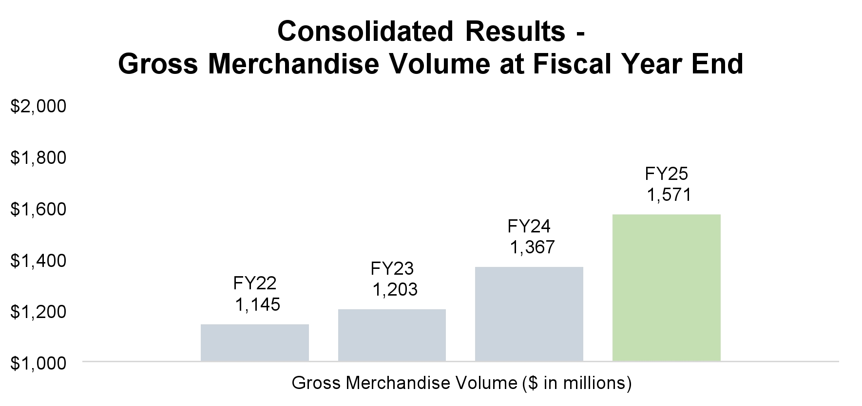
59

EXECUTIVE COMPENSATION

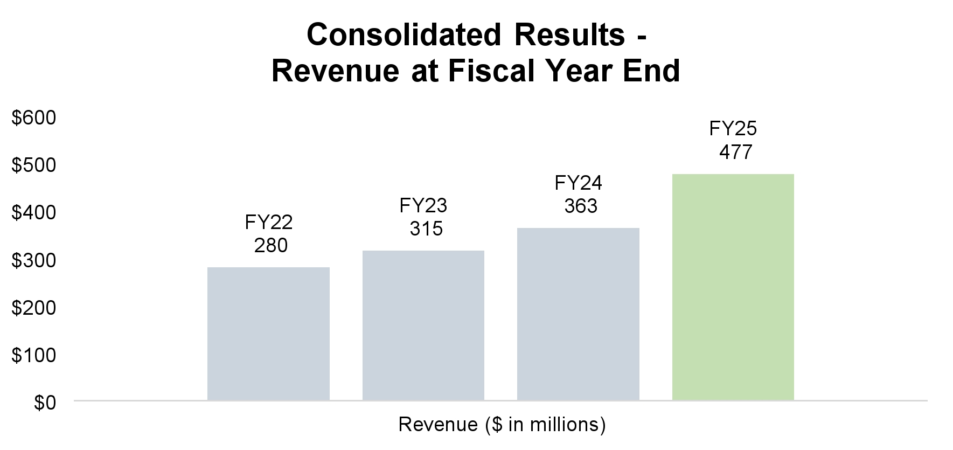
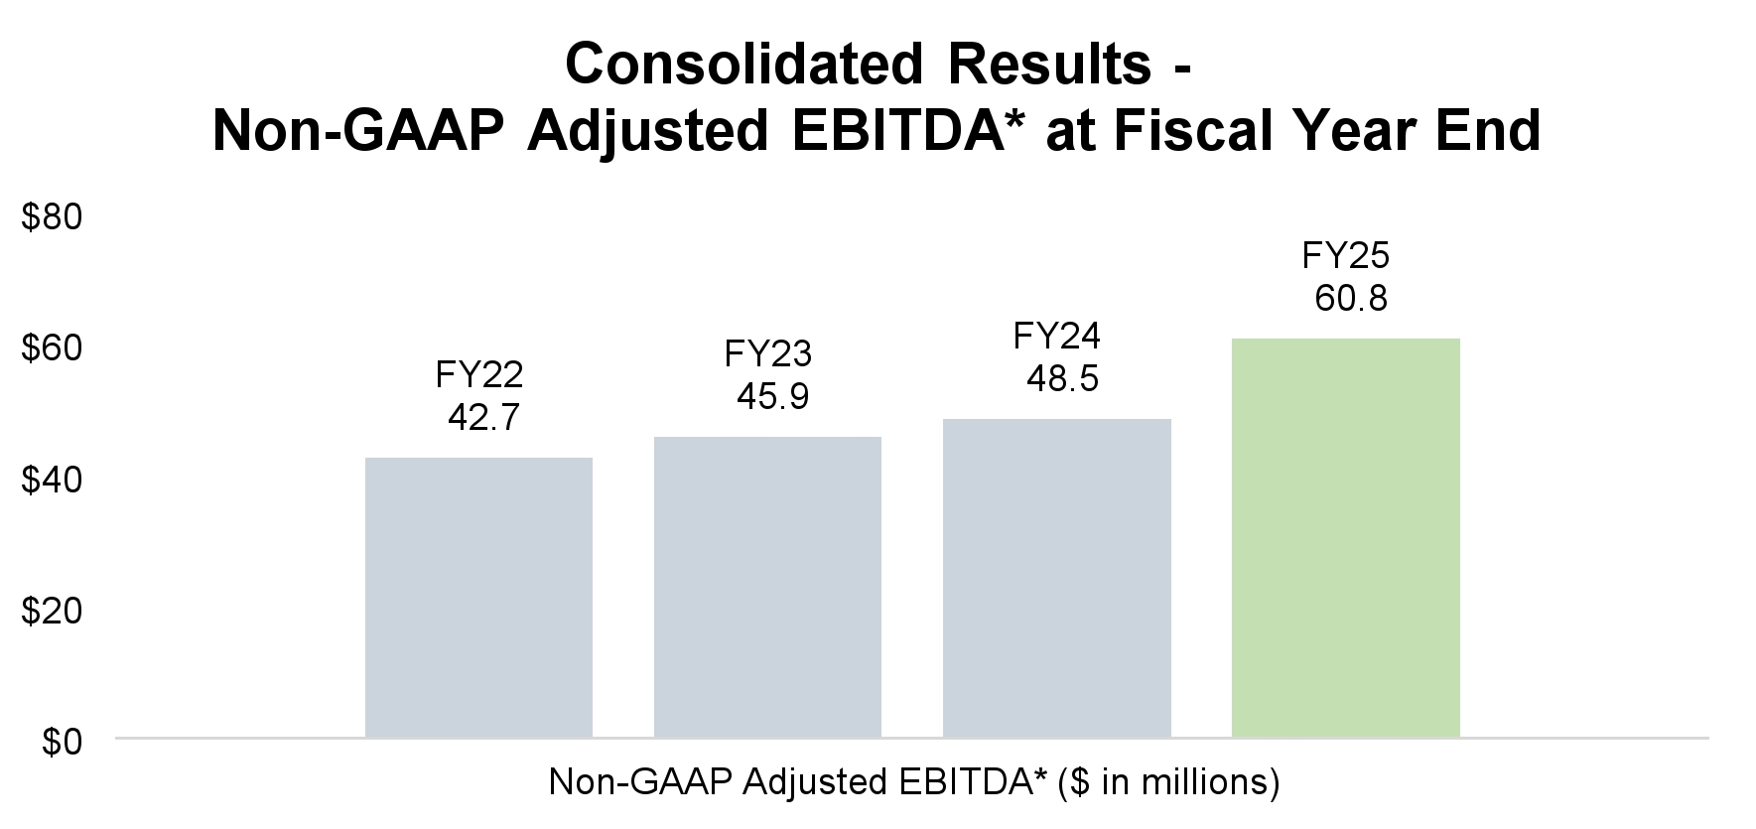
* For the twelve months ended September 30, 2025, 2024, 2023, and 2022, Net Income was $28.1M, $20.0M, $21.0M, and $40.3M respectively. For a reconciliation of Net Income to Non-GAAP EBITDA and Non-GAAP Adjusted EBITDA for the periods presented, see page 55 of the 2025 Form 10-K (filed with the SEC on November 20, 2025) and page 51 of our Annual Report on Form 10-K for the fiscal year ended September 30, 2024 (filed with the SEC on December 12, 2024).

60

EXECUTIVE COMPENSATION

The Company’s actual performance for fiscal 2025 resulted in above-target payments to our NEOs under our annual incentive program and our long-term incentive programs completed during fiscal 2025. Additional information on target compensation and the compensation actually received by our NEOs is described in additional detail in the below charts.

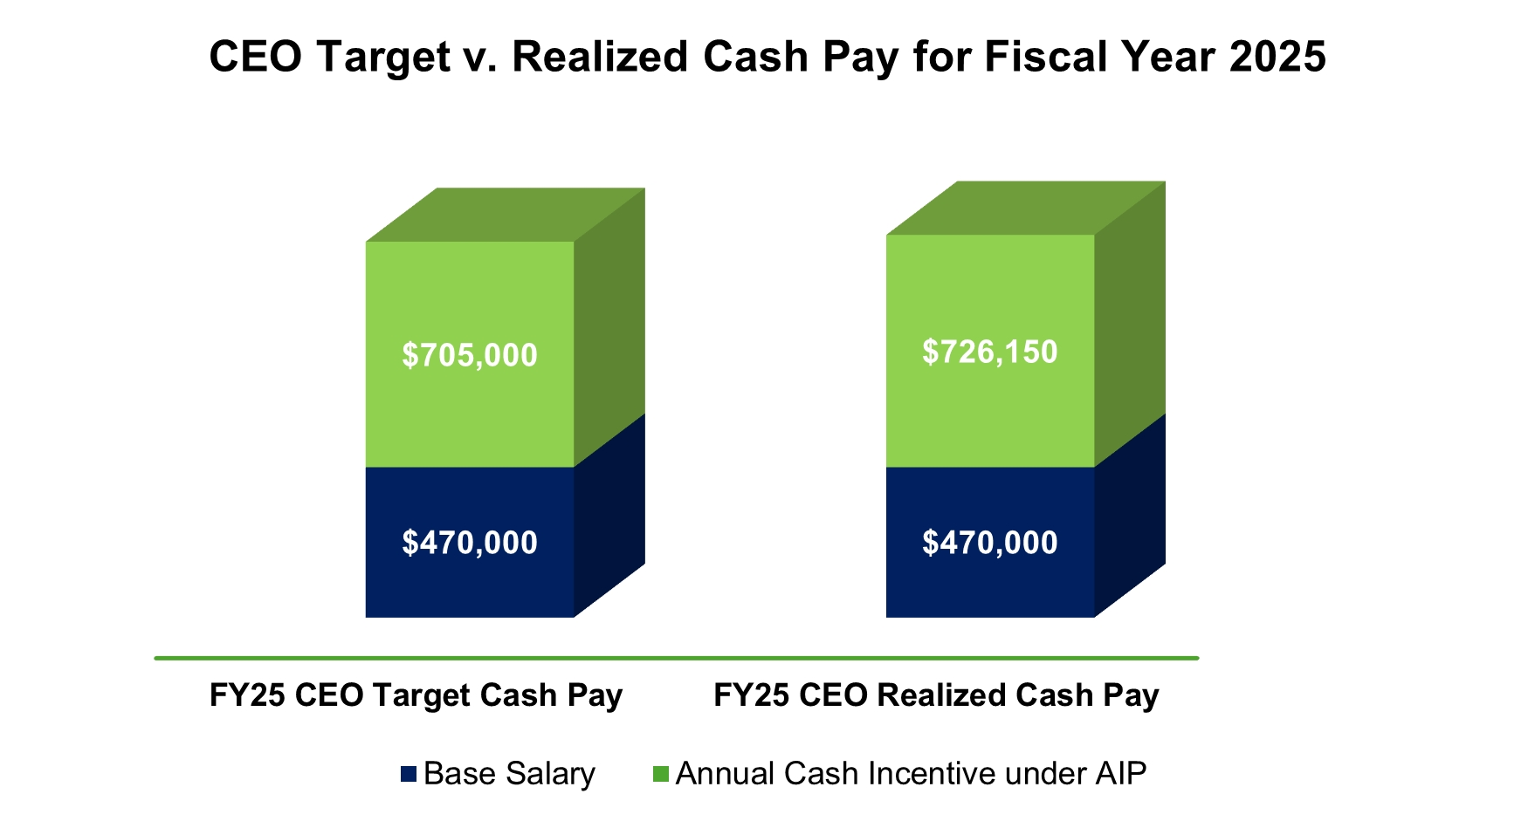

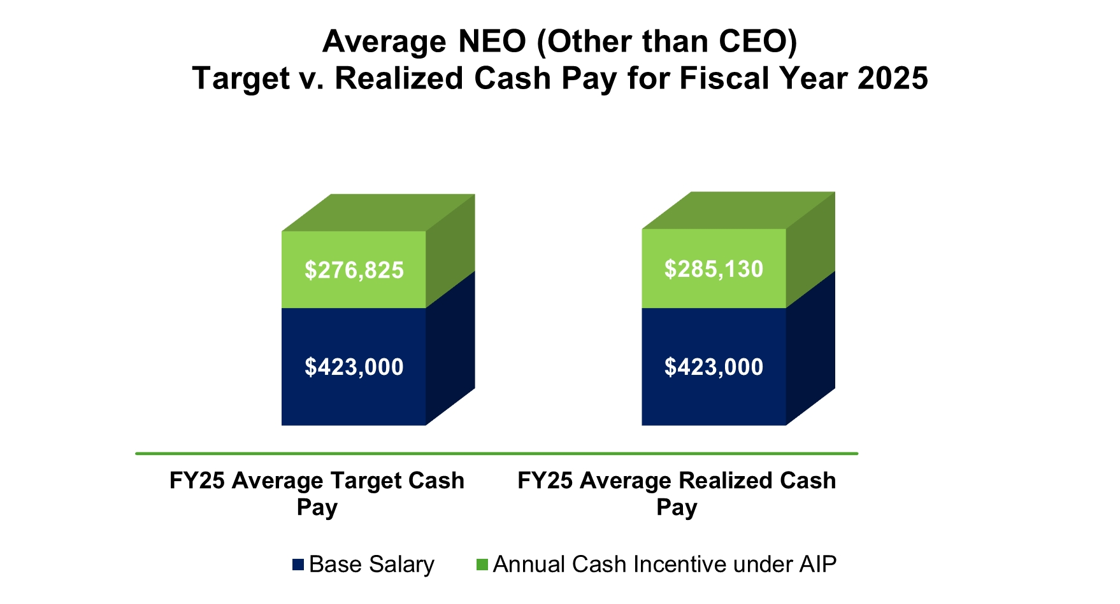

61

EXECUTIVE COMPENSATION

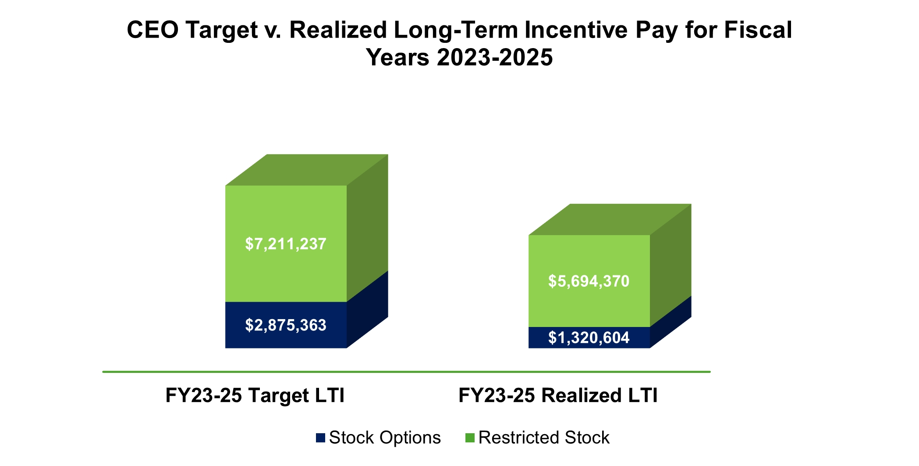

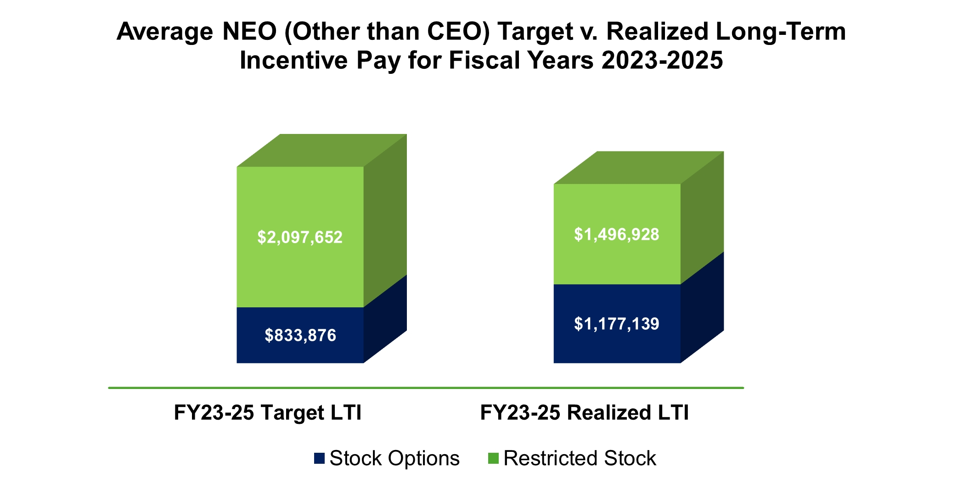

* The average NEO target and realized amounts reflected in the above charts were calculated based on the compensation of Messrs. Celaya, Daunt, Weiskircher and Shaffer.
** Realized long-term equity incentive pay includes only those options exercised in the applicable period.
62

EXECUTIVE COMPENSATION

Best Practices

Our approach to executive compensation incorporates these best practices:
✓
The Compensation Committee receives objective advice from an independent compensation consultant, Aon plc.
✓
Our Board has adopted a clawback policy applicable to all cash incentive payments and performance-based equity awards granted to our executive officers.
✓
No employee is entitled to any “single trigger” equity acceleration with a change in control.
✓
All named executive officers must own Company common stock equal to 150% of their annual base salaries (600% for the Chairman and CEO).
✓
We do not provide excise tax gross-ups.
“Say-on-Pay” Advisory Vote on Executive Compensation
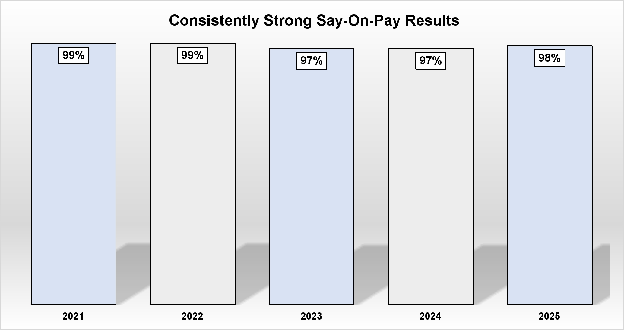
We asked stockholders to vote on a “say on pay” advisory vote on our executive compensation at the 2025 Annual Meeting of Stockholders. Stockholders expressed substantial support for the compensation of our NEOs with approximately 98% of the votes cast in favor of the “say on pay” proposal. The Compensation Committee carefully evaluated the results of the 2025 advisory vote at its March 2025 meeting. The Compensation Committee also considers many other factors in evaluating our executive compensation programs as discussed in this Compensation Discussion and Analysis, including the Compensation Committee’s assessment of total shareholder return, the interaction of our compensation programs with our corporate business objectives, evaluations of our programs by external consultants, and a review of peer group and survey data, each of which is evaluated in the context of the Compensation Committee’s fiduciary duty to act as the directors determine to be in stockholders’ best interests. While each factor bore on the Compensation Committee’s decisions regarding executive compensation, the Compensation Committee did not change our executive compensation program and policies as a direct result of the 2025 “say on pay” advisory vote.
63

EXECUTIVE COMPENSATION

General Compensation Philosophy
The Company’s executive compensation program is designed to:
•
align executives’ interests with those of our stockholders;
•
support the attainment of our short-term and long-term financial, operational, and strategic objectives;
•
reward executives for continuous growth in earnings and stockholder value;
•
attract, retain and motivate key executives; and
•
encourage a long-term commitment to the Company.

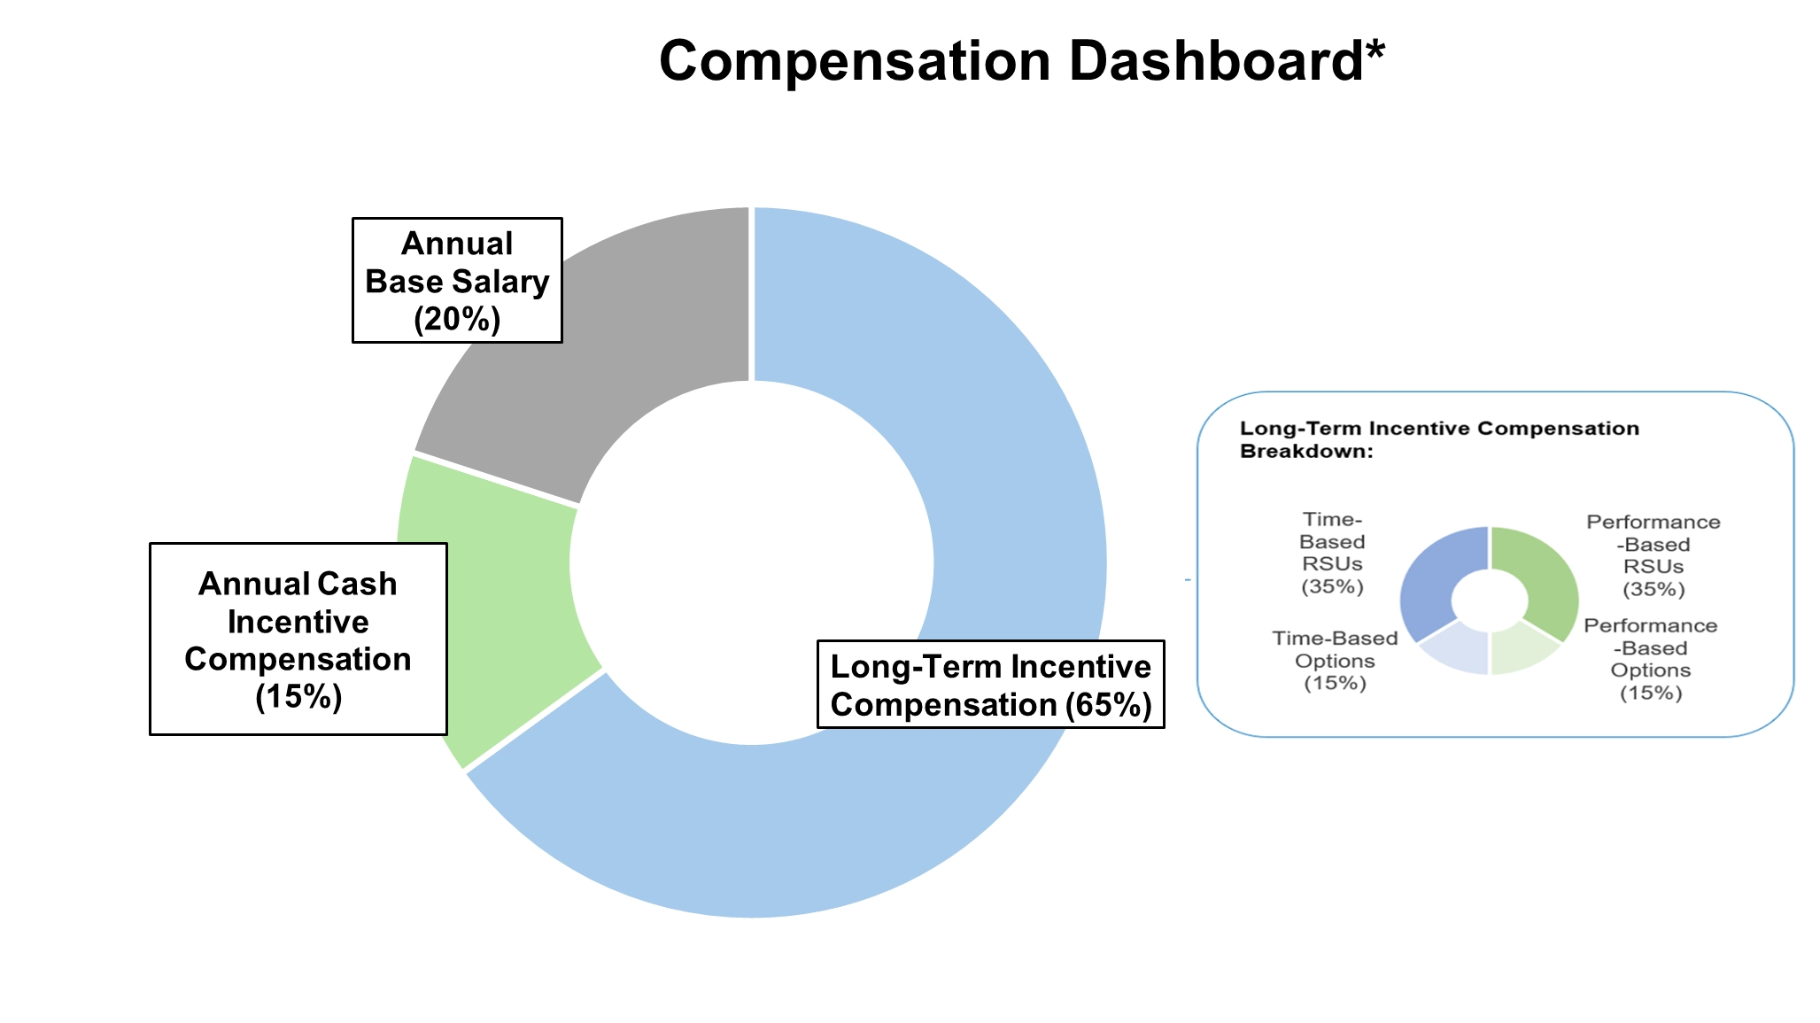

* Percentages calculated based upon the average target total compensation of our NEOs (inclusive of Mr. Angrick) for fiscal 2025.
Short-Term Incentive Compensation |  | Long-Term Incentive Compensation
Annual Base Salary | Annual Cash Incentive | •  Aligns executives’ interests with stockholders’ interests and drives decisions and achieves goals that will help us remain competitive;  •  Attracts executives with an interest in creating long-term stockholder value;  •  Rewards executives for building and sustaining stockholder value; and  •  Retains executives both through growth in their equity value and the vesting provisions of our stock awards.
•  Attracts and retains executives by fairly compensating them for performing the fundamental requirements of their positions. | •  Motivates executives to achieve specific annual financial, operational and strategic goals and objectives whose achievements are critical to short-term and long-term success;  •  Rewards executives in proportion to the goals achieved each year; and  •  Attracts executives with an interest in linking their composition package directly to higher corporate performance.

64

EXECUTIVE COMPENSATION

Factors Considered When Determining Compensation. The Compensation Committee seeks to set executive compensation at competitive levels that it considers appropriate for a company of our size and stage of growth. Annually, the Compensation Committee determines and approves the total compensation level of each of our NEOs based on its evaluation of external market conditions and Company performance. The Compensation Committee also considers each executive’s level of experience, unique skills and abilities critical to the Company, and the executive’s tenure, position, responsibilities and performance with the Company. The Compensation Committee considers recommendations from the Chairman and CEO regarding levels for base salary, annual incentive awards and long-term incentive awards for NEOs. The Chairman and CEO annually provides to the Compensation Committee historical and prospective breakdowns of the total direct compensation components for each NEO.
Pay Mix. Because our NEOs are in a position to directly influence our performance, a significant portion of their compensation is delivered as at-risk compensation in the form of an annual cash incentive award and a long-term incentive award. We rely on a mix of compensation components intended to reward short-term results (in the form of annual cash incentive awards) and motivate long-term performance (in the form of stock options and RSU grants that vest over several years). We do not have a specific allocation target between cash and equity compensation or between annual and long-term incentive compensation. Instead, we retain flexibility when determining the compensation mix to react to our evolving business environment and our specific hiring and retention requirements. In fiscal 2025, approximately 49% or more of the target total direct compensation for each of our NEOs, including approximately 52% of the target total direct compensation for the Chairman and CEO, was performance-based or tied directly to the performance of our stock (in the form of target annual cash incentive awards and performance-based stock options and RSU awards), consistent with our compensation philosophy to link executive compensation with stockholder returns and achievement of strategic business objectives.
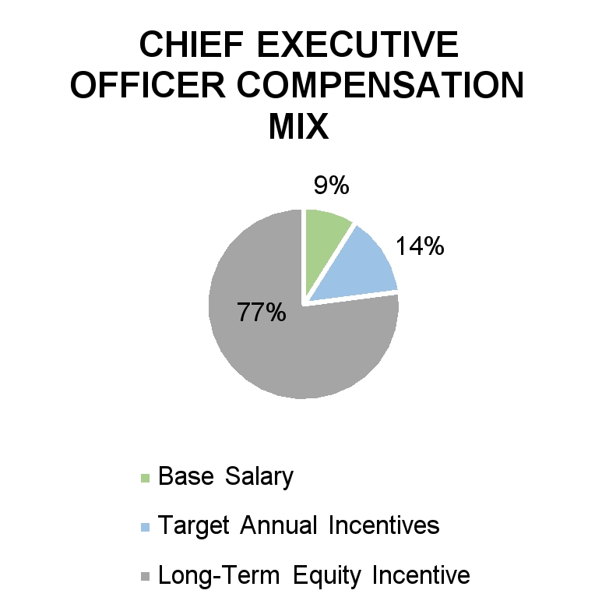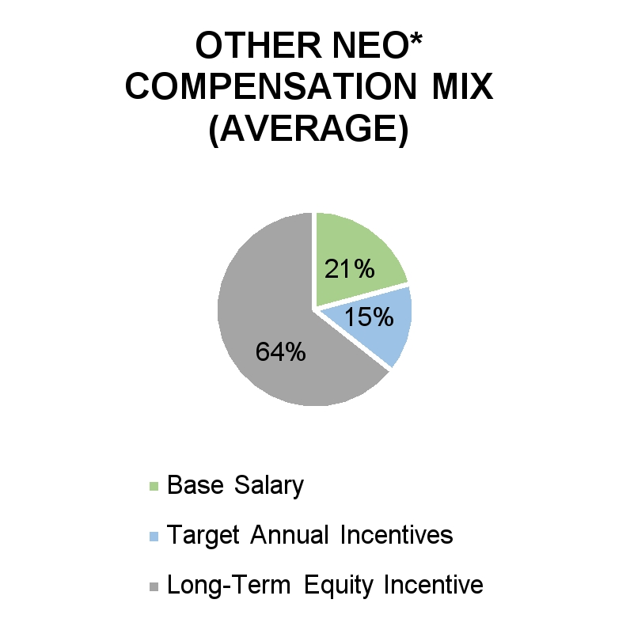
* Percentages reflect the average compensation of Messrs. Celaya, Daunt, Weiskircher and Shaffer for fiscal 2025.

Role of the Compensation Consultant. The Compensation Committee has engaged Aon plc (the “Compensation Consultant”), a leading industry compensation consultant, on an annual basis to assess the market competitiveness of our executive compensation program with the goal of creating a compensation program that attracts and retains the executive talent essential to achieving our business plans. For fiscal 2025, the Compensation Committee engaged the Compensation Consultant to assess the market competitiveness of our executive compensation program and to assist in evaluating and setting executive compensation levels. Prior to such engagement, the Compensation Committee determined that there was no conflict of interest between the Compensation Committee and the Compensation Consultant. In making this determination, the Compensation Committee considered the following six factors regarding the Compensation Consultant:
(i)
the provision of other services to us by the Compensation Consultant;
(ii)
the fees paid by us to the Compensation Consultant, as a percentage of the total revenue of the Compensation Consultant;
(iii)
the policies and procedures of the Compensation Consultant designed to prevent conflicts of interest;
65

EXECUTIVE COMPENSATION

(iv)
any business or personal relationship between the Compensation Consultant and any member of the Compensation Committee;
(v)
any of our stock owned by the Compensation Consultant; and
(vi)
any business or personal relationship between the Compensation Consultant and any of our executive officers.
The scope of the Compensation Consultant’s work included a review of the Company’s executive compensation practices, assistance with developing an appropriate peer group, and presentation to the Compensation Committee of a report regarding executive compensation trends for similarly sized companies and the market competitiveness of our executive compensation program. The Compensation Consultant was engaged directly by the Compensation Committee and provided no services other than the executive and director compensation consulting services.
To assist the Compensation Committee in its market review for fiscal 2025, the Compensation Consultant prepared an analysis of the market competitiveness of the aggregate value of total direct compensation (i.e., base salary, annual cash bonus and long-term equity incentives) and the market competitiveness of each element of compensation for each NEO. The market review was based upon two different sources of compensation data—the Radford Global Technology Survey and publicly available market data from a selected peer group of companies. The Radford Global Technology Survey is a national survey that contains compensation data for high-technology sector companies. The survey data was used as a market reference to assess how the Company’s compensation practices for top executives compare to market practices and to confirm that the overall compensation mix is reasonably aligned with the marketplace.
The peer companies utilized in the review were updated for fiscal 2025 by the Compensation Consultant with input from the Compensation Committee and were approved by the Compensation Committee. The updated peer group was developed using several criteria (e.g., sector, market capitalization, revenue and headcount) and consists of companies of similar size and complexity that occupy the e-commerce space. As part of the update for fiscal 2025, three companies (American Software, Everbridge and Model N) were removed from the fiscal 2024 peer group due to acquisition; and (ii) seven companies (CarParts.com, comScore, DHI Group, LivePerson, PetMed Express, Shutterstock, and Upland Software) were removed due to market capitalization below the target range. Nine new companies (Auction Technology Group, CarGurus, EverCommerce, EverQuote, LiveRamp, OPENLANE, TripAdvisor, Yelp and Yext) were added to the peer group. The peer group companies for the fiscal 2025 review were:
•  ACV Auctions | •  OPENLANE
•  Agilysys | •  Porch Group
•  Auction Technology Group | •  PROS
•  BigCommerce | •  PubMatic
•  CarGurus | •  QuinStreet
•  Cars.com | •  RB Global (previously Ritchie Bros.)
•  Eventbrite | •  The RealReal
•  EverCommerce | •  TripAdivsor
•  EverQuote | •  TrueCar
•  LiveRamp | •  Yelp
•  Magnite | •  Yext
At the time of the fiscal 2025 review, we were at the 33rd percentile of the peer group for revenue, the 20th percentile for headcount, and the 52nd percentile for market capitalization.
The Compensation Committee considers market data in setting compensation levels but does not target or position NEO pay levels at a specific percentile level relative to the peer group. Instead, the Compensation Committee reviews total direct compensation and the mix of the compensation components relative to the peer group as one factor in determining if compensation is adequate to attract and retain qualified executives. The compensation decisions specific to each component of total direct compensation for the NEOs are discussed below.
66

EXECUTIVE COMPENSATION

Base Salary
Summary. Base salaries for NEOs are designed to be competitive when compared with prevailing market rates. Base salaries are reviewed annually and at the time of promotion or other changes in responsibilities. In determining whether to award base salary increases, the Compensation Committee considers the Company’s overall business outlook, the Company’s budget, the executive’s individual performance, historical compensation, market compensation levels for comparable positions, internal pay equity and other factors, including any retention concerns. Under the employment agreements in place with our NEOs, the Compensation Committee may not reduce the salary of a NEO downward unless the NEO consents to a reduction.
Fiscal 2025. For fiscal 2025, the Compensation Committee approved base salaries in the following amounts for our NEOs:
Named Executive Officer | 2025 Salary | 2024 Salary | Percentage Increase from 2024
William P. Angrick, III | $470,000 | $460,000 | 2%
Jorge A. Celaya | $459,000 | $450,000 | 2%
John P. Daunt | $412,000 | $400,000 | 3%
Steven J. Weiskircher | $414,000 | $401,000 | 3%
Mark A. Shaffer | $407,000 | $387,000 | 5%

For fiscal 2025, the Compensation Committee considered several factors, including experience, tenure, individual performance and organizational structure, and determined to increase the base salary by the percentages noted above with the goal of ensuring fair and market-aligned base salary levels for each of our NEOs. The increase for Mr. Shaffer was slightly higher than the other NEOs to bring his compensation closer to market standards for similarly-situated executives.
Fiscal 2026. For fiscal 2026, the Compensation Committee approved base salaries in the following amounts for our NEOs:
Named Executive Officer | 2026 Salary | Percentage  Increase from 2025
William P. Angrick, III | $485,000 | 3%
Jorge A. Celaya | $475,000 | 3%
John P. Daunt | $439,000 | 7%
Steven J. Weiskircher | $437,000 | 6%
Mark A. Shaffer | $435,000 | 7%
For fiscal 2026, the Compensation Committee determined to increase the base salary by the percentages noted above. The percentage increase for Mr. Daunt, Mr. Weiskircher and Mr. Shaffer is higher than the other NEOs to further align their compensation with the market.
67

EXECUTIVE COMPENSATION

Annual Incentive Compensation
Summary. Each of our NEOs are eligible to participate in the Liquidity Services, Inc. Annual Incentive Plan (the “AIP”). The AIP, which is administered by the Compensation Committee, provides our NEOs the opportunity to earn annual incentive compensation in the form of “at risk” performance-based cash bonuses. These cash bonuses are designed to motivate our NEOs to achieve certain corporate financial performance objectives (the “Performance Objectives”) consistent with the Company’s strategic plan. The more successful the Company’s performance (as measured against the Performance Objectives), the higher the potential payout under the AIP. Payouts of annual cash bonuses vary significantly from year to year based on the Company’s financial performance. For example, over the last five years, the payout to our Chairman and CEO has ranged from approximately 47% to 225% of his base salary.
At the beginning of each fiscal year, the Compensation Committee sets the Performance Objectives as well as the range of possible payouts for each of our NEOs. As part of this process, the Compensation Committee selects the financial metrics against which the Company’s performance will be measured. These metrics typically include those that management uses to gauge the Company’s performance (e.g., Consolidated Adjusted EBITDA and Consolidated Direct Profit). As used herein, the terms “Consolidated Adjusted EBITDA” and “Consolidated AEBITDA” have the same meaning as Non-GAAP Adjusted EBITDA as described in the 2025 Form 10-K. As used herein, the term “Consolidated Direct Profit” means the Company’s total segment revenue less cost of goods sold (excluding depreciation and amortization).
The Compensation Committee also establishes a threshold, target and maximum achievement level for each metric. If the Company’s performance falls below the threshold level for a metric, there is no payout on that metric. If the threshold level is met, our NEOs are eligible for a payout on that metric. The amount of such payout is dependent upon the Company’s actual performance as measured against the achievement levels for the metric. If the Company’s actual performance exceeds the threshold level on one metric but fails to do so on another, the payout to our NEOs would be limited accordingly as further described below.
The Compensation Committee endeavors to set appropriate threshold, target and maximum achievement levels. These levels are evaluated annually with input from the Compensation Consultant and are consistent with the Company’s business plan and strategic objectives. The Compensation Committee cannot specify the degree of difficulty required to meet target achievement levels but believes that achievement would require substantial and sustained performance by the Company.
As mentioned above, the range of possible payouts a NEO is eligible to receive is set by the Compensation Committee at the beginning of each fiscal year. The Compensation Committee sets a target bonus for each NEO, which the NEO will be eligible to receive if the Company’s performance equals the target achievement levels on each metric. The target bonus is set as a percentage of base salary based upon (1) the relative scope and responsibility of the NEO’s position and his, her or their respective impact on overall Company performance; and (2) comparative compensation data. If the Company’s performance exceeds the threshold achievement level but does not reach the target achievement level for a metric, the NEO will be eligible for a payout below target for that metric. If the Company’s performance exceeds the target achievement level for a metric, the NEO will be eligible for a payout above target for that metric subject to the applicable maximum established by the Compensation Committee. NEOs receive no payouts for below-threshold or above-maximum achievement. Additional information on the range of possible payouts to our NEOs for fiscal 2025 is provided below. Notwithstanding the foregoing, our NEOs are not entitled to any payout under the AIP. The Compensation Committee retains the discretion to increase or decrease payouts based on the Company’s (or the NEO’s) performance during the fiscal year.
Fiscal 2025 Performance Objectives and Achievement Levels. At its October 2024 meeting, the Compensation Committee established the Performance Objectives for fiscal 2025. The metrics chosen were Consolidated Direct Profit and Consolidated AEBITDA, weighted equally. The Compensation Committee selected these metrics because they are key metrics used by management to measure the Company’s performance. These are the same metrics and weights utilized for fiscal 2024.
The Compensation Committee also determined that if the Company’s actual performance met the threshold set forth below for a metric, our NEOs would be eligible to receive a 20% payout on that metric. If actual performance fell between the threshold and the target on a metric, our NEOs would be eligible to receive a payout between 20% and 100% of the target payout on that metric. If actual performance met the target on a metric, our NEOs would be eligible to receive a 100% payout on that metric. If actual performance fell between the target and the maximum on a metric, our NEOs would
68

EXECUTIVE COMPENSATION

be eligible to receive a payout between 100% and 150% of the target payout on that metric. The Compensation Committee chose to cap payouts at 150% of the target payout for fiscal 2025. As a result, even if the Company’s actual performance exceeded the maximum set forth below, our NEOs would be limited to a 150% payout on that metric.
Consolidated Direct Profit
Achievement Levels
Threshold | Target | Maximum
$190.8M | $210.5M | $223.9M

Consolidated AEBITDA
Achievement Levels
Threshold | Target | Maximum
$49.9M | $59.3M | $69.0M

The Compensation Committee strives to set target at a level which requires considerable improvement to the Company’s financial performance year-over-year, further emphasizing our pay-for-performance approach to executive compensation. The target achievement levels set forth above require approximately 22% year-over-year growth.
Fiscal 2025 Target and Maximum Awards. As described above, the amount ultimately paid to each NEO depends on the Company’s actual performance as measured against the Performance Objectives. The below table shows the target and maximum awards for fiscal 2025:
Named Executive Officer | Fiscal 2025  Target Award as  Percentage of  Base Salary | Fiscal 2025  Annual  Incentive  Target | Fiscal 2025  Maximum Award as  Percentage of  Base Salary | Fiscal 2025  Annual  Incentive  Maximum
William P. Angrick, III | 150% | $705,000 | 225% | $1,057,500
Jorge A. Celaya | 80% | $367,200 | 120% | $550,800
John P. Daunt | 80% | $329,600 | 120% | $494,400
Steven J. Weiskircher | 50% | $207,000 | 75% | $310,500
Mark A. Shaffer | 50% | $203,500 | 75% | $305,250

The target award percentages for fiscal 2025 remained the same as in fiscal 2024 for each of our NEOs.
Fiscal 2025 Results and Payouts. At the end of fiscal 2025, our Chairman and CEO assessed the Company’s performance against the Performance Objectives and made a recommendation to the Compensation Committee regarding payouts to our NEOs. The Compensation Committee considered the recommendations, independently assessed the Company’s performance against the Performance Objectives and approved the payouts described below.
The Company’s actual performance in fiscal 2025 exceeded the threshold achievement level but fell just short of the target achievement level on the Consolidated Direct Profit metric and exceeded the target achievement level on the Consolidated AEBITDA metric. As a result, the Compensation Committee approved payouts to our NEOs equal to 97% of the target bonus for the Consolidated Direct Profit metric and 109% of the target bonus for the Consolidated AEBITDA metric.
69

EXECUTIVE COMPENSATION

Fiscal 2025 results and related payments appear in the table below.
Name and Principal Position | Consolidated Direct Profit | Consolidated Adjusted EBITDA | Fiscal 2025 Incentive  Target | Fiscal 2025  Actual  Payout | Fiscal 2025 Actual Payout as a  % of Target
William P. Angrick, III  Chairman and  Chief Executive Officer | 97% | 109% | $705,000 | $726,150 | 103%
Jorge A. Celaya  Chief Financial Officer | 97% | 109% | $367,200 | $378,216 | 103%
John P. Daunt  Chief Commercial Officer | 97% | 109% | $329,600 | $339,488 | 103%
Steven J. Weiskircher  Chief Technology Officer | 97% | 109% | $207,000 | $213,210 | 103%
Mark A. Shaffer  Chief Legal Officer and  Corporate Secretary | 97% | 109% | $203,500 | $209,605 | 103%

Fiscal 2026 Annual Incentive Compensation. At its October 2025 meeting, the Compensation Committee determined that the Performance Objectives for fiscal 2026 would be the same as those selected for fiscal 2025 (i.e., Consolidated Direct Profit and Consolidated AEBITDA weighted equally). These metrics were selected because they continue to be the key metrics used by management to measure the Company’s performance. The consistent use of these metrics also enables clear year-over-year comparisons. Additionally, as in fiscal 2025, the Compensation Committee chose to limit maximum payouts to our NEOs to 150% of the target bonus for fiscal 2026. The threshold, target and maximum achievement levels for each of the Performance Objectives will be disclosed in our 2027 proxy statement.
In addition to setting the Performance Objectives for fiscal 2026, the Compensation Committee reviewed the target and maximum awards for our NEOs at its October 2025 meeting and set the following award opportunities for fiscal 2026:
Named Executive Officer | Fiscal 2026  Target Award as  Percentage of  Base Salary | Fiscal 2026  Annual  Incentive  Target | Fiscal 2026  Maximum Award as Percentage of  Base Salary | Fiscal 2026  Annual  Incentive  Maximum
William P. Angrick, III | 150% | $727,500 | 225% | $1,091,250
Jorge A. Celaya | 80% | $380,000 | 120% | $570,000
John P. Daunt | 80% | $351,200 | 120% | $526,800
Steven J. Weiskircher | 60% | $262,200 | 90% | $393,300
Mark A. Shaffer | 50% | $217,500 | 75% | $326,250
The target award percentages for fiscal 2026 remained the same as in fiscal 2025 for each of Mr. Angrick, Celaya, Daunt and Shaffer. The target award percentage for Mr. Weiskircher was increased from 50% for fiscal 2025 to 60% for fiscal 2026 due to his increased responsibility as the executive leading our Software Solutions operating segment, which was established in fiscal 2025.
70

EXECUTIVE COMPENSATION

Long-Term Incentive Compensation
Summary. We grant long-term equity compensation on an annual basis to our executive officers to attract, retain and reward our executives and strengthen the mutuality of interests between our executives and our stockholders. The Compensation Committee annually determines whether to grant equity-based incentives to executives. In making its determinations, the Compensation Committee considers factors such as market data, the executive’s and the Company’s performance in the last year and the results achieved by the executive, the executive’s base salary and the Compensation Committee’s view regarding the future potential of long-term contributions of the executive. Recommendations of the Chairman and CEO are also considered with respect to executive officers other than the Chairman and CEO.
The Compensation Committee has historically made the annual grants of long-term incentive compensation at a regularly scheduled meeting after financial results are available for the prior fiscal year. As the Compensation Committee’s meeting schedule is established before the start of each fiscal year, the proximity of any grants to earnings announcements or other market events is coincidental. The Compensation Committee’s policy is to grant option and RSU awards on or after the date it approves them. For options, the exercise price is determined under the terms of the LTIP (typically, the closing price of our common stock on the Nasdaq Stock Market on the date of grant) and cannot be less than the fair market value of our common stock as of that date. In the case of Mr. Angrick, who beneficially owns greater than 10% of the Company’s outstanding common stock, the option exercise price for any options granted to him which are intended to be incentive stock options cannot be less than 110% of the fair market value of our common stock on the date of grant. Besides grants of options made as part of long-term incentive compensation awards, executive officers may receive options with the commencement of employment or upon promotion. In these cases, the exercise price is typically the closing price of our common stock on the Nasdaq Stock Market on the date the Compensation Committee approves the award.
Fiscal 2025 Long-Term Equity Compensation. For fiscal 2025, the Compensation Committee chose to grant a mix of option and RSU awards to each of our NEOs. Each NEO received 70% of his equity compensation in the form of RSUs and 30% in the form of options. Half of the granted options and RSUs have time-based vesting criteria while the other half have performance-based vesting criteria. The time-based options vest over a four-year period with 25% vesting on January 1, 2026 and 1/48th vesting each month thereafter for 36 months. The time-based RSUs vest over a four-year period with 25% vesting on each of January 1, 2026, January 1, 2027, January 1, 2028 and January 1, 2029.
Performance-based options and RSUs vest only if the Company achieves certain financial milestones. For fiscal 2025, the Compensation Committee selected Consolidated Direct Profit and Consolidated AEBITDA, each weighted equally, as the financial milestones that must be satisfied for performance-based vesting. Beginning on January 1, 2026 and on each April 1, July 1, October 1 and January 1 through January 1, 2029 (each, a “Measurement Date”), the Company’s trailing 12-month Consolidated Direct Profit and Consolidated AEBITDA results will be compared to the below tables to determine what percentage of vesting has occurred.
Consolidated Direct Profit
Results | % of Total Award Vesting
$215M | 10%
$240M | 20%
$250M | 30%
$265M | 40%
$280M | 50%

Consolidated AEBITDA
Results | % of Total Award Vesting
$60M | 10%
$62M | 20%
$66M | 30%
$69M | 40%
$73M | 50%

The two metrics will be evaluated independently consistent with the Company’s historic practice with respect to assessing the achievement of performance-based vesting criteria. For example, if as of a Measurement Date, the
71

EXECUTIVE COMPENSATION

Company’s trailing 12-month Consolidated Direct Profit is $216 million and Consolidated AEBITDA is $59 million, only the first Consolidated Direct Profit threshold would be met and 10% of the total grant would vest. If, however, on the same Measurement Date, the Company’s trailing 12-month Consolidated Direct Profit is $216 million and its Consolidated AEBITDA is $61 million, both the first Consolidated Direct Profit and the first Consolidated AEBITDA thresholds would be met and 20% of the total grant would vest. Vesting is also cumulative. For example, as described above, if on a Measurement Date, the first Consolidated Direct Profit threshold is met but the first Consolidated AEBITDA threshold is not, 10% of the total grant would vest. If, as of a subsequent Measurement Date, the first Consolidated AEBITDA threshold is met, an additional 10% of the total grant would vest for a cumulative total of 20%.
The long-term equity compensation awards for fiscal 2025 were approved by the Compensation Committee at its October 30, 2024 meeting. In determining the award for each of our NEOs, the Compensation Committee considered the award granted to each NEO in fiscal 2024, each NEO’s job responsibilities, the awards granted to similarly situated executives at peer group companies, each NEO’s experience and individual performance and recommendations of the Chairman and CEO.
The target value of each NEO’s equity compensation for fiscal 2025 as a percentage of base salary is as shown in the table below.
Named Executive Officer | Target Value  of Equity Compensation  as a Percentage of  Base Salary
William P. Angrick, III | 832%
Jorge A. Celaya | 274%
John P. Daunt | 329%
Steven J. Weiskircher | 292%
Mark A. Shaffer | 191%
The following award types were granted to our NEOs in fiscal 2025:
Award Type | Vesting Schedule | Performance Goals
Time-Based Options | 12/48th on 1/1/2026 and 1/48th monthly thereafter for 36 months | N/A
Time-Based RSUs | 25% on 1/1/2026 and 25% on each of 1/1/2027, 1/1/2028 and 1/1/2029 | N/A
Performance-Based Options | Vesting from 1/1/2026 through 1/1/2029 | Based on trailing 12-month Consolidated Direct Profit and Consolidated AEBITDA results measured quarterly from 1/1/2026 through 1/1/2029
Performance-Based RSUs | Vesting from 1/1/2026 through 1/1/2029 | Based on trailing 12-month Consolidated Direct Profit and Consolidated AEBITDA results measured quarterly from 1/1/2026 through 1/1/2029

72

EXECUTIVE COMPENSATION

The number of options and RSUs granted to our NEOs in fiscal 2025 is included in the “Grants of Plan Based Awards for Fiscal 2025” table below.
Fiscal 2026 Long-Term Equity Compensation. In October 2025, the Compensation Committee determined to grant our NEOs the same mix of options and RSUs for fiscal 2026 as it granted for fiscal 2025. For each NEO, 70% of his, her or their equity compensation for fiscal 2026 will be RSUs and 30% will be options. Half of the granted options and RSUs have time-based vesting criteria while the other half have performance-based vesting criteria. The time-based options vest over a four-year period with 25% vesting on January 1, 2027 and 1/48th vesting each month thereafter for 36 months. The time-based RSUs vest over a four-year period with 25% vesting on each of January 1, 2027, January 1, 2028, January 1, 2029 and January 1, 2030. The performance-based options and RSUs vest based on the Company’s Consolidated Direct Profit and Consolidated AEBIDTA results over a four-year performance period ending January 1, 2030. As was the case for fiscal 2025, the Compensation Committee decided to use Consolidated Direct Profit and Consolidated AEBIDTA as performance metrics as they continue to be key metrics used by management to measure the Company’s performance, enabling clear year-over-year comparisons. The Compensation Committee determined to use a four year performance period (as was the case for fiscal 2025) to continue to provide a meaningful opportunity to achieve the performance targets.
Other Compensation and Benefit Programs
Our NEOs are eligible to participate in benefit plans available to substantially all of our employees, including the 401(k) Plan, medical insurance, dental insurance, life insurance and disability insurance programs. We do not provide our NEOs with any additional benefits or perquisites not available to all other employees.
Employment Agreements
We have entered into employment agreements with each of our NEOs that provide for, among other things, specified payments in the event of termination of employment under certain circumstances. The terms of these agreements are described under “Employment Agreements” below. The Compensation Committee believes it is important to provide our executives with some measure of financial security if their employment with the Company is terminated without cause or in connection with certain unforeseen circumstances. The Compensation Committee believes that these arrangements encourage an executive to comply with post-termination restrictive non-competition covenants and to cooperate with the Company both before and after the executive’s employment is terminated. The Compensation Committee believes these arrangements are reasonable and that it is beneficial to have agreements in place that specify the exact terms and benefits an executive receives if the Company elects to terminate such executive’s employment. Such agreements encourage executives to make sound decisions in the interest of our long-term performance, regardless of personal employment risk.
Stock Ownership and Anti-Hedging Requirements
In fiscal 2014, the Board adopted an Executive Stock Ownership Policy obligating NEOs to hold a number of shares of our common stock as shown in the below table.
Executive | Ownership Requirement as a Percentage of Base Salary
CEO | 600%
Other NEOs | 150%

Each NEO has five years after such NEO’s date of hire or designation as a NEO to satisfy this requirement. Each of our NEOs has satisfied or is on track to satisfy the stock ownership requirement within the applicable timeframe.

Pursuant to the Executive Stock Ownership Policy, a NEO may not purchase any financial instrument or enter into any transaction that hedges, pledges, or offsets any decrease in the market value of our common stock (including, but not limited to, prepaid variable forward contracts, equity swaps, collars, or exchange funds) except with the advance approval of the Board. On September 11, 2020, the Board approved in advance Mr. Angrick’s pledge of 1,400,000 shares of common stock. This approval was reviewed and extended on December 6, 2021 until such date as the Board revokes its approval. In reviewing and extending this approval, the Board took note of certain facts and circumstances that helped moderate risk to the Company from the pledge, including: (i) shares pledged by Mr. Angrick would be derived from shares purchased by
73

EXECUTIVE COMPENSATION

Mr. Angrick for investment purposes as compared to shares received by Mr. Angrick as executive compensation; (ii) the pledge having a 50% loan-to-value ratio and only requiring funding for the difference between 50% of the original share value at the time of pledge and the then current price; (iii) the limited size of the pledge in reference to Mr. Angrick’s overall holdings; and (iv) Mr. Angrick’s lack of reliance on the pledged shares for compliance with the Executive Stock Ownership Policy. No other NEO has requested or been granted approval to enter into such a transaction.
A copy of the Executive Stock Ownership Policy is available on the Company’s website at https://investors.liquidityservices.com/corporate-governance.
Clawback Policy
On October 26, 2022, the SEC adopted final rules to implement the requirements of the Dodd-Frank Wall Street Reform and Consumer Protection Act of 2010 (the “Dodd-Frank Act”), which direct the national securities exchanges and associations (including our own securities exchange, Nasdaq) to establish listing standards requiring each issuer to develop and implement a policy providing for the recovery, in the event of an accounting restatement, of incentive-based compensation received by current or former executive officers where the compensation was based on erroneously reported financial information. Following Nasdaq’s adoption of updated listing standards as required by the final rules, the Company amended its clawback policy effective October 1, 2023 (the “Amended Policy”) to comply with these requirements. A copy of the Amended Policy is available on the Company’s website at https://investors.liquidityservices.com/corporate-governance.
Policies and Practices Related to the Grant of Certain Equity Awards Close in Time to the Release of Material Nonpublic Information
Our equity awards are generally granted on fixed dates determined in advance. The Compensation Committee’s general practice is to complete its annual executive compensation review and determine performance goals and target compensation for our executives, which coincides with the Company’s regularly scheduled Board meetings, then such equity awards are granted. Annual equity awards are typically granted to our executives in the first quarter of each fiscal year. On limited occasions, the Compensation Committee may grant equity awards outside of our annual grant cycle for new hires, promotions, recognition, retention, or other purposes.
Our Compensation Committee approves all equity award grants on or before the grant date and does not grant equity awards in anticipation of the release of material nonpublic information. Similarly, the Compensation Committee does not time the release of material nonpublic information based on equity award grant dates.
74

EXECUTIVE COMPENSATION

Summary Compensation Table
The following table summarizes the compensation of our NEOs, which includes our principal executive officer (Mr. Angrick), our principal financial officer (Mr. Celaya) and our three other most highly compensated executive officers (Mr. Daunt, Mr. Weiskircher and Mr. Shaffer) serving as of September 30, 2025.
Name and Principal Position | Year | Salary(1) | Bonus | Stock  Awards(2) | Option  Awards(2) | Non-Equity  Incentive Plan  Compensation(3) | All Other  Compensation(4) | Total
William P. Angrick, III  Chairman and  Chief Executive Officer | 2025 | $470,000 |  | 2,726,282 | 1,183,455 | 726,150 | 16,084 | 5,121,971
 | 2024 | 460,000 |  | 2,414,859 | 895,033 | 510,600 | 15,650 | 4,296,142
 | 2023 | 435,000 |  | 2,070,096 | 796,876 | 456,750 | 13,295 | 3,772,017
Jorge A. Celaya  Chief Financial Officer | 2025 | $459,000 |  | 886,420 | 371,637 | 378,216 | 15,244 | 2,110,517
Jorge A. Celaya  Chief Financial Officer | 2024 | 450,000 |  | 1,049,045 | 393,848 | 266,400 | 14,810 | 2,174,103
Jorge A. Celaya  Chief Financial Officer | 2023 | 404,175 |  | 627,512 | 248,602 | 226,338 | 12,455 | 1,519,082
John P. Daunt  Chief Commercial Officer | 2025 | $412,000 |  | 955,604 | 400,554 | 339,488 | 15,844 | 2,123,490
John P. Daunt  Chief Commercial Officer | 2024 | 400,000 |  | 757,154 | 284,284 | 236,800 | 15,410 | 1,693,648
John P. Daunt  Chief Commercial Officer | 2023 | 383,959 |  | 627,512 | 248,602 | 215,017 | 12,893 | 1,487,983
Steven J. Weiskircher  Chief Technology Officer | 2025 | $414,000 |  | 851,828 | 357,714 | 213,210 | 14,404 | 1,851,156
Steven J. Weiskircher  Chief Technology Officer | 2024 | 401,000 |  | 699,363 | 262,626 | 148,370 | 13,970 | 1,525,329
Steven J. Weiskircher  Chief Technology Officer | 2023 | 379,990 |  | 423,594 | 167,776 | 132,997 | 11,434 | 1,115,791
Mark A. Shaffer  Chief Legal Officer and  Corporate Secretary | 2025 | $407,000 |  | 546,986 | 229,194 | 209,605 | 14,846 | 1,407,631
 | 2024 | 387,000 |  | 573,203 | 215,215 | 143,190 | 14,089 | 1,332,697
 | 2023 | 354,768 |  | 392,385 | 155,451 | 124,169 | 11,434 | 1,038,207

(1)
Each of the NEOs contributed a portion of his, her or their salary to the 401(k) Plan.
(2)
The amounts reported in these columns reflect the aggregate grant date fair value of options and RSUs granted to each of the NEOs in the years shown, computed in accordance with GAAP, disregarding estimates of forfeitures related to service-based vesting conditions. The amounts reported for performance-based awards were calculated assuming that all applicable performance goals would be achieved. For additional information about these calculations, see the “Grants of Plan-Based Awards for Fiscal 2025” table included in this proxy statement. For additional information about the assumptions used in these calculations, see Note 2 and Note 13 to our audited consolidated financial statements included in the 2025 Form 10-K. At no time, did the Company exceed the aggregate limit on the number of shares available for grant under the LTIP, or any other limits under the LTIP.
(3)
The amounts in the Non-Equity Incentive Plan Compensation column represent the cash bonuses described under the section of this proxy statement entitled “Annual Incentive Compensation.” These cash bonuses were paid to our NEOs in fiscal 2026 for performance in fiscal 2025.
(4)
The payments listed for fiscal 2025 in the “All Other Compensation” column above reflect the following amounts and, unless noted below, are based upon the actual cost expended by the Company:
For Mr. Angrick, the amount shown includes: $10,350 for 401(k) Plan matching contributions, $1,282 for short-term and long-term disability insurance premium payments, $3,612 for group term life insurance premium payments, and $840.06 for cell phone reimbursement.
For Mr. Celaya, the amount shown includes: $10,350 for 401(k) Plan matching contributions, $1,282 for short-term and long-term disability insurance premium payments, and $3,612 for group term life insurance premium payments.
For Mr. Daunt, the amount shown includes: $10,350 for 401(k) Plan matching contributions, $1,282 for short-term and long-term disability insurance premium payments, $3,612 for group term life insurance premium payments, and $600.08 for Health Savings Account employer contribution.
For Mr. Weiskircher, the amount shown includes: $10,350 for 401(k) Plan matching contributions, $1,282 or short-term and long-term disability insurance premium payments, $1,932 for group term life insurance premium payments, and $840.06 for cell phone reimbursement.
For Mr. Shaffer, the amount shown includes: $10,350 for 401(k) Plan matching contributions, $1,282 for short-term and long-term disability insurance premium payments, $1,932 for group term life insurance premium payments, $840.06 for cell phone reimbursement, and $442 for internet reimbursement. Reimbursement for internet expenses is required by applicable law in Mr. Shaffer’s state of residence.
75

EXECUTIVE COMPENSATION

Employment Agreements
In January 2023, the Company entered into amended and restated employment agreements (the “A&R Agreements”) with all of our executive officers, including each of our NEOs. Each of our NEOs had entered into employment agreements with the Company prior to January 2023; however, after reviewing the terms of those agreements and discussing the terms with the Compensation Consultant, the Compensation Committee determined that it was in the best interest of the Company to enter into updated agreements. The terms of the A&R Agreements are better aligned with market terms for similarly situated executives. The terms are also consistent among all of our executive officers to ensure that each NEO is entitled to the same benefits as his, her or their peers.
As was the case with the prior employment agreements, the A&R Agreements provide for, among other things, the term of employment, compensation and benefits payable during the term of such agreement and compensation payable when an executive’s employment is terminated under certain conditions. The Compensation Committee continues to believe it is important to provide our NEOs with some measure of financial security in the event that their employment with the Company is terminated without cause or in connection with certain unforeseen circumstances. The Compensation Committee views these arrangements as providing encouragement for NEOs to comply with post-termination restrictive covenants and to cooperate with the Company both before and after his, her or their employment is terminated. The Compensation Committee considers these arrangements to be reasonable and believes that it is beneficial to have agreements in place that specify the exact terms and benefits a NEO receives if the Company elects to terminate such NEO’s employment. Such agreements encourage NEOs to make sound decisions in the interest of the Company’s long-term performance, regardless of personal employment risk.
Key Provisions of A&R Agreements. As noted above, the A&R Agreement entered into with each NEO contains the same terms to ensure that each NEO is entitled to the same benefits as his, her or their peers. The key provisions of each A&R Agreement are summarized below:
•
Each A&R Agreement provides that the NEO’s employment will continue until terminated in accordance with the terms of the agreement.
•
Each NEO is entitled to an annual base salary equal to at least the amount approved by the Compensation Committee for fiscal 2023, which may be increased, but not decreased without the NEO’s consent.
•
Each NEO is eligible for an annual cash incentive opportunity based on a percentage of the NEO’s base salary set by the Compensation Committee; provided that the Compensation Committee approves a payout of the bonus and the NEO is employed on the last day of the fiscal year to which the bonus relates.
•
Each NEO is eligible to receive long-term incentive awards as approved by the Compensation Committee.
•
Each A&R Agreement also provides for certain payments in the event a NEO’s employment is terminated under the following circumstances:
o
If the NEO’s employment is terminated because of such NEO’s death, the NEO’s estate will receive such NEO’s base salary through the next full calendar month and all other unpaid amounts owed under the A&R Agreement.
o
If the NEO’s employment is terminated because of disability, the NEO is entitled to 25% of such NEO’s annual base salary and all other unpaid amounts owed under the A&R Agreement.
o
If the NEO’s employment is terminated by the Company with cause or by the NEO without good reason, the NEO is entitled to such NEO’s base salary through the date of termination and all other unpaid amounts owed under the A&R Agreement.
o
If the NEO’s employment is terminated by the Company other than for cause, disability or death, or is terminated by the NEO for good reason, the NEO will receive:
(1) such NEO’s base salary through the date of termination and all other unpaid amounts owed under the A&R Agreement;
76

EXECUTIVE COMPENSATION

(2) a severance package equal to 12 months of such NEO’s base salary plus an amount equal to such NEO’s target incentive bonus for the fiscal year in which such NEO is terminated (the “Severance Payment”); and

(3) a lump sum payment reflecting 12 months of the total premium required to maintain coverage under the Consolidated Omnibus Budget Reconciliation Act of 1985 (“COBRA”), less 12 months of the NEO’s monthly premium contribution in effect immediately prior to termination. This amount is only payable to the extent the NEO had such coverage prior to termination.

The NEO is only entitled to the Severance Payment if such NEO signs a general release of claims in favor of the Company. The terms “cause” and “good reason” have the same meaning across each of the A&R Agreements, except that in the case of Mr. Celaya, the term “good reason” also includes a change in his reporting line to someone other than the Company’s Chief Executive Officer, consistent with his prior employment agreement with the Company.

We also have confidentiality, non-competition and intellectual property agreements with our NEOs. These agreements typically provide that the NEO may not disclose or transfer any of our confidential information to any person, business entity or other organization without authorization from us, and that the NEO may not, during his, her or their employment with us and for 12 months thereafter, hire or solicit any of our employees for employment with another person or entity or in any way interfere with the relationship we have with any of our employees, clients, or other business relationships. Further, these agreements also typically provide that the NEO may not, during his, her or their employment with us and for up to 12 months thereafter, compete with us. These agreements typically also provide that all ideas, designs, works and inventions made by the NEO in the course of such NEO’s employment with us are our exclusive property, and that the copyrights of all writings produced by the NEO during the course of such NEO’s work for us are the property of the Company.
Grants of Plan-Based Awards for Fiscal 2025
The following table provides additional information about plan-based awards granted to our NEOs in fiscal 2025. Our NEOs received five types of plan-based awards in fiscal 2025: annual cash bonuses under the AIP (the “2025 Cash Award”), time-based stock options under the LTIP (the “2025 Options”), time-based RSUs under the LTIP (the “2025 RSUs”), performance-based stock options under the LTIP (the “2025 Performance Options”) and performance-based RSUs under the LTIP (the “2025 Performance RSUs”).
Name | Grant Date | Compensation  Committee  Approval  Date | Estimated Future Payouts  Under Non-Equity Incentive  Plan Awards(1) |  |  | Estimated  Future  Payouts  Under  Equity  Incentive  Plan  Awards(2) | All Other  Stock  Awards:  Number of  Shares of  Stock or  Units(3)  (#) | All Other  Option  Awards:  Number of  Securities  Underlying  Options(4)  (#) | Exercise or  Base Price  of Option  Awards(5)  ($/Share) | Grant Date  Fair Value  of Stock &  Option  Awards(6)  ($)
Name | Grant Date | Compensation  Committee  Approval  Date |  |  |  | Threshold  ($) |  |  |  |  | Target  ($) | Maximum  ($) | Target  (#)
William P. Angrick, III
2025 Cash Award | N/A | 10/30/2024 | 141,000 | 705,000 | 1,057,500 | - | - | - | - | -
2025 Options | 10/30/2024 | 10/30/2024 | - | - | - | - | - | 53,550 | $23.78 | $591,728
2025 RSUs | 10/30/2024 | 10/30/2024 | - | - | - | - | 63,050 | - | - | $1,363,141
2025 Performance Options | 10/30/2024 | 10/30/2024 | - | - | - | 53,550 | - | - | $23.78 | $591,728
2025 Performance RSUs | 10/30/2024 | 10/30/2024 | - | - | - | 63,050 | - | - | - | $1,363,141
77

EXECUTIVE COMPENSATION

Name | Grant Date | Compensation  Committee  Approval  Date | Estimated Future Payouts  Under Non-Equity Incentive  Plan Awards(1) |  |  | Estimated  Future  Payouts  Under  Equity  Incentive  Plan  Awards(2) | All Other  Stock  Awards:  Number of  Shares of  Stock or  Units(3)  (#) | All Other  Option  Awards:  Number of  Securities  Underlying  Options(4)  (#) | Exercise or  Base Price  of Option  Awards(5)  ($/Share) | Grant Date  Fair Value  of Stock &  Option  Awards(6)  ($)
Name | Grant Date | Compensation  Committee  Approval  Date |  |  |  | Threshold  ($) |  |  |  |  | Target  ($) | Maximum  ($) | Target  (#)
Jorge A. Celaya
2025 Cash Award | N/A | 10/30/2024 | 73,440 | 367,200 | 550,800 | - | - | - | - | -
2025 Options | 10/30/2024 | 10/30/2024 | - | - | - | - | - | 17,350 | $21.62 | $185,819
2025 RSUs | 10/30/2024 | 10/30/2024 | - | - | - | - | 20,500 | - | - | $443,210
2025 Performance Options | 10/30/2024 | 10/30/2024 | - | - | - | 17,350 | - | - | $21.62 | $185,819
2025 Performance RSUs | 10/30/2024 | 10/30/2024 | - | - | - | 20,500 | - | - | - | $443,210
John P. Daunt
2025 Cash Award | N/A | 10/30/2024 | 65,920 | 329,600 | 494,400 | - | - | - | - | -
2025 Options | 10/30/2024 | 10/30/2024 | - | - | - | - | - | 18,700 | $21.62 | $200,277
2025 RSUs | 10/30/2024 | 10/30/2024 | - | - | - | - | 22,100 | - | - | $477,802
2025 Performance Options | 10/30/2024 | 10/30/2024 | - | - | - | 18,700 | - | - | $21.62 | $200,277
2025 Performance RSUs | 10/30/2024 | 10/30/2024 | - | - | - | 22,100 | - | - | - | $477,802
Steven J. Weiskircher
2025 Cash Award | N/A | 10/30/2024 | 41,400 | 207,000 | 310,500 | - | - | - | - | -
2025 Options | 10/30/2024 | 10/30/2024 | - | - | - | - | - | 16,700 | $21.62 | $178,857
2025 RSUs | 10/30/2024 | 10/30/2024 | - | - | - | - | 19,700 | - | - | $425,914
2025 Performance Options | 10/30/2024 | 10/30/2024 | - | - | - | 16,700 | - | - | $21.62 | $178,857
2025 Performance RSUs | 10/30/2024 | 10/30/2024 | - | - | - | 19,700 | - | - | - | $425,914
Mark A. Shaffer
2025 Cash Award | N/A | 10/30/2024 | 40,700 | 203,500 | 305,250 | - | - | - | - | -
2025 Options | 10/30/2024 | 10/30/2024 | - | - | - | - | - | 10,700 | $21.62 | $114,597
2025 RSUs | 10/30/2024 | 10/30/2024 | - | - | - | - | 12,650 | - | - | $273,493
2025 Performance Options | 10/30/2024 | 10/30/2024 | - | - | - | 10,700 | - | - | $21.62 | $114,597
2025 Performance RSUs | 10/30/2024 | 10/30/2024 | - | - | - | 12,650 | - | - | - | $273,493

(1)

Amounts shown represent the threshold, target and maximum awards that could have been earned by the NEO under the AIP as annual incentive compensation for fiscal 2025. Actual bonuses paid for fiscal 2025 are shown in the Summary Compensation Table in the “Non-Equity Incentive Plan Compensation” column. For a discussion of the AIP, see “Executive Compensation—Annual Incentive Compensation”.

(2)
Amounts shown represent the number of performance-based RSUs or options that could be earned by the NEO if the performance goal described under “Executive Compensation—Long-Term Incentive Compensation” is achieved in full. The performance-based RSUs and options reported in this column were granted under the LTIP.
(3)
These time-based RSUs were granted under the LTIP and vest over a four-year period, with 25% vesting on each of January 1, 2026, January 1, 2027, January 1, 2028 and January 1, 2029.
(4)
The options were granted under the LTIP and vest over a four-year period, with 12/48th vesting on January 1, 2026 and 1/48th vesting each month thereafter for 36 months.
(5)
The options have an exercise price equal to the closing price of our common stock on the Nasdaq Stock Market on the grant date, except that the stock options granted to Mr. Angrick have an exercise price equal to 110% of the closing price of our common stock on the Nasdaq Stock Market on the grant date.
78

EXECUTIVE COMPENSATION

(6)
The amounts reported in this column for awards represent the full grant date fair value of the awards calculated in accordance with GAAP. The value of the time-based RSUs as of the grant date is calculated by multiplying the closing price of our common stock on the Nasdaq Stock Market on the grant date ($21.62) times the number of RSUs awarded. For performance-based RSUs, this value is calculated assuming the maximum performance levels are attained. The value of the time-based options as of the grant date is determined by the Black Scholes model. The value of the performance-based options as of the grant date is determined by an integrated Monte Carlo simulation model assuming the maximum performance levels are attained. For additional information about the assumptions used in these calculations, see Note 2 to the audited consolidated financial statements of the Company in the 2025 Form 10-K.
The following is a description of material factors necessary to understand the information regarding the awards reflected in the “Grants of Plan-Based Awards for Fiscal 2025” table.
For information regarding the AIP, please see “Annual Incentive Compensation” above. Awards under this plan are paid in cash.
Stock option awards granted in fiscal 2025 were granted under the LTIP. The LTIP provides that the price of each option shall be at least the fair market value on the grant date of a share of our common stock; provided, however, that if the grantee holds more than 10% of the total combined voting power of all classes of outstanding stock of the Company, the price of an option granted to such person will be at least 110% of the fair market value on the grant date. Under the LTIP, the fair market value of a share of common stock is generally the closing price of our common stock on the Nasdaq Stock Market on the grant date.
The option awards reflected in the “Grants of Plan-Based Awards for Fiscal 2025” table under “2025 Options” and “2025 Performance Options” are qualified and non-qualified stock options to purchase shares of our common stock approved by the Compensation Committee and granted to the NEOs as a part of our fiscal 2025 annual grant of long-term incentive compensation as described above under “Executive Compensation—Long-Term Incentive Compensation”. The options may vest earlier than as set forth in the footnotes above upon a change of control of the Company if the options are not assumed or substituted by the surviving corporation. Unvested options will also vest if the executive is involuntarily terminated by the Company within one year following a change of control. The option term may not exceed 10 years and may be shortened in the event of death, disability or termination of service.
The stock awards reflected in the “Grants of Plan-Based Awards for Fiscal 2025” table under “2025 RSUs” and “2025 Performance Stock Units” are time-based and performance-based RSU awards, respectively, which were approved by the Compensation Committee and granted to the NEOs as described above under “Executive Compensation—Long-Term Incentive Compensation”. The RSUs may vest earlier upon a change of control of the Company if the awards are not assumed, continued or substituted by the surviving corporation.
79

EXECUTIVE COMPENSATION

Outstanding Equity Awards at 2025 Fiscal Year End
The following table provides information on the holdings of stock options of each NEO as of September 30, 2025.
Outstanding Option Awards at 2025 Fiscal Year End
Name | Grant  Date | Number of  Securities  Underlying  Options  (#)  Exercisable | Number of  Securities  Underlying  Unexercised  Options  (#)  Unexercisable | Equity  Incentive Plan  Awards:  Number of  Securities  Underlying  Unexercised  Unearned  Options  (#) | Option  Exercise  Price(1)  ($) | Option  Expiration  Date
William P. Angrick, III
 | 3/3/2017(2) | 38,000 | - | - | 9.13 | 3/3/2027
 | 3/3/2017(3) | 27,360 | - | - | 9.13 | 3/3/2027
 | 12/11/2017(4) | 68,938 | - | - | 4.92 | 12/11/2027
 | 12/11/2017(3) | 48,019 | - | - | 4.92 | 12/11/2027
 | 12/4/2018(5) | 105,247 | - | - | 6.72 | 12/4/2028
 | 12/4/2018(3) | 124,200 | - | - | 6.72 | 12/4/2028
 | 12/3/2019(6) | 139,900 | - | - | 7.36 | 12/3/2029
 | 12/3/2019(3) | 139,900 | - | - | 7.36 | 12/3/2029
 | 12/1/2020(7) | 131,950 | - | - | 10.41 | 12/1/2030
 | 12/1/2020(3) | 131,950 | - | - | 10.41 | 12/1/2030
 | 12/7/2021(8) | 51,897 | 4,718 | - | 24.42 | 12/7/2031
 | 12/7/2021(3) | 22,646 | - | - | 24.42 | 12/7/2031
 | 12/23/2022(9) | 35,417 | 17,708 | - | 15.40 | 12/23/2032
 | 12/23/2022(3) | 26,562 | - | 26,563 | 15.40 | 12/23/2032
 | 12/22/2023(10) | 20,904 | 29,266 | - | 19.04 | 12/22/2033
 | 12/22/2023(3) | 15,051 | - | 35,119 | 19.04 | 12/22/2033
 | 10/30/2024(11) | - | 53,550 | - | 23.78 | 10/30/2034
 | 10/30/2024(3) | - | - | 53,550 | 23.78 | 10/30/2034

80

EXECUTIVE COMPENSATION

Outstanding Option Awards at 2025 Fiscal Year End
Name | Grant  Date | Number of  Securities  Underlying  Options  (#)  Exercisable | Number of  Securities  Underlying  Unexercised  Options  (#)  Unexercisable | Equity  Incentive Plan  Awards:  Number of  Securities  Underlying  Unexercised  Unearned  Options  (#) | Option  Exercise  Price(1)  ($) | Option  Expiration  Date
Jorge A. Celaya
 | 12/3/2019(6) | 13,770 | - | - | 6.69 | 12/3/2029
 | 12/1/2020(7) | 55,050 | - | - | 9.46 | 12/1/2030
 | 12/1/2020(3) | 55,050 | - | - | 9.46 | 12/1/2030
 | 12/7/2021(8) | 7,095 | 645 | - | 22.20 | 12/7/2031
 | 12/7/2021(3) | 3,096 | - | 4,644 | 22.20 | 12/7/2031
 | 12/23/2022(9) | 11,093 | 5,547 | - | 14.00 | 12/23/2032
 | 12/23/2022(3) | 8,320 | - | 8,320 | 14.00 | 12/23/2032
 | 12/22/2023(10) | 9,017 | 12,623 | - | 17.31 | 12/22/2033
 | 12/22/2023(3) | 6,492 | - | 15,148 | 17.31 | 12/22/2033
 | 10/30/2024(11) | - | 17,350 | - | 21.62 | 10/30/2034
 | 10/30/2024(3) | - | - | 17,350 | 21.62 | 10/30/2034
John P. Daunt
 | 12/4/2018(3) | 10,066 | - | - | 6.11 | 12/4/2028
 | 12/1/2020(7) | 1,275 | - | - | 9.46 | 12/1/2030
 | 12/7/2021(8) | 1,451 | 645 | - | 22.20 | 12/7/2031
 | 12/7/2021(3) | - | - | 4,644 | 22.20 | 12/7/2031
 | 12/23/2022(9) | 3,120 | 5,547 | - | 14.00 | 12/23/2032
 | 12/23/2022(3) | 6,656 | - | 8,320 | 14.00 | 12/23/2032
 | 12/22/2023(10) | 2,278 | 9,112 | - | 17.31 | 12/22/2033
 | 12/22/2023(3) | 4,686 | - | 10,934 | 17.31 | 12/22/2033
 | 10/30/2024(11) | - | 18,700 | - | 21.62 | 10/30/2034
 | 10/30/2024(3) | - | - | 18,700 | 21.62 | 10/30/2034

81

EXECUTIVE COMPENSATION

Outstanding Option Awards at 2025 Fiscal Year End
Name | Grant  Date | Number of  Securities  Underlying  Options  (#)  Exercisable | Number of  Securities  Underlying  Unexercised  Options  (#)  Unexercisable | Equity  Incentive Plan  Awards:  Number of  Securities  Underlying  Unexercised  Unearned  Options  (#) | Option  Exercise  Price(1)  ($) | Option  Expiration  Date
Steven J. Weiskircher
 | 12/7/2021(8) | 1,805 | 1,032 | - | 22.20 | 12/7/2031
 | 12/7/2021(3) | - | - | 7,428 | 22.20 | 12/7/2031
 | 12/23/2022(9) | 1,638 | 3,743 | - | 14.00 | 12/23/2032
 | 12/23/2022(3) | 4,492 | - | 5,615 | 14.00 | 12/23/2032
 | 12/22/2023(10) | 2,104 | 8,418 | - | 17.31 | 12/22/2033
 | 12/22/2023(3) | 4,329 | - | 10,101 | 17.31 | 12/22/2033
 | 10/30/2024(11) | - | 16,700 | - | 21.62 | 10/30/2034
 | 10/30/2024(3) | - | - | 16,700 | 21.62 | 10/30/2034
Mark A. Shaffer
 | 12/7/2021(8) | 1,129 | 645 | - | 22.20 | 12/7/2031
 | 12/7/2021(3) | - | - | 4,644 | 22.20 | 12/7/2031
 | 12/23/2022(9) | 1,518 | 3,468 | - | 14.00 | 12/23/2032
 | 12/23/2022(3) | 4,162 | - | 5,203 | 14.00 | 12/23/2032
 | 12/22/2023(10) | 1,724 | 739 | - | 17.31 | 12/22/2033
 | 12/22/2023(3) | 3,547 | - | 8,278 | 17.31 | 12/22/2033
 | 10/30/2024(11) | - | 10,700 | - | 21.62 | 10/30/2034
 | 10/30/2024(3) | - | - | 10,700 | 21.62 | 10/30/2034

(1)
The closing price of our common stock on the Nasdaq Stock Market on the grant date is the exercise price for stock options, except stock options granted to Mr. Angrick. The exercise price for Mr. Angrick’s outstanding stock options is 110% of the closing price of our common stock on the Nasdaq Stock Market on the grant date.
(2)
These are time-based options that fully vested on October 1, 2020.
(3)
These options vest based on the achievement of certain financial milestones.
(4)
These are time-based options that fully vested on October 1, 2021.
(5)
These are time-based options that fully vested on January 1, 2023.
(6)
These are time-based options that fully vested on January 1, 2024.
(7)
These are time-based options that fully vested on January 1, 2025.
(8)
These are time-based options that fully vested on January 1, 2026.
(9)
These are time-based options that vest as follows: 25% vested on January 1, 2024 and thereafter, 2.08% vest each month for 36 months. These options will become fully vested on January 1, 2027.
(10)
These are time-based options that vest as follows: 25% vested on January 1, 2025 and thereafter, 2.08% vest each month for 36 months. These options will become fully vested on January 1, 2028.
(11)
These are time-based options that vest as follows: 25% vested on January 1, 2026 and thereafter, 2.08% vest each month for 36 months. These options will become fully vested on January 1, 2029.
82

EXECUTIVE COMPENSATION

The following table provides information on the holdings of stock awards of each NEO as of September 30, 2025.
Outstanding Stock Awards at 2025 Fiscal Year End
Name | Grant  Date | Number of  Shares or  Units of Stock  That Have Not  Vested(1)  (#) | Market Value of  Shares or Units  of Stock That  Have Not Vested  ($) | Equity Incentive Plan Awards:  Number of Unearned Shares, Units, or Other Rights That Have Not  Vested(2)  (#) | Equity Incentive  Plan Awards:  Market or Payout  Value of Unearned  Shares, Units, or  Other Rights That  Have Not Vested  ($)
William P. Angrick, III
 | 12/7/2021 | 15,700 | $430,651 | - | -
 | 12/7/2021 | - | - | 37,680 | $1,033,562
 | 12/5/2022 | 34,160 | $937,009 | - | -
 | 12/5/2022 | - | - | 34,160 | $937,009
 | 12/5/2023 | 46,226 | $1,267,979 | - | -
 | 12/5/2023 | - | - | 43,145 | $1,183,467
 | 10/30/2024 | 63,050 | $1,729,462 | - | -
 | 10/30/2024 | - | - | 63,050 | $1,729,462
Jorge A. Celaya
 | 12/7/2021 | 2,180 | $59,797 | - | -
 | 12/7/2021 | - | - | 5,232 | $143,514
 | 12/5/2022 | 10,355 | $284,038 | - | -
 | 12/5/2022 | - | - | 10,355 | $284,038
 | 12/5/2023 | 20,081 | $550,822 | - | -
 | 12/5/2023 | - | - | 18,743 | $514,120
 | 10/30/2024 | 20,500 | $562,315 | - | -
 | 10/30/2024 | - | - | 20,500 | $562,315
John P. Daunt
 | 12/7/2021 | 2,180 | $59,797 | - | -
 | 12/7/2021 | - | - | 5,232 | $143,514
 | 12/5/2022 | 10,355 | $284,038 | - | -
 | 12/5/2022 | - | - | 10,355 | $284,038
 | 12/5/2023 | 14,494 | $397,570 | - | -
 | 12/5/2023 | - | - | 13,528 | $371,073
 | 10/30/2024 | 22,100 | $606,203 | - | -
 | 10/30/2024 | - | - | 22,100 | $606,203
83

EXECUTIVE COMPENSATION

Outstanding Stock Awards at 2025 Fiscal Year End
Name | Grant  Date | Number of  Shares or  Units of Stock  That Have Not  Vested(1)  (#) | Market Value of  Shares or Units  of Stock That  Have Not Vested  ($) | Equity Incentive Plan Awards:  Number of Unearned Shares, Units, or Other Rights That Have Not  Vested(2)  (#) | Equity Incentive  Plan Awards:  Market or Payout  Value of Unearned  Shares, Units, or  Other Rights That  Have Not Vested  ($)
Steven J. Weiskircher
 | 12/7/2021 | 3,490 | $95,731 | - | -
 | 12/7/2021 | - | - | 8,376 | $229,754
 | 12/5/2022 | 6,990 | $191,736 | - | -
 | 12/5/2022 | - | - | 6,990 | $191,736
 | 12/5/2023 | 13,387 | $367,205 | - | -
 | 12/5/2023 | - | - | 12,495 | $342,738
 | 10/30/2024 | 19,700 | $540,371 | - | -
 | 10/30/2024 | - | - | 19,700 | $540,371
Mark A. Shaffer
 | 12/7/2021 | 2,180 | $59,797 | - | -
 | 12/7/2021 | - | - | 5,232 | $143,514
 | 12/23/2022 | 6,475 | $177,609 | - | -
 | 12/23/2022 | - | - | 6,475 | $177,609
 | 12/5/2023 | 10,972 | $300,962 | - | -
 | 12/5/2023 | - | - | 10,241 | $280,911
 | 10/30/2024 | 12,650 | $346,990 | - | -
 | 10/30/2024 | - | - | 12,650 | $346,990

(1)
These amounts refer to time-based RSU awards granted under the LTIP, which vest over a four-year period in 25% installments.
(2)
These amounts refer to performance-based RSU awards granted under the LTIP, which vest, if at all, based on the Company’s achievement of certain financial performance goals.
84

EXECUTIVE COMPENSATION

Option Exercises and Stock Vested During Fiscal 2025
The following table shows the stock options that were exercised, and the restrictions on RSUs that lapsed, during fiscal 2025 for each of our NEOs. The values shown below are before payment of any applicable withholding tax and/or broker commissions.
 | Option Awards |  | Stock Awards
Name | Number of  Shares  Acquired on  Exercise  (#) | Value  Realized  upon  Exercise(1)  ($) | Number of  Shares  Acquired on  Vesting  (#) | Value  Realized on  Vesting(2)  ($)
William P. Angrick, III | 15,499 | $279,602 | 131,884 | $4,235,783
Jorge A. Celaya | 0 | $0 | 38,413 | $1,222,500
John P. Daunt | 7,313 | $334,498 | 34,590 | $1,093,556
Steven J. Weiskircher | 9,380 | $404,776 | 31,552 | $1,013,791
Mark A. Shaffer | 10,846 | $413,795 | 25,339 | $810,387

(1)
The value realized on exercise is calculated as the difference between (A) either (i) the actual sales price of the shares underlying the options exercised if the shares were immediately sold upon exercise or (ii) the closing price of the shares underlying options exercised if the shares were not immediately sold after exercise and (B) the applicable exercise price of the options.
(2)
The value realized on vesting is calculated by multiplying (A) the closing price of a common share on the vesting date and (B) the number of shares acquired on vesting before withholding taxes.
Potential Payments upon Termination of Employment and Change of Control
Payments upon Termination of Employment. We have entered into the A&R Agreements with each of our NEOs that provide compensation upon certain triggering events that result in termination of employment. The A&R Agreements are described under “Employment Agreements” above and summarized in the table below.
 |  | Termination (other than for cause or by employee without good reason)(1) | Death | Disability
 | Severance | Lump-Sum Cash Payment(2) | Base salary through the next full calendar month | 25% of annual base salary
 | Time-Based Options and RSUs | Unvested amounts do not accelerate in connection with any triggering event.
 | Performance-Based Options and RSUs | Unvested amounts do not accelerate in connection with any triggering event.

(1)
For information with respect to terminations following a change in control, see “Change of Control Arrangements” below.
(2)
If a NEO is terminated by the Company without cause or by the employee with good reason, the NEO is entitled to the sum of: (a) 12 months of base salary; and (b) such NEO’s target bonus for the fiscal year of termination. Additionally, the NEO is entitled to payment of 12 months of medical, vision and dental coverage under COBRA (to the extent such NEO had such coverage while employed). For additional information, please see “Employment Agreements” above.
85

EXECUTIVE COMPENSATION

Change in Control Arrangements
Effective January 17, 2023, each of our NEOs entered into a Change in Control Agreement with the Company (each, a “CIC Agreement”), which entitles them to receive certain benefits upon a change in control. For purposes of the CIC Agreements, a “change in control” generally means (1) the dissolution or liquidation of the Company or a merger, consolidation, or reorganization of the Company with one or more other entities in which the Company is not the surviving entity, (2) the sale of substantially all of the assets of the Company or (3) any transaction which results in any person or entity (other than persons who are stockholders or affiliates of the Company immediately prior to the transaction) owning 50% or more of the combined voting power of all of the classes of stock of the Company.
In the event a change in control takes place, each NEO shall be entitled to a base salary and an annual cash incentive opportunity equivalent to that in place prior to the change in control and shall be eligible to participate in any employee benefit programs offered to similarly-situated employees. Additionally, each NEO is entitled to the following payments if such NEO’s employment is terminated by the Company without cause or by the NEO for good reason within one year of the change in control:
(1)
A lump sum payment equal to 1.5x (2x for the CEO) the sum of (a) the NEO’s base salary and (b) the NEO’s target bonus for the fiscal year in which the change in control took place; and
(2)
A lump sum payment equal to the NEO’s target bonus for the fiscal year in which the change in control took place, prorated based on the number of months worked in that fiscal year; and
(3)
A lump sum payment reflecting 12 months of the total premium required to maintain coverage under COBRA, less 12 months of the NEO’s monthly premium contribution in effect immediately prior to termination. This amount is only payable to the extent the NEO had benefits coverage that was COBRA eligible prior to termination.
To receive the above-described payments, the NEO is required to deliver a general release of all claims in favor of the Company. Additionally, in the event a NEO has two agreements with the Company providing for benefits upon a change in control, such NEO is entitled to receive the better of the two benefits provided, but not both. For purposes of these CIC Agreements, the terms “cause” and “good reason” have the same meaning as is provided for these terms in the LTIP.
Stock Options and Restricted Stock. Our NEOs hold unvested options and RSUs under the LTIP. The LTIP contains provisions regarding the treatment of any unvested options and RSUs in connection with a change in control of the Company. In the event of a “corporate transaction”, provision will be made in writing for the assumption or continuation of options and RSUs theretofore granted (and any other outstanding equity awards that may have been granted under the LTIP), or for the substitution for such options and RSUs (and any other outstanding equity awards that may have been granted under the LTIP) for new options and RSUs relating to the stock of a successor entity, or a parent or subsidiary thereof, with appropriate adjustments as to the number of shares (disregarding any consideration that is not common stock) and option exercise prices, in which event the LTIP, options and RSUs theretofore granted will continue in the manner and under the terms so provided; if the successor entity refuses to assume or substitute the awards, (i) all outstanding RSUs will be deemed to have vested and the shares of stock subject thereto will be delivered immediately prior to the occurrence of such corporate transaction, and (ii) either of the following two actions will be taken:

(A)
fifteen days prior to the scheduled consummation of the corporate transaction, all outstanding options will become immediately exercisable and will remain exercisable for a period of fifteen days, or
(B)
the Board may elect, in its sole discretion, to cancel any outstanding awards of options and/or restricted stock and pay or deliver, or cause to be paid or delivered, to the holder thereof an amount in cash or securities having a value (as determined by the Board acting in good faith), in the case of restricted stock, equal to the formula or fixed price per share paid to holders of shares of our common stock in the transaction and, in the case of options, equal to the product of the number of shares of our common stock subject to the option (the “Award Shares”) multiplied by the amount, if any, by which (I) the formula or fixed price per share paid to holders of shares of our common stock pursuant to such transaction exceeds (II) the option exercise price applicable to such Award Shares.
86

EXECUTIVE COMPENSATION

With respect to the Company’s establishment of an exercise window, (i) any exercise of an option during such fifteen-day period will be conditioned upon the consummation of the event and will be effective only immediately before the consummation of the event, and (ii) upon consummation of any corporate transaction the LTIP, and all outstanding but unexercised options, will terminate.
Qualifying Termination Following a Change in Control. In the event that outstanding awards are assumed or substituted by a successor entity and a NEO experiences a termination without cause or for good reason within one year following the occurrence of the corporate transaction, all outstanding RSUs will be deemed to have vested and the shares of our common stock subject thereto will be delivered upon such termination and all outstanding options will become immediately exercisable and remain exercisable for a period of one year following such termination, or until the expiration date of such option, if earlier. For this purpose, “good reason” generally means a voluntary resignation of the NEO following a material adverse change in the NEO’s position, duties or responsibilities, a reduction in base salary, receipt of a notice that the NEO’s principal workplace will be relocated more than 50 miles or a material breach by the Company of the NEO’s employment agreement.
Under the LTIP, a “corporate transaction” has the same meaning as a “change in control” under the CIC Agreements, as described above. If the options are assumed or continued by the surviving company, or the surviving company substitutes the options with a substantially equivalent option, then no such acceleration of vesting or cancellation of options shall occur.

The post-termination payments table below quantifies the compensation that would have become payable under plans and arrangements in effect on September 30, 2025 if each NEO’s employment had terminated on such date. All values were calculated as of September 30, 2025 based on the closing price of our common stock on the Nasdaq Stock Market on the last trading day of fiscal 2025 ($27.43). These amounts are estimates only, as the actual obligation can only be determined at the time of a NEO’s separation from the Company. The amounts described below are in addition to benefits that are generally available to our employees such as distributions under the 401(k) Plan, life insurance, disability benefits and accrued vacation.
Name | Type of Termination
Name |  | Death(1) | Disability(2) | By Company  with Cause  or By the  Executive  without  Good Reason | By Company  without  Cause  or By the  Executive  with  Good Reason(3) | By Company  without Cause  or By the  Executive  with  Good Reason  following a  Corporate  Transaction(4) | Retirement
William P. Angrick, III
Salary | $78,333 | $117,500 | — | $470,000 | $2,350,000 | —
Bonus | — | — | — | $705,000 | $705,000 | —
Health Benefits | — | — | — | $17,223 | $17,223 | —
Option Awards | — | — | — | — | — | —
Stock Awards(5) | — | — | — | — | $9,248,601 | —
TOTAL | $78,333 | $117,500 | — | $1,192,223 | $12,320,824 | —
87

EXECUTIVE COMPENSATION

Name | Type of Termination
Name |  | Death(1) | Disability(2) | By Company  with Cause  or By the  Executive  without  Good Reason | By Company  without  Cause  or By the  Executive  with  Good Reason(3) | By Company  without Cause  or By the  Executive  with  Good Reason  following a  Corporate  Transaction(4) | Retirement
Jorge A. Celaya
Salary | $76,500 | $114,750 | — | $459,000 | $1,239,300 | —
Bonus | — | — | — | $367,200 | $367,200 | —
Health Benefits | — | — | — | $11,825 | $11,825 | —
Option Awards | — | — | — | — | — | —
Stock Awards(5) | — | — | — | — | $2,960,959 | —
TOTAL | $76,500 | $114,750 | — | $838,025 | $4,579,284 | —
John P. Daunt
Salary | $68,667 | $103,000 | — | $412,000 | $1,112,400 | —
Bonus | — | — | — | $329,600 | $329,600 | —
Health Benefits | — | — | — | $15,924 | $15,924 | —
Option Awards | — | — | — | — | — | —
Stock Awards(5) | — | — | — | — | $2,752,436 | —
TOTAL | $68,667 | $103,000 | — | $757,524 | $4,210,360 | —
Steven J. Weiskircher
Salary | $69,000 | $103,500 | — | $414,000 | $931,500 | —
Bonus | — | — | — | $207,000 | $207,000 | —
Health Benefits | — | — | — | $1,134 | $1,134 | —
Option Awards | — | — | — | — | — | —
Stock Awards(5) | — | — | — | — | $2,499,641 | —
TOTAL | $69,000 | $103,500 | — | $622,134 | $3,639,275 | —
Mark A. Shaffer
Salary | $67,833 | $101,750 | — | $407,000 | $915,750 | —
Bonus | — | — | — | $203,500 | $203,500 | —
Health Benefits | — | — | — | $17,223 | $17,223 | —
Option Awards | — | — | — | — | — | —
Stock Awards(5) | — | — | — | — | $1,834,381 | —
TOTAL | $67,833 | $101,750 | — | $627,723 | $2,970,854 | —

(1)
If a NEO’s employment is terminated because of such NEO’s death, the NEO’s estate will receive such NEO’s base salary through the next full calendar month. The amount shown in this column is the maximum payment that will be paid and represents two months’ base salary.
(2)
If a NEO’s employment is terminated because of disability, the NEO is entitled to 25% of such NEO’s annual base salary. The amount shown in this column equals 25% of the applicable NEO’s base salary for fiscal 2025.
88

EXECUTIVE COMPENSATION

(3)
If a NEO’s employment is terminated by the Company other than for cause, disability or death, or is terminated by the NEO for good reason, such NEO will receive a severance package equal to (1) 12 months of such NEO’s base salary plus an amount equal to such NEO’s target incentive bonus for the fiscal year in which such NEO is terminated; and (2) a lump sum payment reflecting 12 months of the total premium required to maintain coverage under the Consolidated Omnibus Budget Reconciliation Act of 1985 (“COBRA”), less 12 months of the NEO’s monthly premium contribution in effect immediately prior to termination (the “COBRA Amount”). The amounts shown in this column shows each NEO’s salary and target bonus for fiscal 2025 and the COBRA Amount for each NEO.
(4)
Each NEO is entitled to the following payments if such NEO’s employment is terminated by the Company without cause or by the NEO for good reason within one year of a change in control: (1) a lump sum payment equal to 1.5x (2x for the CEO) the sum of (a) the NEO’s base salary and (b) the NEO’s target bonus for the fiscal year in which the change in control took place (“Severance Payment”); and (2) a lump sum payment equal to the NEO’s target bonus for the fiscal year in which the change in control took place, prorated based on the number of months worked (“Prorated Bonus”); and (3) the COBRA Amount. For each NEO, the number reflected in the Salary row of this column is the Severance Payment, the number reflected in the Bonus row of this column is the Prorated Bonus assuming 12 months of service; and the number reflected in the Health Benefits row of this column is the COBRA Amount.
(5)

The amounts reflected in this table for “Stock Awards” are based on the number of unvested RSUs held by the NEO as of the last day of fiscal 2025, multiplied by the closing price of our common stock on the Nasdaq Stock Market on the last day of fiscal 2025 ($27.43). This calculation assumes that, pursuant to the LTIP, such unvested RSUs were deemed vested as a result of a corporate transaction.

Pay Ratio Disclosure
As required by the Dodd-Frank Act and Item 402(u) of Regulation S-K, we are providing the following information about the relationship of the annual total compensation of our employees and the annual total compensation of William P. Angrick, III, our CEO. For fiscal 2025, our last completed fiscal year, the ratio of the annual total compensation of our Chief Executive Officer to the median of the annual total compensation of all employees (other than our CEO) was approximately 51 to 1.
To determine the pay ratio, we compared the annual total compensation of our CEO to the annual total compensation of our median employee as of September 30, 2025, the last date of our most recently completed fiscal year. We determine a median employee on a yearly basis by taking the following steps:
First, we analyze our employee population. As of September 30, 2025, our employee population consisted of 818 individuals located in 11 countries. The vast majority (99.4%) of our employee population was located in our six main countries (i.e., Canada, China (including Hong Kong), Germany, India, the United Kingdom and the United States).
Second, we determine which employees to exclude from our identification of our median employee as permitted by SEC rules. For fiscal 2025, we determined to exclude all employees located outside of our six main countries due to the small number of employees in each excluded country. A total of five employees, constituting less than 0.6% of our employee population as of September 30, 2025, were excluded due to geographic location. These employees were located in the following countries: Austria (1 individual), France (1 individual), Malaysia (1 individual), the Philippines (1 individual), and Poland (1 individual).
Third, we compare the base salary of our employees (other than the CEO and those employees excluded due to geographic location as described above) as reflected in our payroll records for our measurement period. We selected base salary as our compensation measure because it is readily available in our existing payroll systems, is consistently calculated for each employee, and is a reasonable proxy for total compensation for purposes of determining the median employee.
Once we identified our median employee, we calculated such employee’s annual total compensation for fiscal 2025 in accordance with the requirements of Item 402(c)(2)(x) of Regulation S-K. The median employee’s annual total compensation for fiscal 2025 was $100,796, which includes salary, incentive payments, and a 401k contribution. With respect to the CEO, we used the amount reported as total compensation in the Summary Compensation Table included in this proxy statement ($5,121,971). Any estimates and assumptions used to calculate the CEO’s total annual compensation are described in footnotes to the Summary Compensation Table. We then used the annual total compensation of the median employee and of our CEO to calculate the pay ratio (approximately 51 to 1).
The pay ratio reported above is a reasonable estimate calculated in a manner consistent with SEC rules, based on our internal records and the methodology described above. The SEC rules for identifying the median compensated employee allow companies to adopt a variety of methodologies, to apply certain exclusions and to make reasonable estimates and assumptions that reflect their employee populations and compensation practices. The pay ratio reported by other companies may not be comparable to the pay ratio reported above, as other companies have different employee
89

EXECUTIVE COMPENSATION

populations and compensation practices and may use different methodologies, exclusions, estimates and assumptions in calculating their own pay ratios.
Pay for Performance
The following disclosures are being provided in accordance with final rules adopted by the SEC on August 2, 2022, pursuant to the Dodd-Frank Act. Certain measures disclosed in the table below, including “Compensation Actually Paid,” are calculated in accordance with those rules; however, the Compensation Committee did not necessarily consider these measures (except Consolidated Adjusted EBITDA), these calculations, or the below pay for performance analysis, in setting compensation for the named executive officers or for linking executive compensation with Company performance for fiscal 2025 or any prior periods disclosed below. For a description of the Compensation Committee’s processes, policies and considerations when setting compensation and evaluating executive performance, please see the “Compensation Discussion and Analysis” beginning on page 58 of this proxy statement.
Year | Summary Compensation Table Total for PEO(1) | Compensation Actually Paid to PEO(2) | Average Summary Compensation Table Total for Non-PEO NEOs(3) | Average Compensation Actually Paid to Non-PEO NEOs(2) | Value of Initial Fixed $100 Investment Based On: |  | Net Income (in thousands) | Consolidated Adjusted EBITDA (in thousands)
 |  |  |  |  | Company Total Shareholder Return | Peer Group Total Shareholder Return(4) | Net Income (in thousands) | Consolidated Adjusted EBITDA (in thousands)
(a) | (b) | (c) | (d) | (e) | (f) | (g) | (h) | (i)
2025 | $5,121,971 | $5,966,479 | $1,873,199 | $2,068,602 | $368 | $103 | $28,093 | $60,816
2024 | $4,296,142 | $7,121,791 | $1,678,944 | $2,578,215 | $306 | $33 | $19,991 | $48,500
2023 | $3,772,017 | $4,057,079 | $1,290,266 | $1,353,590 | $236 | $92 | $20,978 | $45,855
2022 | $4,340,496 | $2,161,273 | $1,039,170 | $492,498 | $218 | $74 | $40,324 | $42,747
2021 | $2,781,410 | $12,914,959 | $1,324,948 | $4,855,371 | $290 | $113 | $50,949 | $42,888
(1)
The Company’s Principal Executive Officer (the “PEO”) for the years presented in this table was Mr. Angrick.
(2)
The non-PEO NEOs for each of the years presented in this table were Mr. Celaya, Mr. Daunt, Mr. Weiskircher and Mr. Shaffer.
(3)
SEC rules require certain adjustments be made to the Summary Compensation Table (“SCT”) totals to determine “compensation actually paid” as reported in this table. Compensation actually paid (“CAP”) does not necessarily represent cash and/or equity value transferred to our PEO or any of our non-PEO NEOs, but rather is a value calculated under applicable SEC rules. In accordance with Item 402(v) of Regulation S-K, the following adjustments were made to calculate CAP:
 | 2025 |  | 2024
 | PEO  ($) | Average of Other NEOs ($) | PEO  ($) | Average of Other NEOs ($)
Total Compensation from SCT | $5,121,971 | $1,873,199 | $4,296,142 | $1,678,944
Adjustments for stock and option awards:
Subtract SCT amounts of stock and option awards | $(3,909,737) | $(1,149,984) | $(3,309,892) | $(1,058,685)
Add fair value at year-end of awards granted during the covered fiscal year that were outstanding and unvested at year-end | $3,837,908 | $1,186,794 | $4,563,099 | $1,456,499
+/- The difference between fair value of awards from the end of the prior fiscal year to the end of the covered fiscal year for awards granted in any prior fiscal year that are outstanding and unvested at the end of the covered fiscal year | $(1,031,284) | $(236,520) | $1,484,942 | $463,870
+/- The change in fair value from the end of the prior fiscal year to the vesting date for awards granted in any prior fiscal year which vested during the covered fiscal year | $1,947,622 | $395,114 | $87,500 | $37,586
Subtract fair value at the end of prior fiscal year for awards granted in any prior fiscal year that fail to meet the applicable vesting conditions during the covered fiscal year | - | - | - | -
Compensation Actually Paid (as calculated) | $5,966,479 | $2,068,602 | $7,121,791 | $2,578,215

90

EXECUTIVE COMPENSATION

 | 2023 |  | 2022 |  | 2021
 | PEO  ($) | Average of Other NEOs  ($) | PEO  ($) | Average of Other NEOs  ($) | PEO  ($) | Average of Other NEOs  ($)
Total Compensation from SCT | $3,772,017 | $1,290,266 | $4,340,496 | $1,039,170 | $2,781,410 | $1,324,948
Adjustments for stock and option awards:
Subtract SCT amounts of stock and option awards | $(2,866,971) | $(722,859) | $(3,707,628) | $(592,564) | $(1,410,588) | $(639,566)
Add fair value at year-end of awards granted during the covered fiscal year that were outstanding and unvested at year-end | $3,456,661 | $835,250 | $2,421,355 | $379,951 | $4,794,495 | $2,024,832
+/- The difference between fair value of awards from the end of the prior fiscal year to the end of the covered fiscal year for awards granted in any prior fiscal year that are outstanding and unvested at the end of the covered fiscal year | $(63,535) | $1,673 | $(860,264) | $(333,416) | $2,318,076 | $776,968
+/- The change in fair value from the end of the prior fiscal year to the vesting date for awards granted in any prior fiscal year which vested during the covered fiscal year | $(241,093) | $(50,741) | $(32,686) | $(643) | $4,431,565 | $1,368,189
Subtract fair value at the end of prior fiscal year for awards granted in any prior fiscal year that fail to meet the applicable vesting conditions during the covered fiscal year | - | - | - | - | - | -
Compensation Actually Paid (as calculated) | $4,057,079 | $1,353,590 | $2,161,273 | $492,498 | $12,914,959 | $4,855,371
(4)
The peer group used for purposes of this table is the same peer group utilized for purposes of Item 5 of the 2025 Form 10-K.
The following chart sets forth the relationship between CAP to our PEO, the average of CAP to our other Non-PEO NEOs, and the Company’s cumulative TSR over the five most recently completed fiscal years.

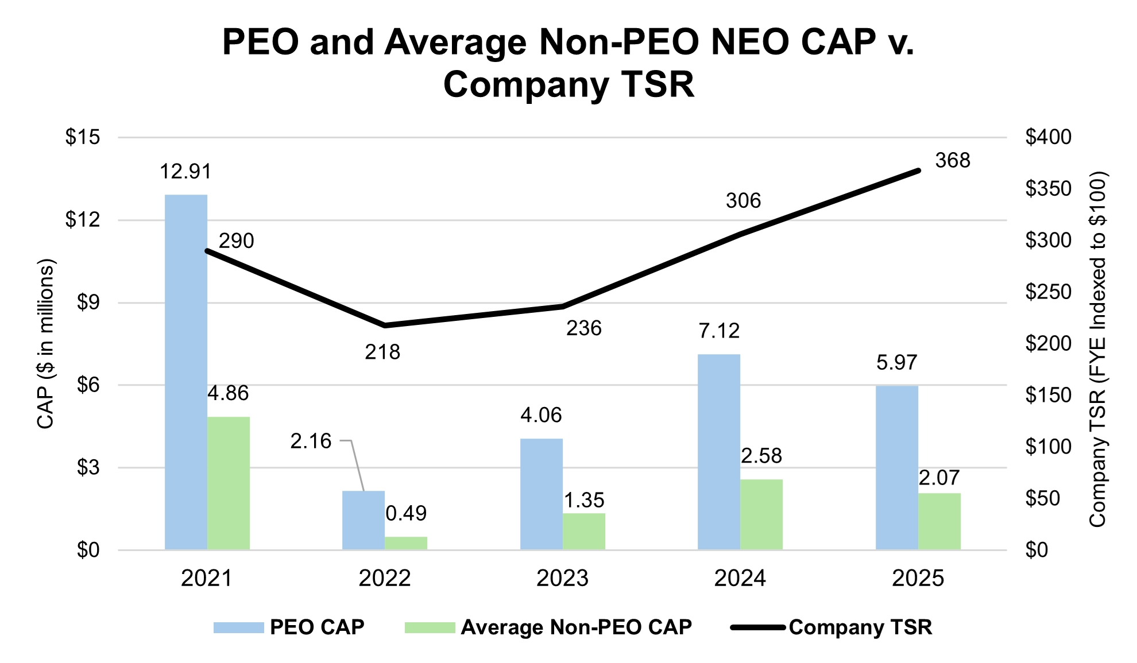

91

EXECUTIVE COMPENSATION

The following chart sets forth the relationship between CAP to our PEO, the average of CAP to our Non-PEO NEOs, and our Net Income during the five most recently completed fiscal years.
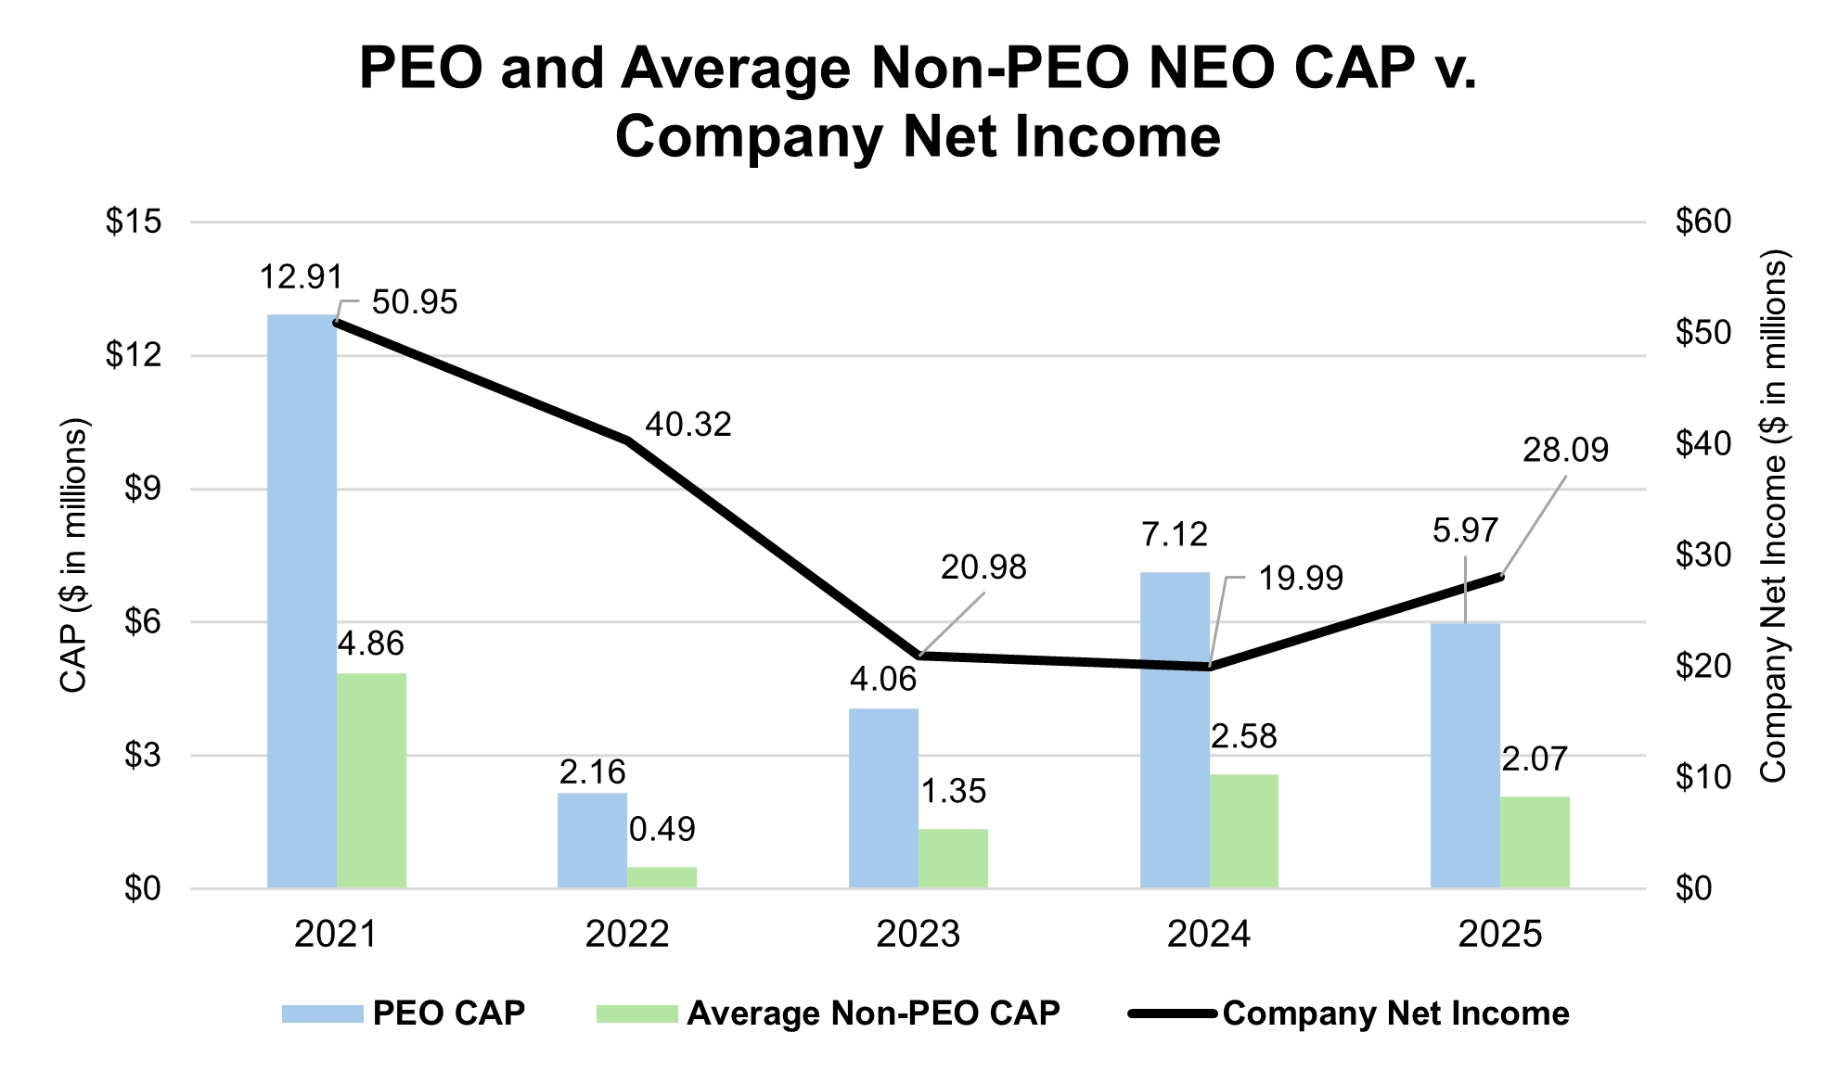

The following chart sets forth the relationship between CAP to our PEO, the average of CAP to our Non-PEO NEOs, and our Company-Selected Measure (Consolidated Adjusted EBITDA) during the five most recently completed fiscal years.

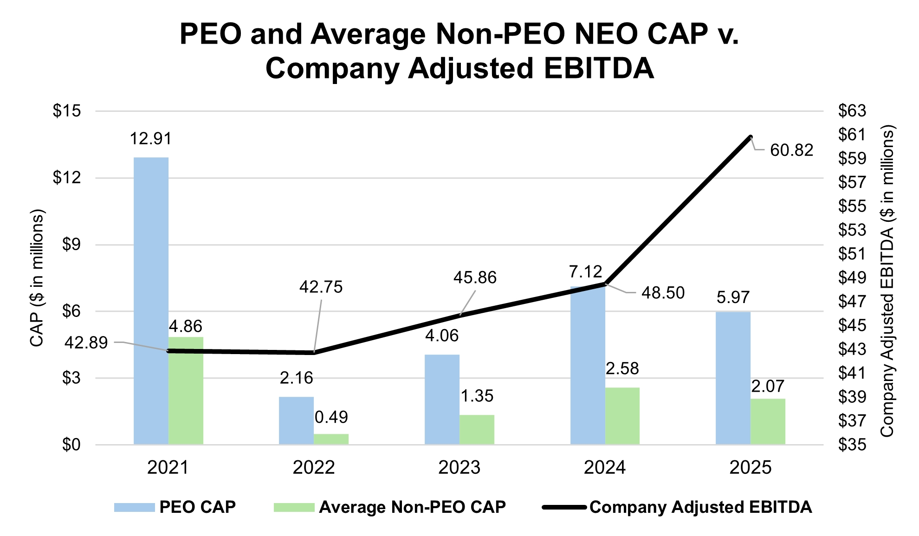

92

EXECUTIVE COMPENSATION

The following chart compares our cumulative TSR over the five most recently completed fiscal years to that of our peer group.

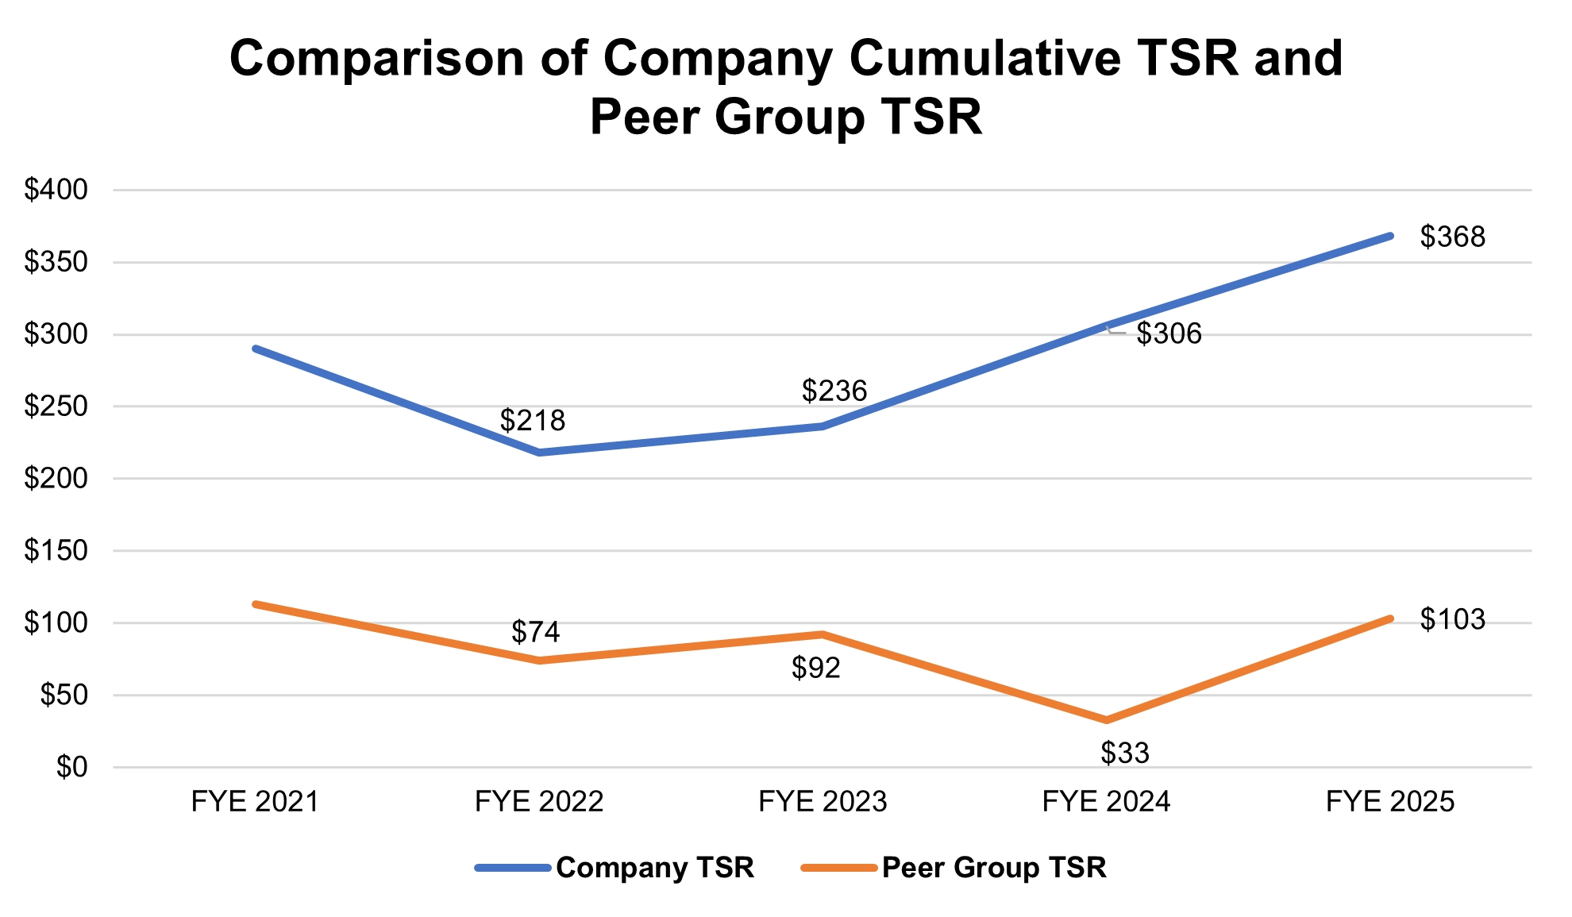

The following table presents the financial performance measures that the Company considers to have been the most important in linking CAP to our PEO and non-PEO NEOs to Company performance. The measures in this table are not ranked.

Consolidated Adjusted EBITDA
Consolidated Direct Profit
Stock Price

93

Compensation Committee

Compensation Committee Report
The Compensation Committee of our Board of Directors has reviewed and discussed the Compensation Discussion and Analysis contained within this proxy statement with management and based on such review and discussions, our Compensation Committee recommended to our Board of Directors that the Compensation Discussion and Analysis be included in this proxy statement and incorporated into the 2025 Form 10-K.
Compensation Committee
Beatriz V. Infante, Chair
Katharin S. Dyer
Edward J. Kolodzieski

Compensation Committee Interlocks and Insider Participation
The members of our Compensation Committee during fiscal 2025 were Ms. Dyer, Ms. Infante and Mr. Kolodzieski. No member of the Compensation Committee has been an officer or employee of the Company or any of our subsidiaries at any time. None of our executive officers serves as a member of the board of directors or compensation committee of any other company that has one or more executive officers serving as a member of our Board or our Compensation Committee.
94

EQUITY Compensation Plan Information

Shares of our common stock are authorized for issuance to directors, employees and consultants under the LTIP. We have also issued shares under our 2005 Stock Option and Incentive Plan in the past. We will not make any further awards under the 2005 Stock Option and Incentive Plan. Both of these plans were approved by our stockholders. In connection with our acquisition of Machinio Corp. (“Machinio”) in 2018 (the “Machinio Acquisition”), we assumed the 2014 Machinio Corp. Stock Incentive Plan (the “Machinio Plan”). After we assumed the Machinio Plan, we issued awards of Company stock under it to Machinio employees that became our employees following the Machinio Acquisition. The Machinio Plan was approved by Machinio’s stockholders prior to the Machinio Acquisition, but it was not approved by our stockholders consistent with applicable Nasdaq rules. Additional information regarding the Machinio Plan is provided below. The following table provides information as of September 30, 2025 regarding outstanding options and shares reserved for issuance under the LTIP and the Machinio Plan.

Plan Category | Number of  Securities to be  Issued Upon  Exercise of  Outstanding  Options | Weighted-Average  Exercise Price of  Outstanding  Options ($) | Number of Securities  Remaining Available  for Future Issuance  Under Equity  Compensation Plans  (Excluding  Securities Reflected  in Column (a))
 | (a) | (b) | (c)
Equity compensation plans approved by security holders | 3,780,846(1) | $13.13(2) | 1,325,740(3)
Equity compensation plans not approved by security holders(4) | 68,2505) | $0.99 (2) | -
Total | 3,849,096 | $13.13 | 1,325,740

(1)
Includes 1,609,671 unvested shares of restricted stock outstanding as of September 30, 2025 that were issued pursuant to awards granted under the LTIP.
(2)
Only outstanding option awards were used in computing the average exercise price of outstanding options.
(3)
Shares available for future awards under the LTIP may be granted as stock options, restricted stock or RSUs.
(4)
The Machinio Plan was assumed by the Company in connection with the Machinio Acquisition. The Machinio Plan was approved by Machinio’s stockholders before the Machinio Acquisition but was not approved by the Company’s stockholders as permitted by applicable rules.
(5)
Includes 67,500 unvested shares of restricted stock outstanding as of September 30, 2025 that were issued pursuant to awards granted under the Machinio Plan.
2014 Machinio Corp. Stock Incentive Plan
As noted above, we assumed the Machinio Plan in connection with the Machinio Acquisition on July 10, 2018. The Machinio Plan permits the grant of stock option, restricted stock and unrestricted stock awards to Machinio’s officers, employees, directors and consultants. A person is not eligible to receive an award under the Machinio Plan if such person was employed, immediately before the Machinio Acquisition, by the Company or any of its subsidiaries.
As of July 10, 2018, all outstanding, vested, in-the-money options under the Machinio Plan were converted into the right to receive cash, net of exercise price. In-the-money unvested stock options were converted into non-qualified options to purchase the Company’s common stock. Out-of-the-money options were cancelled. We also assumed the Machinio Plan and the remaining shares reserved for issuance under the Machinio Plan were converted into shares of the Company’s common stock. These shares were issued under the Machinio Plan to employees of Machinio immediately following the Machinio Acquisition as restricted stock awards. No further awards may be granted under the Machinio Plan. A copy of the Machinio Plan is included as Exhibit 10.1 to the Company’s Form S-8 Registration Statement filed with the SEC on July 10, 2018.
95

Requirements, Including Deadlines, for Submission of Proxy Proposals, Nomination of Directors and
Other Business of Stockholders

Under Exchange Act Rule 14a-8, if a stockholder wants us to include a proposal in our proxy statement and form of proxy for presentation at our 2027 Annual Meeting of Stockholders, the proposal must comply with Rule 14a-8 and must be received by us at our principal executive offices at 6931 Arlington Road, Suite 460, Bethesda, MD 20814, to the attention of the Corporate Secretary, no later than September 18, 2026.
In addition, our bylaws contain certain procedures that a stockholder must follow to nominate persons for election as directors or to introduce an item of business at an Annual Meeting of Stockholders, other than non-binding proposals presented under Exchange Act Rule 14a-8. These procedures provide that for nominations or other business to be properly brought before an annual meeting by a stockholder:
•
the stockholder must have given timely notice thereof in writing to our Corporate Secretary;
•
such business must be a proper matter for stockholder action under the General Corporation Law of the State of Delaware;
•
if the stockholder, or the beneficial owner on whose behalf any such proposal or nomination is made, has provided us with a Solicitation Notice, as that term is defined below, such stockholder or beneficial owner must, in the case of a proposal, have delivered a proxy statement and form of proxy to holders of at least the percentage of our voting shares required under applicable law to carry any such proposal, or, in the case of a nomination or nominations, have delivered a proxy statement and form of proxy to holders of a percentage of our voting shares reasonably believed by such stockholder or beneficial holder to be sufficient to elect the nominee or nominees proposed to be nominated by such stockholder, and must, in either case, have included in such materials the Solicitation Notice; and
•
if no Solicitation Notice has been timely provided, the stockholder or beneficial owner proposing such business or nomination must not have solicited a number of proxies sufficient to have required the delivery of such a Solicitation Notice.
To be timely, a stockholder’s notice must be delivered to our Corporate Secretary at our principal executive offices not less than 90 or more than 120 days prior to the first anniversary of the date of the preceding year’s Annual Meeting of Stockholders. Therefore, in order to be considered timely with respect to the 2027 Annual Meeting of Stockholders, it must be received no earlier than October 29, 2026 and no later than November 28, 2026.
If, however, the date of the Annual Meeting is advanced more than 30 days prior to or delayed by more than 70 days after the anniversary of the preceding year’s Annual Meeting, notice by the stockholder must be delivered no earlier than the close of business on the 120th day prior to such Annual Meeting and not later than the close of business on the later of:
•
the 90th day prior to such Annual Meeting, or
•
the 10th day following the day on which public announcement of the date of such meeting is first made.
In no event shall the public announcement of an adjournment or postponement of an annual meeting commence a new time period or extend any time period for the giving of a stockholder’s notice as described above.
In addition, notwithstanding the above timelines, in the event that the number of directors to be elected to the Board is increased and we do not make a public announcement naming all of the nominees for director or specifying the size of
96

REQUIREMENTS, INCLUDING DEADLINES, FOR SUBMISSION OF PROXY PROPOSALS, NOMINATION OF DIRECTORS AND OTHER BUSINESS OF STOCKHOLDERS

the increased Board at least 100 days prior to the first anniversary of the date of the preceding year’s Annual Meeting of Stockholders, a stockholder’s notice shall also be considered timely, but only with respect to nominees for any new positions created by such increase, if delivered to the Corporate Secretary at our principal executive offices not later than the close of business on the 10th day following the day on which we first made such public announcement.
Such notice shall set forth the following information:
•
as to each person who the stockholder proposes to nominate for election or reelection as a director, all information relating to such person as would be required to be disclosed in solicitations of proxies for the election of such nominees as directors pursuant to Regulation 14A under the Exchange Act, and such person’s written consent to being named in the proxy statement as nominee and to serve as director if elected;
•
as to any other business that the stockholder proposes to bring before the meeting, a brief description of such business, the text of the proposal or business, the reasons for conducting such business at the meeting and any material interest in such business of such stockholder and the beneficial owner, if any, on whose behalf the proposal is made;
•
as to the stockholder giving the notice and the beneficial owner, if any, on whose behalf the nomination or proposal is made:
•
the name and address of such stockholder, as they appear on our books, and of such beneficial owner;
•
the class and number of shares of our stock that are owned beneficially and of record by such stockholder and such beneficial owner; and
•
a representation that either such stockholder or beneficial owner intends to deliver a proxy statement and form of proxy to holders of, in the case of a proposal, at least the percentage of our voting shares required under applicable law to carry the proposal or, in the case of a nomination or nominations, a sufficient number of holders of our voting shares to elect such nominee or nominees (an affirmative statement of such intent is referred to as a “Solicitation Notice”).
If any proposed nomination or business is not in compliance with the foregoing procedures, the chairman of the meeting has the power to declare that any defectively proposed business or nomination shall not be presented for stockholder action at the meeting and shall be disregarded.
Stockholders must also comply with all applicable requirements of the Exchange Act and the rules and regulations thereunder. These procedures do not affect any rights of stockholders to request inclusion of proposals in the Company’s proxy statement pursuant to Rule 14a-8 under the Exchange Act.
Universal Proxy Card Requirements
In addition to complying with the Company’s bylaws as described above (including the obligation to provide timely notice and certain required information and disclosures), stockholders who intend to solicit proxies in support of a director candidate other than the Company’s nominees for consideration by the stockholders at the Company’s 2027 Annual Meeting of Stockholders and who seek to include such nominees on the Company's proxy card must also comply with the SEC’s “universal proxy card” rules under Rule 14a-19 of the Exchange Act (“Rule 14a-19”).
Rule 14a-19 requires proponents to provide a notice to the Corporate Secretary of the Company, no later than December 28, 2026, setting forth all of the information and disclosures required by Rule 14a-19.
If the 2027 Annual Meeting of Stockholders is set for a date that is not within 30 calendar days of the anniversary of the date of the 2026 Annual Meeting of Stockholders, then notice must be provided by the later of 60 calendar days prior to the date of the 2027 Annual Meeting of Stockholders or by the close of business on the tenth calendar day following the day on which a public announcement of the date of the 2027 Annual Meeting of Stockholders is first made.
97

Annual Report

Our Annual Report for the fiscal year ended September 30, 2025 is included with these proxy materials. A copy of our Annual Report, including the financial statements and the financial statement schedules included therein, is also available without charge online at https://investors.liquidityservices.com/financial-information/annual-reports, or upon written request to us at Liquidity Services, Inc., 6931 Arlington Road, Suite 460, Bethesda, MD 20814, Attn: Corporate Secretary. The Company’s copying costs will be charged if copies of exhibits to the Annual Report are requested.
98

Appendix A

2026 AMENDMENT TO THE
LIQUIDITY SERVICES, INC. THIRD AMENDED AND RESTATED
2006 OMNIBUS LONG-TERM INCENTIVE PLAN

WHEREAS, Liquidity Services, Inc., a Delaware corporation (“Company”), established and sponsors the Liquidity Services, Inc. Third Amended and Restated 2006 Omnibus Long-Term Incentive Plan (as previously amended, the “Plan”);
WHEREAS, pursuant to Section 5.3 of the Plan, the Board of Directors of the Company (“Board”) reserved the right to amend the Plan at any time; and
WHEREAS, the Board desired to amend the Plan to increase the number of shares of Stock available for issuance under the Plan.
NOW, THEREFORE, pursuant to the power reserved by Section 5.3 of the Plan, the Board amends the Plan as follows, subject to and effective upon approval by the Company’s stockholders at the Annual Meeting of Stockholders on February 26, 2026 (defined terms used herein, but not otherwise defined in this amendment, shall have the meanings ascribed to them in the Plan):
1. The first sentence of Section 4 of the Plan is amended in its entirety to read as follows: “Subject to adjustment as provided in Section 17 hereof, the number of shares of Stock available for issuance under the Plan shall be Twenty-Five Million Seven Hundred Twenty-Five Thousand (25,725,000).”
IN WITNESS WHEREOF, this amendment, having been first duly authorized, approved and adopted by the Board, and approved by the Company’s stockholders at the February 26, 2026 Annual Meeting of Stockholders, is hereby executed below by a duly authorized officer of the Company on this 26th day of February 2026.

LIQUIDITY SERVICES, INC.

By:
Name:
Title:

A-1

Appendix B

LIQUIDITY SERVICES, INC. THIRD AMENDED AND RESTATED
2006 OMNIBUS LONG-TERM INCENTIVE PLAN
(Effective Date: February 20, 2020,
as amended February 24, 2022 and February 29, 2024)
Liquidity Services, Inc., a Delaware corporation (the “Company”), sets forth herein the terms of its Third Amended and Restated 2006 Omnibus Long-Term Incentive Plan (the “Plan”), as follows:
1. PURPOSE
The Plan is intended to enhance the Company’s and its Affiliates’ (as defined herein) ability to attract and retain highly qualified officers, directors, key employees, and other persons, and to motivate such persons to serve the Company and its Affiliates and to expend maximum effort to improve the business results and earnings of the Company, by providing to such persons an opportunity to acquire or increase a direct proprietary interest in the operations and future success of the Company. To this end, the Plan provides for the grant of stock options, stock appreciation rights, restricted stock, stock units, dividend equivalent rights and cash awards. Any of these awards may, but need not, be made as performance incentives to reward attainment of annual or long-term performance goals in accordance with the terms hereof. Stock options granted under the Plan may be non-qualified stock options or incentive stock options, as provided herein.
2. DEFINITIONS
For purposes of interpreting the Plan and related documents (including Award Agreements), the following definitions shall apply:
2.1 “Affiliate” means, with respect to the Company, any company or other trade or business that controls, is controlled by or is under common control with the Company within the meaning of Rule 405 of Regulation C under the Securities Act, including, without limitation, any Subsidiary.
2.2 “Annual Incentive Award” means an Award made subject to attainment of performance goals (as described in Section 14) over a performance period of up to one year (the Company’s fiscal year, unless otherwise specified by the Committee).
2.3 “Award” means a grant of an Option, Stock Appreciation Right, Restricted Stock, Stock Unit, Dividend Equivalent Rights, or cash award under the Plan.
2.4 “Award Agreement” means a written or electronic agreement or other instrument that evidences and sets out the terms and conditions of an Award.
2.5 “Benefit Arrangement” shall have the meaning set forth in Section 15 hereof.
2.6 “Board” means the Board of Directors of the Company.
2.7 “Cause” means, as determined by the Board and unless otherwise provided in an applicable agreement with the Company or an Affiliate, (i) gross negligence or willful misconduct in connection with the performance of duties; (ii) conviction of a criminal offense (other than minor traffic offenses); or (iii) material breach of any term of any employment, consulting or other services, confidentiality, intellectual property or non-competition agreements, if any, between the Service Provider and the Company or an Affiliate.
B-1

appendix b

2.8 “Code” means the Internal Revenue Code of 1986, as now in effect or as hereafter amended.
2.9 “Committee” means the Compensation Committee of the Board.
2.10 “Company” means Liquidity Services, Inc. and any successor thereto.
2.11 “Corporate Transaction” means (i) the dissolution or liquidation of the Company or a merger, consolidation, or reorganization of the Company with one or more other entities in which the Company is not the surviving entity, (ii) a sale of substantially all of the assets of the Company to another person or entity, or (iii) any transaction (including without limitation a merger or reorganization in which the Company is the surviving entity) which results in any person or entity (other than persons who are stockholders or Affiliates immediately prior to the transaction) owning 50% or more of the combined voting power of all classes of stock of the Company.
2.12 “Covered Employee” means a Grantee who is a covered employee within the meaning of Section 162(m)(3) of the Code.
2.13 “Disability” means the Grantee is unable to perform each of the essential duties of such Grantee’s position by reason of a medically determinable physical or mental impairment which is potentially permanent in character or which can be expected to last for a continuous period of not less than 12 months; provided, however, that, with respect to rules regarding expiration of an Incentive Stock Option following termination of the Grantee’s Service, Disability shall mean the Grantee is unable to engage in any substantial gainful activity by reason of a medically determinable physical or mental impairment which can be expected to result in death or which has lasted or can be expected to last for a continuous period of not less than 12 months.
2.14 “Dividend Equivalent Right” means a right, granted to a Grantee under Section 13 hereof, to receive cash, Stock, other Awards or other property equal in value to dividends paid with respect to a specified number of shares of Stock, or other periodic payments.
2.15 “Effective Date” has the meaning set forth in Section 5.1 of the Plan.
2.16 “Exchange Act” means the Securities Exchange Act of 1934, as now in effect or as hereafter amended.
2.17 “Fair Market Value” means the value of a share of Stock, determined as follows: if on the Grant Date or other determination date the Stock is listed on an established national or regional stock exchange, is admitted to quotation on The Nasdaq Stock Market, Inc. or is publicly traded on an established securities market, the Fair Market Value of a share of Stock shall be the closing price of the Stock on such exchange or in such market (if there is more than one such exchange or market the Board shall determine the appropriate exchange or market) on the Grant Date or such other determination date (or if there is no such reported closing price, the Fair Market Value shall be the mean between the highest bid and lowest asked prices or between the high and low sale prices on such trading day) or, if no sale of Stock is reported for such trading day, on the next preceding day on which any sale shall have been reported. If the Stock is not listed on such an exchange, quoted on such system or traded on such a market, Fair Market Value shall be the value of the Stock as determined by the Board in good faith.
2.18 “Family Member” means a person who is a spouse, former spouse, child, stepchild, grandchild, parent, stepparent, grandparent, niece, nephew, mother-in-law, father-in-law, son-in-law, daughter-in-law, brother, sister, brother-in-law, or sister-in-law, including adoptive relationships, of the Grantee, any person sharing the Grantee’s household (other than a tenant or employee), a trust in which any one or more of these persons have more than fifty percent of the beneficial interest, a foundation in which any one or more of these persons (or the Grantee) control the management of assets, and any other entity in which one or more of these persons (or the Grantee) own more than fifty percent of the voting interests.
2.19 “Good Reason” means, without Grantee’s consent, (1) a material reduction in the position, duties or responsibilities of the Grantee from those in effect immediately prior to such change; (2) a reduction in the Grantee’s base salary; (3) a relocation of the Grantee’s primary work location to a distance of more than fifty (50) miles from its location as of immediately prior to such change; or (4) a material breach by the Company of any employment agreement between the Company and the Grantee.
B-2

appendix b

2.20 “Grant Date” means, as determined by the Board, the latest to occur of (i) the date as of which the Board approves an Award, (ii) the date on which the recipient of an Award first becomes eligible to receive an Award under Section 6 hereof, or (iii) such other date as may be specified by the Board.
2.21 “Grantee” means a person who receives or holds an Award under the Plan.
2.22 “Incentive Stock Option” means an “incentive stock option” within the meaning of Section 422 of the Code, or the corresponding provision of any subsequently enacted tax statute, as amended from time to time.
2.23 “Non-qualified Stock Option” means an Option that is not an Incentive Stock Option.
2.24 “Option” means an option to purchase one or more shares of Stock pursuant to the Plan.
2.25 “Option Price” means the exercise price for each share of Stock subject to an Option.
2.26 “Other Agreement” shall have the meaning set forth in Section 15 hereof.
2.27 “Outside Director” means a member of the Board who is not an officer or employee of the Company.
2.28 “Performance Award” means an Award made subject to the attainment of performance goals (as described in Section 14) over a performance period of up to ten (10) years.
2.29 “Plan” means this Liquidity Services, Inc. Third Amended and Restated 2006 Omnibus Long-Term Incentive Plan.
2.30 “Purchase Price” means the purchase price for each share of Stock pursuant to a grant of Restricted Stock.
2.31 “Reporting Person” means a person who is required to file reports under Section 16(a) of the Exchange Act.
2.32 “Restricted Stock” means shares of Stock, awarded to a Grantee pursuant to Section 10 hereof.
2.33 “SAR Exercise Price” means the per share exercise price of a SAR granted to a Grantee under Section 9 hereof.
2.34 “Securities Act” means the Securities Act of 1933, as now in effect or as hereafter amended.
2.35 “Service” means service as a Service Provider to the Company or an Affiliate. Unless otherwise stated in the applicable Award Agreement, a Grantee’s change in position or duties shall not result in interrupted or terminated Service, so long as such Grantee continues to be a Service Provider to the Company or an Affiliate. Subject to the preceding sentence, whether a termination of Service shall have occurred for purposes of the Plan shall be determined by the Board, which determination shall be final, binding and conclusive.
2.36 “Service Provider” means an employee, officer or director of the Company or an Affiliate, or a consultant or adviser currently providing services to the Company or an Affiliate.
2.37 “Stock” means the common stock, par value $.001 per share, of the Company.
2.38 “Stock Appreciation Right” or “SAR” means a right granted to a Grantee under Section 9 hereof.
2.39 “Stock Unit” means a bookkeeping entry representing the equivalent of one share of Stock awarded to a Grantee pursuant to Section 10 hereof.
2.40 “Subsidiary” means any “subsidiary corporation” of the Company within the meaning of Section 424(f) of the Code.
B-3

appendix b

2.41 “Substitute Awards” means Awards granted upon assumption of, or in substitution for, outstanding awards previously granted by a company or other entity acquired by the Company or any Affiliate or with which the Company or any Affiliate combines.
2.42 “Termination Date” means the date upon which an Option shall terminate or expire, as set forth in Section 8.3 hereof.
2.43 “Ten Percent Stockholder” means an individual who owns more than ten percent (10%) of the total combined voting power of all classes of outstanding stock of the Company, its parent or any of its Subsidiaries. In determining stock ownership, the attribution rules of Section 424(d) of the Code shall be applied.
3. ADMINISTRATION OF THE PLAN
3.1. Board
The Board shall have such powers and authorities related to the administration of the Plan as are consistent with the Company’s certificate of incorporation and by-laws and applicable law. The Board shall have full power and authority to take all actions and to make all determinations required or provided for under the Plan, any Award or any Award Agreement, and shall have full power and authority to take all such other actions and make all such other determinations not inconsistent with the specific terms and provisions of the Plan that the Board deems to be necessary or appropriate to the administration of the Plan, any Award or any Award Agreement. All such actions and determinations shall be by the affirmative vote of a majority of the members of the Board present at a meeting or by unanimous consent of the Board executed in writing in accordance with the Company’s certificate of incorporation and by-laws and applicable law. The interpretation and construction by the Board of any provision of the Plan, any Award or any Award Agreement shall be final, binding and conclusive.
3.2. Committee
The Board from time to time may delegate to the Committee such powers and authorities related to the administration and implementation of the Plan, as set forth in Section 3.1 above and other applicable provisions, as the Board shall determine, consistent with the certificate of incorporation and by-laws of the Company and applicable law.
The Board may also appoint one or more separate committees of the Board, each composed of one or more directors of the Company who need not be Outside Directors, who may administer the Plan with respect to employees or other Service Providers who are not officers or directors of the Company, may grant Awards under the Plan to such employees or other Service Providers, and may determine all terms of such Awards. In the event that the Plan, any Award or any Award Agreement entered into hereunder provides for any action to be taken by or determination to be made by the Board, such action may be taken, or such determination may be made by the Committee if the power and authority to do so has been delegated to the Committee by the Board as provided for in this Section. Unless otherwise expressly determined by the Board, any such action or determination by the Committee shall be final, binding and conclusive. To the extent permitted by law, the Committee may delegate its authority under the Plan to a member of the Board.
3.3. Delegation to Management
The Board (or the Committee, if the Board’s powers have been delegated to the Committee pursuant to Section 3.2) may by resolution authorize one or more officers of the Company to perform any or all things that the Board or the Committee, as applicable, is authorized and empowered to do or perform under the Plan, and for all purposes under this Plan, such officer or officers shall be treated as the administrator; provided, however, that the resolution so authorizing such officer or officers shall specify the total number of Awards (if any) such officer or officers may award pursuant to such delegated authority, and any such Award shall be subject to the form of Award Agreement theretofore approved by the Board and/or Compensation Committee; and, provided, further, that such authorization shall not provide for the grant of Awards to officers or directors of the Company. No such officer shall designate himself or herself as a recipient of any Awards granted under authority delegated to such officer.
B-4

appendix b

3.4 Terms of Awards
Subject to the other terms and conditions of the Plan, the Board shall have full and final authority to:
(i) designate Grantees,
(ii) determine the type or types of Awards to be made to a Grantee,
(iii) determine the number of shares of Stock to be subject to an Award,
(iv) establish the terms and conditions of each Award (including, but not limited to, the exercise price of any Option, the nature and duration of any restriction or condition (or provision for lapse thereof) relating to the vesting, exercise, transfer, or forfeiture of an Award or the shares of Stock subject thereto, and any terms or conditions that may be necessary to qualify Options as Incentive Stock Options),
(v) prescribe the form of each Award Agreement evidencing an Award, and
(vi) amend, modify, or supplement the terms of any outstanding Award. Such authority specifically includes the authority, in order to effectuate the purposes of the Plan but without amending the Plan, to modify Awards to eligible individuals who are foreign nationals or are individuals who are employed outside the United States to recognize differences in local law, tax policy, or custom. Notwithstanding the foregoing, no amendment, modification or supplement of any Award shall, without the consent of the Grantee, impair the Grantee’s rights under such Award and no amendment or modification to an Award that would treated as a repricing under the rules of the stock exchange or market on which the Stock is listed or quoted shall be made without approval of the Company’s stockholders.
The Company may retain the right in an Award Agreement to cause a forfeiture of the gain realized by a Grantee on account of actions taken by the Grantee in violation or breach of or in conflict with any employment agreement, non-competition agreement, any agreement prohibiting solicitation of employees or clients of the Company or any Affiliate thereof or any confidentiality obligation with respect to the Company or any Affiliate thereof or otherwise in competition with the Company or any Affiliate thereof, to the extent specified in such Award Agreement applicable to the Grantee. Furthermore, the Company may annul an Award if the Grantee is an employee of the Company or an Affiliate thereof and is terminated for Cause as defined in the applicable Award Agreement or the Plan, as applicable. The grant of any Award shall be contingent upon the Grantee executing the appropriate Award Agreement.
Notwithstanding the foregoing, no amendment or modification may be made to an outstanding Option or SAR which reduces the Option Price or SAR Exercise Price, either by lowering the Option Price or SAR Exercise Price or by canceling the outstanding Option or SAR and granting either a replacement Option or SAR with a lower exercise price, another Award or a cash payment in lieu thereof without the approval of the stockholders of the Company, provided, that, appropriate adjustments may be made to outstanding Options and SARs pursuant to Section 17.
3.5. Deferral Arrangement
The Board may permit or require the deferral of any award payment into a deferred compensation arrangement, subject to such rules and procedures as it may establish, which may include provisions for the payment or crediting of interest or dividend equivalents, including converting such credits into deferred Stock equivalents, restricting deferrals to comply with hardship distribution rules affecting 401(k) plans. Any such deferrals shall be made in a manner that complies with Code Section 409A.
3.6. No Liability
No member of the Board or of the Committee or any officer delegated authority pursuant to this Section 3 shall be liable for any action or determination made in good faith with respect to the Plan or any Award or Award Agreement.
B-5

appendix b

3.7. Share Issuance
Notwithstanding any provision of this Plan to the contrary, the issuance of the Stock under the Plan may be evidenced in such a manner as the Board, in its discretion, deems appropriate, including, without limitation, book-entry registration or issuance of one or more Stock certificates.
4. STOCK SUBJECT TO THE PLAN
Subject to adjustment as provided in Section 17 hereof, the number of shares of Stock available for issuance under the Plan shall be Twenty-Two Million Eight Hundred Thousand (22,800,000). For this purpose, every share of Stock issued pursuant to an Award granted after January 9, 2015 (i) that is an Option or SAR shall count as one share and (ii) every share of Stock issued pursuant to an Award granted after January 9, 2015 other than an Option or SAR shall count as 1.5 shares of Stock. The number of shares that may be issued as Incentive Stock Options shall not exceed nineteen million one hundred thousand (19,100,000). Stock issued or to be issued under the Plan shall be authorized but unissued shares; or, to the extent permitted by applicable law, issued shares that have been reacquired by the Company. If any shares covered by an Award are not purchased or are forfeited, or if an Award otherwise terminates without delivery of any Stock subject thereto, then the number of shares of Stock counted against the aggregate number of shares available under the Plan with respect to such Award shall, to the extent of any such forfeiture or termination, again be available for making Awards under the Plan; provided, however, that any shares of Stock that again become available for grant pursuant to this Section 4 after January 9, 2015 shall be added back on a one-for-one basis if such shares of Stock were subject to Awards of Options or SARs or added back as one and one-half (1.5) shares of Stock for all shares granted as Awards other than Options or SARs. Notwithstanding the foregoing, the following shares shall not be available for future grant: (a) shares tendered or withheld in payment of the exercise price of an Option, and (b) shares withheld by the Company or otherwise received by the Company to satisfy tax withholding obligations in connection with an Award. In addition, all shares covered by a SAR (including shares subject to a stock-settled SAR that were issued upon the net settlement or net exercise of such SAR) shall be counted against the number of shares of Stock available for issuance under the Plan and shares purchased in the open market using Option proceeds shall not be available for future grants under the Plan.
The Board shall have the right to substitute or assume Awards in connection with mergers, reorganizations, separations, or other transactions to which Section 424(a) of the Code applies. The number of shares of Stock reserved pursuant to Section 4 may be increased by the corresponding number of Awards assumed and, in the case of a substitution, by the net increase in the number of shares of Stock subject to Awards before and after the substitution.
5. EFFECTIVE DATE, DURATION AND AMENDMENTS
5.1. Effective Date
The Plan was originally effective December 2, 2005 and was amended and restated effective as of February 26, 2015 and February 23, 2017. This third amended and restated version of the Plan was adopted by the Board as of January 14, 2020 (the “Approval Date”) and shall become effective upon approval by the Company’s stockholders at the Company’s 2020 Annual Meeting of Stockholders on February 20, 2020 (the “Effective Date”).
5.2. Term
The Plan shall remain available for the grant of Awards until the tenth (10th) anniversary of the Approval Date. Notwithstanding the foregoing, the Plan may be terminated at such earlier time as the Board may determine as provided in Section 5.3.
5.3. Amendment and Termination of the Plan
The Board may, at any time and from time to time, amend, suspend, or terminate the Plan as to any shares of Stock as to which Awards have not been made. An amendment shall be contingent on approval of the Company’s stockholders to the extent stated by the Board, required by applicable law or required by applicable stock exchange or market listing requirements. No Awards shall be made after termination of the Plan. No amendment, suspension, or termination of the
B-6

appendix b

Plan shall, without the consent of the Grantee, impair rights or obligations under any Award theretofore awarded under the Plan.
6. AWARD ELIGIBILITY AND LIMITATIONS
6.1. Service Providers and Other Persons
Subject to this Section 6, Awards may be made under the Plan to: (i) any Service Provider to the Company or of any Affiliate, including any Service Provider who is an officer or director of the Company, or of any Affiliate, as the Board shall determine and designate from time to time, (ii) any Outside Director, and (iii) any other individual providing services to the Company or any Affiliate whose participation in the Plan is determined to be in the best interests of the Company by the Board.
6.2. Successive Awards and Substitute Awards
An eligible person may receive more than one Award, subject to such restrictions as are provided herein. Notwithstanding Sections 8.1 and 9.1, the Option Price of an Option or the grant price of a SAR that is a Substitute Award may be less than 100% of the Fair Market Value of a share of Common Stock on the original date of grant provided that the Option Price or grant price in determined in accordance with the principles of Code Section 424 and the regulations thereunder.
6.3. Limitation on Shares of Stock Subject to Awards and Cash Awards
During any time when the Company has a class of equity security registered under Section 12 of the Exchange Act:
(i) the maximum number of shares of Stock subject to Options or SARs that can be awarded under the Plan to any person eligible for an Award under Section 6 hereof is one million (1,000,000) per calendar year;
(ii) the maximum number of shares that can be awarded under the Plan, other than pursuant to an Option or SARs, to any person eligible for an Award under Section 6 hereof is seven hundred thousand (700,000) per calendar year;
(iii) the maximum amount that may be earned as an Annual Incentive Award or other cash Award in any calendar year by any one Grantee shall be $3,000,000 and the maximum amount that may be earned as a Performance Award or other cash Award in respect of a performance period by any one Grantee shall be $5,000,000; and
(iv) the aggregate dollar value of equity-based (based on the grant date fair value of equity-based Awards) and cash compensation granted under this Plan or otherwise during any calendar year to any single Outside Director shall not exceed $420,000. The foregoing limit shall not count any tandem SARs (as described in Section 9.2).
The preceding limitations in this Section 6.3 are subject to adjustment as provided in Section 17 hereof.
7. AWARD AGREEMENT
Each Award granted pursuant to the Plan shall be evidenced by an Award Agreement, in such form or forms as the Board shall from time to time determine. Award Agreements granted from time to time or at the same time need not contain similar provisions but shall be consistent with the terms of the Plan. Each Award Agreement evidencing an Award of Options shall specify whether such Options are intended to be Non-qualified Stock Options or Incentive Stock Options, and in the absence of such specification such options shall be deemed Non-qualified Stock Options.
B-7

appendix b

8. TERMS AND CONDITIONS OF OPTIONS
8.1. Option Price
The Option Price of each Option shall be fixed by the Board and stated in the Award Agreement evidencing such Option. The Option Price of each Option shall be at least the Fair Market Value on the Grant Date of a share of Stock; provided, however, that in the event that a Grantee is a Ten Percent Stockholder, the Option Price of an Option granted to such Grantee that is intended to be an Incentive Stock Option shall be not less than 110 percent of the Fair Market Value of a share of Stock on the Grant Date. In no case shall the Option Price of any Option be less than the par value of a share of Stock.
8.2. Vesting
Subject to Sections 8.3 and 17.3 hereof, each Option granted under the Plan shall become exercisable at such times and under such conditions as shall be determined by the Board and stated in the Award Agreement; provided, however, that the vesting of any Option that is based on performance criteria and level of achievement versus such criteria will be subject to a performance period of not less than one (1) year, and the vesting of any Option that is based solely upon continued employment and/or the passage of time may not vest in full over a period of less than one (1) year from the Grant Date, except that the administrator may provide for the satisfaction and/or lapse of all conditions under any such Award in the event of the Grantee’s death or disability or in connection with a Corporate Transaction of the Company, and the administrator may provide that any such restriction or limitation will not apply in the case of an Option that is issued in payment or settlement of compensation that has been earned by the Grantee or that qualifies as a Substitute Award. Notwithstanding the foregoing, the Committee may grant Awards covering an aggregate of five percent (5%) or fewer of the total number of shares of Stock authorized for issuance under the Plan without regard to such minimum vesting requirements. For purposes of this Section 8.2, fractional numbers of shares of Stock subject to an Option shall be rounded down to the next nearest whole number. No Option shall be exercisable in whole or in part prior to the date the Plan is approved by the Stockholders of the Company as provided in Section 5.1 hereof.
8.3. Term
Each Option granted under the Plan shall terminate, and all rights to purchase shares of Stock thereunder shall cease, upon the expiration of ten years from the date such Option is granted, or under such circumstances and on such date prior thereto as is set forth in the Plan or as may be fixed by the Board and stated in the Award Agreement relating to such Option (the “Termination Date”); provided, however, that in the event that the Grantee is a Ten Percent Stockholder, an Option granted to such Grantee that is intended to be an Incentive Stock Option shall not be exercisable after the expiration of five years from its Grant Date. Notwithstanding the foregoing, the term of an Option (other than an Incentive Stock Option) shall be automatically extended if, at the time of its scheduled expiration, the Grantee holding such Option is prohibited by law or the Company’s insider trading policy from exercising the Option, which extension shall expire on the thirtieth (30th) day following the date such prohibition no longer applies.
8.4. Termination of Service
Each Award Agreement shall set forth the extent to which the Grantee shall have the right to exercise the Option following termination of the Grantee’s Service. Such provisions shall be determined in the sole discretion of the Board, need not be uniform among all Options issued pursuant to the Plan, and may reflect distinctions based on the reasons for termination of Service.
8.5. Limitations on Exercise of Option
Notwithstanding any other provision of the Plan, in no event may any Option be exercised, in whole or in part, prior to the date the Plan is approved by the stockholders of the Company as provided herein or after the occurrence of an event referred to in Section 17 hereof which results in termination of the Option.
B-8

appendix b

8.6. Method of Exercise
An Option that is exercisable may be exercised by the Grantee’s delivery to the Company of written notice of exercise on any business day, at the Company’s principal office, on the form specified by the Company. Such notice shall specify the number of shares of Stock with respect to which the Option is being exercised and shall be accompanied by payment in full of the Option Price of the shares for which the Option is being exercised plus the amount (if any) of federal and/or other taxes which the Company may, in its judgment, be required or permitted to withhold with respect to an Award. The minimum number of shares of Stock with respect to which an Option may be exercised, in whole or in part, at any time shall be the lesser of (i) 100 shares or such lesser number set forth in the applicable Award Agreement and (ii) the maximum number of shares available for purchase under the Option at the time of exercise.
8.7. Rights of Holders of Options
Unless otherwise stated in the applicable Award Agreement, an individual holding or exercising an Option shall have none of the rights of a stockholder (for example, the right to receive cash or dividend payments or distributions attributable to the subject shares of Stock or to direct the voting of the subject shares of Stock) until the shares of Stock covered thereby are fully paid and issued to him. In no case shall an individual holding an Option receive cash or dividend payments or distributions or dividend equivalents attributable to unvested Stock underlying an Option. Except as provided in Section 17 hereof, no adjustment shall be made for dividends, distributions or other rights for which the record date is prior to the date of such issuance.
8.8. Delivery of Stock Certificates
Promptly after the exercise of an Option by a Grantee and the payment in full of the Option Price, such Grantee shall be entitled to the issuance of a stock certificate or certificates evidencing his or her ownership of the shares of Stock subject to the Option.
8.9. Transferability of Options
Except as provided in Section 8.10, during the lifetime of a Grantee, only the Grantee (or, in the event of legal incapacity or incompetency, the Grantee’s guardian or legal representative) may exercise an Option. Except as provided in Section 8.10, no Option shall be assignable or transferable by the Grantee to whom it is granted, other than by will or the laws of descent and distribution.
8.10. Family Transfers
If authorized in the applicable Award Agreement, a Grantee may transfer, not for value, all or part of an Option which is not an Incentive Stock Option to any Family Member. For the purpose of this Section 8.10, a “not for value” transfer is a transfer which is (i) a gift, (ii) a transfer under a domestic relations order in settlement of marital property rights; or (iii) a transfer to an entity in which more than fifty percent of the voting interests are owned by Family Members (or the Grantee) in exchange for an interest in that entity. Following a transfer under this Section 8.10, any such Option shall continue to be subject to the same terms and conditions as were applicable immediately prior to transfer. Subsequent transfers of transferred Options are prohibited except to Family Members of the original Grantee in accordance with this Section 8.10 or by will or the laws of descent and distribution. The events of termination of Service of Section 8.4 hereof shall continue to be applied with respect to the original Grantee, following which the Option shall be exercisable by the transferee only to the extent, and for the periods specified, in Section 8.4.
8.11. Limitations on Incentive Stock Options
An Option shall constitute an Incentive Stock Option only (i) if the Grantee of such Option is an employee of the Company or any Subsidiary of the Company; (ii) to the extent specifically provided in the related Award Agreement; and (iii) to the extent that the aggregate Fair Market Value (determined at the time the Option is granted) of the shares of Stock with respect to which all Incentive Stock Options held by such Grantee become exercisable for the first time during any calendar year (under the Plan and all other plans of the Grantee’s employer and its Affiliates) does not exceed $100,000. This limitation shall be applied by taking Options into account in the order in which they were granted.
B-9

appendix b

9. TERMS AND CONDITIONS OF STOCK APPRECIATION RIGHTS
9.1. Right to Payment and Grant Price
A SAR shall confer on the Grantee to whom it is granted a right to receive, upon exercise thereof, the excess of (A) the Fair Market Value of one share of Stock on the date of exercise over (B) the grant price of the SAR as determined by the Board. The Award Agreement for a SAR shall specify the grant price of the SAR, which shall be at least the Fair Market Value of a share of Stock on the date of grant. SARs may be granted in conjunction with all or part of an Option granted under the Plan or at any subsequent time during the term of such Option, in conjunction with all or part of any other Award or without regard to any Option or other Award; provided that a SAR that is granted subsequent to the Grant Date of a related Option must have a SAR Price that is no less than the Fair Market Value of one share of Stock on the SAR Grant Date. In no case shall an individual holding an SAR receive cash or dividend payments or distributions or dividend equivalents attributable to unvested Stock underlying an SAR.
9.2. Other Terms
The Board shall determine at the date of grant or thereafter, the time or times at which and the circumstances under which a SAR may be exercised in whole or in part (including based on achievement of performance goals and/or future service requirements), the time or times at which SARs shall cease to be or become exercisable following termination of Service or upon other conditions, the method of exercise, method of settlement, form of consideration payable in settlement, method by or forms in which Stock will be delivered or deemed to be delivered to Grantees, whether or not a SAR shall be in tandem or in combination with any other Award, and any other terms and conditions of any SAR; provided, however, that the term of each SAR shall not exceed ten years, and the vesting of any SAR that is based on performance criteria and level of achievement versus such criteria will be subject to a performance period of not less than one (1) year, and the vesting of any SAR that is based solely upon continued employment and/or the passage of time may not vest in full over a period of less than one (1) year from the Grant Date, except that the administrator may provide for the satisfaction and/or lapse of all conditions under any such Award in the event of the Grantee’s death or disability or in connection with a Corporate Transaction of the Company, and the administrator may provide that any such restriction or limitation will not apply in the case of a SAR that is issued in payment or settlement of compensation that has been earned by the Grantee or that qualifies as a Substitute Award. Notwithstanding the foregoing, the Committee may grant Awards covering an aggregate of five percent (5%) or fewer of the total number of shares of Stock authorized for issuance under the Plan without regard to such minimum vesting requirements.
10. TERMS AND CONDITIONS OF RESTRICTED STOCK AND STOCK UNITS
10.1. Grant of Restricted Stock or Stock Units
Awards of Restricted Stock or Stock Units may be made for no consideration (other than par value of the shares which is deemed paid by Services already rendered).
10.2. Restrictions
At the time a grant of Restricted Stock or Stock Units is made, the Board may, in its sole discretion, establish a period of time (a “restricted period”) applicable to such Restricted Stock or Stock Units. Each Award of Restricted Stock or Stock Units may be subject to a different restricted period. The Board may, in its sole discretion, at the time a grant of Restricted Stock or Stock Units is made, prescribe restrictions in addition to or other than the expiration of the restricted period, including the satisfaction of corporate or individual performance objectives, which may be applicable to all or any portion of the Restricted Stock or Stock Units in accordance with Section 14.1 and 14.2. The grant, issuance, retention, vesting and/or settlement of Shares under any such Award that is based on performance criteria and level of achievement versus such criteria will be subject to a performance period of not less than one (1) year, and the grant, issuance, retention, vesting and/or settlement of shares of Stock under any Restricted Stock or Stock Unit Award that is based solely upon continued employment and/or the passage of time may not vest or be settled in full over a period of less than one (1) year from the Grant Date, except that the administrator may provide for the satisfaction and/or lapse of all conditions under any such Award in the event of the Grantee’s death or disability or in connection with a Corporate Transaction of the Company, and the administrator may provide that any such restriction or limitation will not apply in the case of a Restricted Stock or Stock Unit Award that is issued in payment or settlement of compensation that has been earned by the Grantee or that
B-10

appendix b

qualifies as a Substitute Award. Notwithstanding the foregoing, the Committee may grant Awards covering an aggregate of five percent (5%) or fewer of the total number of shares of Stock authorized for issuance under the Plan without regard to such minimum vesting requirements. Neither Restricted Stock nor Stock Units may be sold, transferred, assigned, pledged or otherwise encumbered or disposed of during the restricted period or prior to the satisfaction of any other restrictions prescribed by the Board with respect to such Restricted Stock or Stock Units.
10.3. Restricted Stock Certificates
The Company shall issue, in the name of each Grantee to whom Restricted Stock has been granted, stock certificates representing the total number of shares of Restricted Stock granted to the Grantee, as soon as reasonably practicable after the Grant Date. The Board may provide in an Award Agreement that either (i) the Secretary of the Company shall hold such certificates for the Grantee’s benefit until such time as the Restricted Stock is forfeited to the Company or the restrictions lapse, or (ii) such certificates shall be delivered to the Grantee, provided, however, that such certificates shall bear a legend or legends that comply with the applicable securities laws and regulations and makes appropriate reference to the restrictions imposed under the Plan and the Award Agreement.
10.4. Rights of Holders of Restricted Stock
Unless the Board otherwise provides in an Award Agreement, holders of Restricted Stock shall have the right to vote such Stock and the right to receive any dividends declared or paid with respect to such Stock provided that any such dividends shall be subject to the same vesting restrictions as the underlying shares of Stock subject to the Award. Dividends accrued with respect to the shares subject to any Restricted Stock Award, whether subject to time-based and/or performance-based vesting criteria, shall become payable no earlier than the date the applicable vesting criteria have been satisfied and the underlying Restricted Stock has become vested and/or been earned, as applicable. The Board may provide that any dividends paid on Restricted Stock must be reinvested in shares of Stock. All distributions, if any, received by a Grantee with respect to Restricted Stock as a result of any stock split, stock dividend, combination of shares, or other similar transaction shall be subject to the restrictions applicable to the original Grant.
10.5. Rights of Holders of Stock Units
10.5.1. Voting and Dividend Rights
Holders of Stock Units shall have no rights as stockholders of the Company. The Board may provide in an Award Agreement evidencing a grant of Stock Units that the holder of such Stock Units shall be entitled to receive, upon the Company’s payment of a cash dividend on its outstanding Stock, a cash payment for each Stock Unit held equal to the per-share dividend paid on the Stock provided that any such dividends shall be subject to the same vesting restrictions as the underlying shares of Stock subject to the Award. Dividends accrued with respect to the shares subject to any Stock Unit Award, whether subject to time-based and/or performance-based vesting criteria, shall become payable no earlier than the date the applicable vesting criteria have been satisfied and the underlying Stock Units have become vested and/or been earned, as applicable. Such Award Agreement may also provide that such cash payment will be deemed reinvested in additional Stock Units at a price per unit equal to the Fair Market Value of a share of Stock on the date that such dividend is paid.
10.5.2. Creditor’s Rights
A holder of Stock Units shall have no rights other than those of a general creditor of the Company. Stock Units represent an unfunded and unsecured obligation of the Company, subject to the terms and conditions of the applicable Award Agreement.
10.6. Termination of Service
Unless the Board otherwise provides in an Award Agreement or in writing after the Award Agreement is issued, upon the termination of a Grantee’s Service, any Restricted Stock or Stock Units held by such Grantee that have not vested, or with respect to which all applicable restrictions and conditions have not lapsed, shall immediately be deemed forfeited. Upon forfeiture of Restricted Stock or Stock Units, the Grantee shall have no further rights with respect to such Award,
B-11

appendix b

including but not limited to any right to vote Restricted Stock or any right to receive dividends with respect to shares of Restricted Stock or Stock Units.
10.7. Purchase of Restricted Stock
The Grantee may be required, to the extent required by applicable law, to purchase the Restricted Stock from the Company at a Purchase Price equal to the greater of (i) the aggregate par value of the shares of Stock represented by such Restricted Stock or (ii) the Purchase Price, if any, specified in the Award Agreement relating to such Restricted Stock. The Purchase Price shall be payable in a form described in Section 12 or, in the discretion of the Board, in consideration for past Services rendered to the Company or an Affiliate.
10.8. Delivery of Stock
Upon the expiration or termination of any restricted period and the satisfaction of any other conditions prescribed by the Board, the restrictions applicable to shares of Restricted Stock or Stock Units settled in Stock shall lapse, and, unless otherwise provided in the Award Agreement, a stock certificate for such shares shall be delivered, free of all such restrictions, to the Grantee or the Grantee’s beneficiary or estate, as the case may be. Neither the Grantee, nor the Grantee’s beneficiary or estate, shall have any further rights with regard to a Stock Unit once the share of Stock represented by the Stock Unit has been delivered.
11. [RESERVED]
12. FORM OF PAYMENT FOR OPTIONS AND RESTRICTED STOCK
12.1. General Rule
Payment of the Option Price for the shares purchased pursuant to the exercise of an Option or the Purchase Price for Restricted Stock shall be made in cash or in cash equivalents acceptable to the Company.
12.2. Surrender of Stock
To the extent the Award Agreement so provides, payment of the Option Price for shares purchased pursuant to the exercise of an Option or the Purchase Price for Restricted Stock may be made all or in part through the tender to the Company of shares of Stock, which shares shall be valued, for purposes of determining the extent to which the Option Price or Purchase Price has been paid thereby, at their Fair Market Value on the date of exercise or surrender.
12.3. Cashless Exercise
With respect to an Option only (and not with respect to Restricted Stock), to the extent permitted by law and to the extent the Award Agreement so provides, payment of the Option Price for shares purchased pursuant to the exercise of an Option may be made all or in part by delivery (on a form acceptable to the Board) of an irrevocable direction to a licensed securities broker acceptable to the Company to sell shares of Stock and to deliver all or part of the sales proceeds to the Company in payment of the Option Price and any withholding taxes described in Section 18.3.
12.4. Other Forms of Payment
To the extent the Award Agreement so provides, payment of the Option Price for shares purchased pursuant to exercise of an Option or the Purchase Price for Restricted Stock may be made in any other form that is consistent with applicable laws, regulations and rules.
13. TERMS AND CONDITIONS OF DIVIDEND EQUIVALENT RIGHTS
13.1. Dividend Equivalent Rights
A Dividend Equivalent Right is an Award entitling the recipient to receive credits based on cash distributions that would have been paid on the shares of Stock specified in the Dividend Equivalent Right (or other award to which it relates)
B-12

appendix b

if such shares had been issued to and held by the recipient. A Dividend Equivalent Right may be granted hereunder to any Grantee. The terms and conditions of Dividend Equivalent Rights shall be specified in the grant. Dividend equivalents credited to the holder of a Dividend Equivalent Right may be paid currently or may be deemed to be reinvested in additional shares of Stock, which may thereafter accrue additional equivalents. Any such reinvestment shall be at Fair Market Value on the date of reinvestment. Dividend Equivalent Rights may be settled in cash or Stock or a combination thereof, in a single installment or installments, all determined in the sole discretion of the Board. A Dividend Equivalent Right granted as a component of another Award may provide that such Dividend Equivalent Right shall be settled upon exercise, settlement, or payment of, or lapse of restrictions on, such other award, and that such Dividend Equivalent Right shall expire or be forfeited or annulled under the same conditions as such other award. A Dividend Equivalent Right granted as a component of another Award may also contain terms and conditions different from such other award. Notwithstanding anything herein to the contrary, in no event will Dividend Equivalent Rights granted as a component of an Award, whether subject to time-based and/or performance-based vesting criteria, be paid during the vesting period with respect to the unvested and/or unearned portion of any such Awards. Dividend Equivalent Rights accrued on shares subject to any such Awards shall become payable no earlier than the date the vesting criteria have been satisfied and the underlying Restricted Stock or Stock Units have become vested and/or been earned, as applicable.
13.2. Termination of Service
Except as may otherwise be provided by the Board either in the Award Agreement or in writing after the Award Agreement is issued, a Grantee’s rights in all Dividend Equivalent Rights or interest equivalents shall automatically terminate upon the Grantee’s termination of Service for any reason.
14. TERMS AND CONDITIONS OF PERFORMANCE AND ANNUAL INCENTIVE AWARDS
14.1. Performance Conditions
The right of a Grantee to exercise or receive a grant or settlement of any Award, and the timing thereof, may be subject to such performance conditions as may be specified by the Board. The Board may use such business criteria and other measures of performance as it may deem appropriate in establishing any performance conditions and may exercise its discretion to reduce the amounts payable under any Award subject to performance conditions, except as limited under Sections 14.2 hereof with respect to a Performance Award or Annual Incentive Award granted on or before November 2, 2017 and intended to qualify under Code Section 162(m). If and to the extent required under Code Section 162(m) with respect to any grants made on or before November 2, 2017, any power or authority relating to a Performance Award or Annual Incentive Award intended to qualify under Code Section 162(m), shall be exercised by the Committee and not the Board.
14.2. Performance or Annual Incentive Awards Granted to Designated Covered Employees
If and to the extent that the Committee determines that a Performance or Annual Incentive Award granted on or before November 2, 2017 to a Grantee who is designated by the Committee as likely to be a Covered Employee should qualify as “performance-based compensation” for purposes of Code Section 162(m), the grant, exercise and/or settlement of such Performance or Annual Incentive Award shall be contingent upon achievement of pre-established performance goals and other terms set forth in this Section 14.2.
14.2.1. Performance Goals Generally
The performance goals for such Performance or Annual Incentive Awards shall consist of one or more business criteria and a targeted level or levels of performance with respect to each of such criteria, as specified by the Committee consistent with this Section 14.2. Performance goals shall be objective and shall otherwise meet the requirements of Code Section 162(m) and regulations thereunder including the requirement that the level or levels of performance targeted by the Committee result in the achievement of performance goals being “substantially uncertain.” The Committee may determine that such Performance or Annual Incentive Awards shall be granted, exercised and/or settled upon achievement of any one performance goal or that two or more of the performance goals must be achieved as a condition to grant, exercise and/or settlement of such Performance or Annual Incentive Awards. Performance goals may differ for Performance or Annual Incentive Awards granted to any one Grantee or to different Grantees.
B-13

appendix b

14.2.2. Business Criteria
One or more of the following business criteria for the Company, on a consolidated basis, and/or specified subsidiaries or business units of the Company (except with respect to the total stockholder return and earnings per share criteria), shall be used exclusively by the Committee in establishing performance goals for such Performance or Annual Incentive Awards: (1) total stockholder return; (2) such total stockholder return as compared to total return (on a comparable basis) of a publicly available index such as, but not limited to, the Standard & Poor’s 500 Stock Index; (3) net income; (4) pretax earnings; (5) contribution margin or earnings before interest expense, taxes, depreciation and amortization; (6) pretax operating earnings after interest expense and before bonuses, service fees, and extraordinary or special items; (7) operating margin; (8) earnings per share; (9) return on equity; (10) return on capital; (11) return on investment; (12) operating earnings; (13) working capital; (14) ratio of debt to stockholders’ equity; (15) revenue; (16) gross merchandise value; (17) launch of a new marketplace on an e-commerce platform or the launch of an existing marketplace on a new e-commerce software platform by a specific date; and (18) growth of a new marketplace or e-commerce product as objectively measured by a gross merchandise volume target, contribution margin, number of sellers and/or buyers or a combination thereof. Business criteria may be measured on an absolute basis or on a relative basis (i.e., performance relative to peer companies) and on a GAAP or non-GAAP basis. To the extent consistent with Section 162(m) of the Code, the Committee may appropriately adjust any evaluation of performance under a business criteria (A) to eliminate the effects of charges for restructurings, discontinued operations, and all items of gain, loss or expense that are unusual or infrequently occurring or related to the acquisition or disposal of a segment of a business or related to a change in accounting principle all as determined in accordance with applicable accounting provisions, as well as the cumulative effect of accounting changes, in each case as determined in accordance with GAAP or identified in the Company’s financial statements or notes to the financial statements, (B) to exclude any of the following events that occurs during a performance period: (i) asset write-downs, (ii) litigation, claims, judgments or settlements, (iii) the effect of changes in tax law or other such laws or provisions affecting reported results, (iv) accruals for reorganization and restructuring programs (v) accruals of any amounts for payment under this Plan or any other compensation arrangement maintained by the Company, (vi) foreign exchange gains and losses, and (vii) acquisitions or divestitures, and (C) for such other events as the Committee deems appropriate, if such adjustment is timely approved in connection with the establishment of such business criteria.
14.2.3. Timing For Establishing Performance Goals
Performance goals shall be established not later than 90 days after the beginning of any performance period applicable to such Performance or Annual Incentive Awards, or at such other date as may be required or permitted for “performance-based compensation” under Code Section 162(m).
14.2.4. Settlement of Performance or Annual Incentive Awards; Other Terms
Settlement of such Performance or Annual Incentive Awards shall be in cash, Stock, other Awards or other property, in the discretion of the Committee. The Committee may, in its discretion, reduce the amount of a settlement otherwise to be made in connection with such Performance or Annual Incentive Awards. The Committee shall specify the circumstances in which such Performance or Annual Incentive Awards shall be paid or forfeited in the event of termination of Service by the Grantee prior to the end of a performance period or settlement of Performance Awards. The Committee shall also have the authority to determine that such Performance or Annual Incentive Awards shall be canceled in the event the Committee, in its reasonable determination, deems at any time during the applicable performance period that the established performance goals have become unachievable.
14.3. Written Determinations
All determinations by the Committee as to the establishment of performance goals, the amount of any potential Performance Awards and as to the achievement of performance goals relating to Performance Awards, and the amount of any potential individual Annual Incentive Awards and the amount of final Annual Incentive Awards, shall be made in writing in the case of any Award intended to qualify under Code Section 162(m). To the extent permitted by Section 162(m), the Committee may delegate any responsibility relating to such Performance Awards or Annual Incentive Awards.
B-14

appendix b

14.4. Status of Section 14.2 Awards Under Code Section 162(m)
It is the intent of the Company that Performance Awards and Annual Incentive Awards under Section 14.2 hereof granted on or before November 2, 2017 to persons who are designated by the Committee as likely to be Covered Employees within the meaning of Code Section 162(m) and regulations thereunder shall, if so designated by the Committee, constitute “qualified performance-based compensation” within the meaning of Code Section 162(m) and regulations thereunder. Accordingly, the terms of Section 14.2, including the definitions of Covered Employee and other terms used therein, shall be interpreted in a manner consistent with Code Section 162(m) and regulations thereunder. The foregoing notwithstanding, because the Committee cannot determine with certainty whether a given Grantee will be a Covered Employee with respect to a fiscal year that has not yet been completed, the term Covered Employee as used herein shall mean only a person designated by the Committee, at the time of grant of Performance Awards or an Annual Incentive Award, as likely to be a Covered Employee with respect to that fiscal year. If any provision of the Plan or any agreement relating to such Performance Awards or Annual Incentive Awards granted on or before November 2, 2017 does not comply or is inconsistent with the requirements of Code Section 162(m) or regulations thereunder, such provision shall be construed or deemed amended to the extent necessary to conform to such requirements.
15. PARACHUTE LIMITATIONS
Notwithstanding any other provision of this Plan or of any other agreement, contract, or understanding heretofore or hereafter entered into by a Grantee with the Company or any Affiliate, except an agreement, contract, or understanding hereafter entered into that expressly modifies or excludes application of this paragraph (an “Other Agreement”), and notwithstanding any formal or informal plan or other arrangement for the direct or indirect provision of compensation to the Grantee (including groups or classes of Grantees or beneficiaries of which the Grantee is a member), whether or not such compensation is deferred, is in cash, or is in the form of a benefit to or for the Grantee (a “Benefit Arrangement”), if the Grantee is a “disqualified individual,” as defined in Section 280G(c) of the Code, any Option, Restricted Stock or Stock Unit held by that Grantee and any right to receive any payment or other benefit under this Plan shall not become exercisable or vested (i) to the extent that such right to exercise, vesting, payment, or benefit, taking into account all other rights, payments, or benefits to or for the Grantee under this Plan, all Other Agreements, and all Benefit Arrangements, would cause any payment or benefit to the Grantee under this Plan to be considered a “parachute payment” within the meaning of Section 280G(b)(2) of the Code as then in effect (a “Parachute Payment”) and (ii) if, as a result of receiving a Parachute Payment, the aggregate after-tax amounts received by the Grantee from the Company under this Plan, all Other Agreements, and all Benefit Arrangements would be less than the maximum after-tax amount that could be received by the Grantee without causing any such payment or benefit to be considered a Parachute Payment. In the event that the receipt of any such right to exercise, vesting, payment, or benefit under this Plan, in conjunction with all other rights, payments, or benefits to or for the Grantee under any Other Agreement or any Benefit Arrangement would cause the Grantee to be considered to have received a Parachute Payment under this Plan that would have the effect of decreasing the after-tax amount received by the Grantee as described in clause (ii) of the preceding sentence, then the Grantee shall have the right, in the Grantee’s sole discretion, to designate those rights, payments, or benefits under this Plan, any Other Agreements, and any Benefit Arrangements that should be reduced or eliminated so as to avoid having the payment or benefit to the Grantee under this Plan be deemed to be a Parachute Payment.
16. REQUIREMENTS OF LAW
16.1. General
The Company shall not be required to sell or issue any shares of Stock under any Award if the sale or issuance of such shares would constitute a violation by the Grantee, any other individual exercising an Option, or the Company of any provision of any law or regulation of any governmental authority, including without limitation any federal or state securities laws or regulations. If at any time the Company shall determine, in its discretion, that the listing, registration or qualification of any shares subject to an Award upon any securities exchange or under any governmental regulatory body is necessary or desirable as a condition of, or in connection with, the issuance or purchase of shares hereunder, no shares of Stock may be issued or sold to the Grantee or any other individual exercising an Option pursuant to such Award unless such listing, registration, qualification, consent or approval shall have been effected or obtained free of any conditions not acceptable to the Company, and any delay caused thereby shall in no way affect the date of termination of the Award. Specifically, in connection with the Securities Act, upon the exercise of any Option or the delivery of any shares of Stock underlying an Award, unless a registration statement under such Act is in effect with respect to the shares of Stock covered by such
B-15

appendix b

Award, the Company shall not be required to sell or issue such shares unless the Board has received evidence satisfactory to it that the Grantee or any other individual exercising an Option may acquire such shares pursuant to an exemption from registration under the Securities Act. Any determination in this connection by the Board shall be final, binding, and conclusive. The Company may, but shall in no event be obligated to, register any securities covered hereby pursuant to the Securities Act. The Company shall not be obligated to take any affirmative action in order to cause the exercise of an Option or the issuance of shares of Stock pursuant to the Plan to comply with any law or regulation of any governmental authority. As to any jurisdiction that expressly imposes the requirement that an Option shall not be exercisable until the shares of Stock covered by such Option are registered or are exempt from registration, the exercise of such Option (under circumstances in which the laws of such jurisdiction apply) shall be deemed conditioned upon the effectiveness of such registration or the availability of such an exemption.
16.2. Rule 16b-3
During any time when the Company has a class of equity security registered under Section 12 of the Exchange Act, it is the intent of the Company that Awards pursuant to the Plan and the exercise of Options granted hereunder will qualify for the exemption provided by Rule 16b-3 under the Exchange Act. To the extent that any provision of the Plan or action by the Board does not comply with the requirements of Rule 16b-3, it shall be deemed inoperative to the extent permitted by law and deemed advisable by the Board and shall not affect the validity of the Plan. In the event that Rule 16b-3 is revised or replaced, the Board may exercise its discretion to modify this Plan in any respect necessary to satisfy the requirements of, or to take advantage of any features of, the revised exemption or its replacement.
17. EFFECT OF CHANGES IN CAPITALIZATION
17.1. Changes in Stock
If the number of outstanding shares of Stock is increased or decreased or the shares of Stock are changed into or exchanged for a different number or kind of shares or other securities of the Company on account of any recapitalization, reclassification, stock split, reverse split, combination of shares, exchange of shares, stock dividend or other distribution payable in capital stock, or other increase or decrease in such shares effected without receipt of consideration by the Company occurring after the Effective Date, the number and kinds of shares for which grants of Options and other Awards may be made under the Plan shall be adjusted proportionately and accordingly by the Company. In addition, the number and kind of shares for which Awards are outstanding shall be adjusted proportionately and accordingly so that the proportionate interest of the Grantee immediately following such event shall, to the extent practicable, be the same as immediately before such event. Any such adjustment in outstanding Options or SARs shall not change the aggregate Option Price or SAR Exercise Price payable with respect to shares that are subject to the unexercised portion of an outstanding Option or SAR, as applicable, but shall include a corresponding proportionate adjustment in the Option Price or SAR Exercise Price per share. The conversion of any convertible securities of the Company shall not be treated as an increase in shares effected without receipt of consideration. Notwithstanding the foregoing, in the event of any distribution to the Company’s stockholders of securities of any other entity or other assets (including an extraordinary dividend but excluding a non-extraordinary dividend of the Company) without receipt of consideration by the Company, the Company may, in such manner as the Company deems appropriate, adjust (i) the number and kind of shares subject to outstanding Awards and/or (ii) the exercise price of outstanding Options and Stock Appreciation Rights to reflect such distribution.
17.2. Reorganization in Which the Company Is the Surviving Entity Which does not Constitute a Corporate Transaction
Subject to Section 17.3 hereof, if the Company shall be the surviving entity in any reorganization, merger, or consolidation of the Company with one or more other entities which does not constitute a Corporate Transaction, any Option or SAR theretofore granted pursuant to the Plan shall pertain to and apply to the securities to which a holder of the number of shares of Stock subject to such Option or SAR would have been entitled immediately following such reorganization, merger, or consolidation, with a corresponding proportionate adjustment of the Option Price or SAR Exercise Price per share so that the aggregate Option Price or SAR Exercise Price thereafter shall be the same as the aggregate Option Price or SAR Exercise Price of the shares remaining subject to the Option or SAR immediately prior to such reorganization, merger, or consolidation. Subject to any contrary language in an Award Agreement evidencing an Award, any restrictions applicable to such Award shall apply as well to any replacement shares received by the Grantee as a result of the reorganization, merger or consolidation. In the event of a transaction described in this Section 17.2, Stock Units shall be
B-16

appendix b

adjusted so as to apply to the securities that a holder of the number of shares of Stock subject to the Stock Units would have been entitled to receive immediately following such transaction.
17.3. Corporate Transaction
Subject to the exceptions set forth in the last sentence of Section 17.4, upon the occurrence of a Corporate Transaction, provision shall be made in writing in connection with such Corporate Transaction for the assumption or continuation of the Options, SARs, Stock Units and Restricted Stock theretofore granted, or for the substitution for such Options, SARs, Stock Units and Restricted Stock for new common stock options and stock appreciation rights and new common stock units and restricted stock relating to the stock of a successor entity, or a parent or subsidiary thereof, with appropriate adjustments as to the number of shares (disregarding any consideration that is not common stock) and option and stock appreciation right exercise prices, in which event the Plan, Options, SARs, Stock Units and Restricted Stock theretofore granted shall continue in the manner and under the terms so provided; provided, however, that if the successor entity refuses to assume or substitute the Awards, (i) all outstanding shares of Restricted Stock shall be deemed to have vested, and all Stock Units shall be deemed to have vested and the shares of Stock subject thereto shall be delivered, immediately prior to the occurrence of such Corporate Transaction, and (ii) either of the following two actions shall be taken:
(A) fifteen days prior to the scheduled consummation of a Corporate Transaction, all Options and SARs outstanding hereunder shall become immediately exercisable and shall remain exercisable for a period of fifteen days, or
(B) the Board may elect, in its sole discretion, to cancel any outstanding Awards of Options, Restricted Stock, Stock Units, and/or SARs and pay or deliver, or cause to be paid or delivered, to the holder thereof an amount in cash or securities having a value (as determined by the Board acting in good faith), in the case of Restricted Stock or Stock Units, equal to the formula or fixed price per share paid to holders of shares of Stock and, in the case of Options or SARs, equal to the product of the number of shares of Stock subject to the Option or SAR (the “Award Shares”) multiplied by the amount, if any, by which (I) the formula or fixed price per share paid to holders of shares of Stock pursuant to such transaction exceeds (II) the Option Price or SAR Exercise Price applicable to such Award Shares.
With respect to the Company’s establishment of an exercise window, (i) any exercise of an Option or SAR during such fifteen-day period shall be conditioned upon the consummation of the event and shall be effective only immediately before the consummation of the event, and (ii) upon consummation of any Corporate Transaction the Plan, and all outstanding but unexercised Options and SARs shall terminate. The Board shall send written notice of an event that will result in such a termination to all individuals who hold Options and SARs not later than the time at which the Company gives notice thereof to its stockholders. Notwithstanding the foregoing, with respect to any Performance Awards so accelerated due to the refusal of the successor entity to assume or substitute such Performance Awards, all conditions to the grant, issuance, retention, vesting or transferability of, or any other restrictions applicable to, such Performance Award shall immediately lapse and such Performance Award shall immediately vest and the Grantee shall have the right to receive a payment based on the number of days that have elapsed in the performance period and on the Company’s actual achievement with respect to such performance-based vesting criteria through the date of the Corporate Transaction (as determined by the administrator).
In the event that Awards are assumed or substituted by a successor entity and a Grantee experiences a termination without Cause or for Good Reason within one year following the occurrence of the Corporate Transaction, all outstanding shares of Restricted Stock shall be deemed to have vested, and all Stock Units shall be deemed to have vested and the shares of Stock subject thereto shall be delivered upon such termination and all Options and SARs outstanding shall become immediately exercisable and shall remain exercisable for a period of one year following such termination, or until the expiration date of such Option or SAR, if earlier.
17.4. Adjustments
Adjustments under this Section 17 related to shares of Stock or securities of the Company shall be made by the Board, whose determination in that respect shall be final, binding and conclusive. No fractional shares or other securities shall be issued pursuant to any such adjustment, and any fractions resulting from any such adjustment shall be eliminated in each case by rounding downward to the nearest whole share. The Board shall determine the effect of a Corporate
B-17

appendix b

Transaction upon Awards other than Options, SARs, Stock Units and Restricted Stock, and such effect shall be set forth in the appropriate Award Agreement. The Board may provide in the Award Agreements at the time of grant, or any time thereafter with the consent of the Grantee, for different provisions to apply to an Award in place of those described in Sections 17.1, 17.2 and 17.3; provided, however, that no Award may provide for single-trigger vesting in connection with a Corporate Transaction unless the successor entity refuses to assume or substitute the Awards as described in Section 17.3.
17.5. No Limitations on Company
The making of Awards pursuant to the Plan shall not affect or limit in any way the right or power of the Company to make adjustments, reclassifications, reorganizations, or changes of its capital or business structure or to merge, consolidate, dissolve, or liquidate, or to sell or transfer all or any part of its business or assets.
18. GENERAL PROVISIONS
18.1. Disclaimer of Rights
No provision in the Plan or in any Award or Award Agreement shall be construed to confer upon any individual the right to remain in the employ or service of the Company or any Affiliate, or to interfere in any way with any contractual or other right or authority of the Company either to increase or decrease the compensation or other payments to any individual at any time, or to terminate any employment or other relationship between any individual and the Company. In addition, notwithstanding anything contained in the Plan to the contrary, unless otherwise stated in the applicable Award Agreement, no Award granted under the Plan shall be affected by any change of duties or position of the Grantee, so long as such Grantee continues to be a director, officer, consultant or employee of the Company or an Affiliate. The obligation of the Company to pay any benefits pursuant to this Plan shall be interpreted as a contractual obligation to pay only those amounts described herein, in the manner and under the conditions prescribed herein. The Plan shall in no way be interpreted to require the Company to transfer any amounts to a third party trustee or otherwise hold any amounts in trust or escrow for payment to any Grantee or beneficiary under the terms of the Plan.
18.2. Nonexclusivity of the Plan
Neither the adoption of the Plan nor the submission of the Plan to the stockholders of the Company for approval shall be construed as creating any limitations upon the right and authority of the Board to adopt such other incentive compensation arrangements (which arrangements may be applicable either generally to a class or classes of individuals or specifically to a particular individual or particular individuals) as the Board in its discretion determines desirable, including, without limitation, the granting of stock options otherwise than under the Plan.
18.3. Withholding Taxes
The Company or an Affiliate, as the case may be, shall have the right to deduct from payments of any kind otherwise due to a Grantee any federal, state, or local taxes of any kind required or permitted by law to be withheld with respect to the vesting of or other lapse of restrictions applicable to an Award or upon the issuance of any shares of Stock upon the exercise of an Option or pursuant to an Award. At the time of such vesting, lapse, or exercise, the Grantee shall pay to the Company or the Affiliate, as the case may be, any amount that the Company or the Affiliate may reasonably determine to be necessary to satisfy such withholding obligation. Subject to the prior approval of the Company or the Affiliate, which may be withheld by the Company or the Affiliate, as the case may be, in its sole discretion, the Grantee may elect to satisfy such obligations, in whole or in part, (i) by causing the Company or the Affiliate to withhold shares of Stock otherwise issuable to the Grantee or (ii) by delivering to the Company or the Affiliate shares of Stock already owned by the Grantee. The shares of Stock so delivered or withheld shall have an aggregate Fair Market Value equal to such withholding obligations. The Fair Market Value of the shares of Stock used to satisfy such withholding obligation shall be determined by the Company or the Affiliate as of the date that the amount of tax to be withheld is to be determined. A Grantee who has made an election pursuant to this Section 18.3 may satisfy his or her withholding obligation only with shares of Stock that are not subject to any repurchase, forfeiture, unfulfilled vesting, or other similar requirements.
B-18

appendix b

18.4. Captions
The use of captions in this Plan or any Award Agreement is for the convenience of reference only and shall not affect the meaning of any provision of the Plan or such Award Agreement.
18.5. Other Provisions
Each Award granted under the Plan may contain such other terms and conditions not inconsistent with the Plan as may be determined by the Board, in its sole discretion.
18.6. Number and Gender
With respect to words used in this Plan, the singular form shall include the plural form, the masculine gender shall include the feminine gender, etc., as the context requires.
18.7. Severability
If any provision of the Plan or any Award Agreement shall be determined to be illegal or unenforceable by any court of law in any jurisdiction, the remaining provisions hereof and thereof shall be severable and enforceable in accordance with their terms, and all provisions shall remain enforceable in any other jurisdiction.
18.8. Governing Law
The validity and construction of this Plan and the instruments evidencing the Awards hereunder shall be governed by the laws of the State of Delaware, other than any conflicts or choice of law rule or principle that might otherwise refer construction or interpretation of this Plan and the instruments evidencing the Awards granted hereunder to the substantive laws of any other jurisdiction.
18.9. Section 409A of the Code
The Board intends to comply with Section 409A of the Code (“Section 409A”), or an exemption to Section 409A, with regard to Awards hereunder that constitute nonqualified deferred compensation within the meaning of Section 409A. To the extent that the Board determines that a Grantee would be subject to the additional 20% tax imposed on certain nonqualified deferred compensation plans pursuant to Section 409A as a result of any provision of any Award granted under this Plan, such provision shall be deemed amended to the minimum extent necessary to avoid application of such additional tax. The nature of any such amendment shall be determined by the Board.
18.10. Compensation Recoupment Policy
Subject to the terms and conditions of the Plan, the administrator may provide that any Grantee and/or any Award, including any shares of Stock subject to an Award, is subject to any recovery, recoupment, clawback and/or other forfeiture policy maintained by the Company from time to time.
[End of Plan]

B-19



